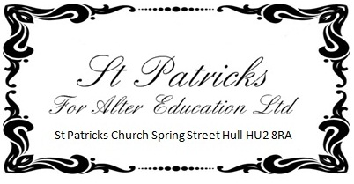

What we do at St Patrick’s to reinforce the teaching and guidance delivered at base schools to educate our children against harmful sexual behaviours, respect for others, sexual preferences, healthy lifestyles and tolerance and respect for others’ religions.
We follow the principles of Kindness, Tolerance and Resilience.

We work as an open group and on a daily basis we and tackle such issues as:

• healthy and respectful relationships, including information on consent;
• what respectful behaviour looks like;
• gender roles, stereotyping, equality;
• body confidence and self-esteem;
• prejudiced behaviour;
• that sexual violence and sexual harassment is always wrong; and
• addressing cultures of sexual harassment.
- Different religions and beliefs exist to our own and we should ask questions to learn rather than use others’ dominant views to disrespect faith
- Zero tolerance to bullying physical, mental and online.
- Learning to support their peers, family and friends with anxiety and concerns with changes in mental health.
The list is not exhaustive and we endeavour to make sure the students understand individualism is a good thing and should be embraced not used as a negative target.

We ensure DSLs have appropriate and regularly updated training and all staff are trained to recognise signs of safety and harmful sexual behaviours.

