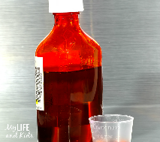 Liquid Medication Tracking Protocol

- When opening liquid medication put the date opened on the label of the bottle
- If receiving more than one bottle of the same liquid medication use up one bottle before opening another bottle. (To ensure this cover the cap of the spare bottle(s) with a tape and date the medication with the date the medication was received at the facility).
- Notify the pharmacy if they have issued more than a 30 day supply of liquid medication due to auto-fill by the pharmacy.
- If sending liquid medication with a consumer when on leave of absence, document on the Release of Responsibility form the name, dose, and amount of liquid medication remaining in each bottle that is sent with the consumer.
- Upon return to the facility from a leave of absence, document on the Release of Responsibility form the amount of liquid medication remaining in each bottle upon return.
- If there is a discrepancy between the amounts of medication sent, the amount returned, and the amount that should have been administered while on leave of absence; document in the progress notes and notify the facility nurse.
- If a pattern of medications errors is noted, a report will be made, to the state-wide common entry point by the facility.

