Costochondritis (kos-toe-KHON-dri-tis)
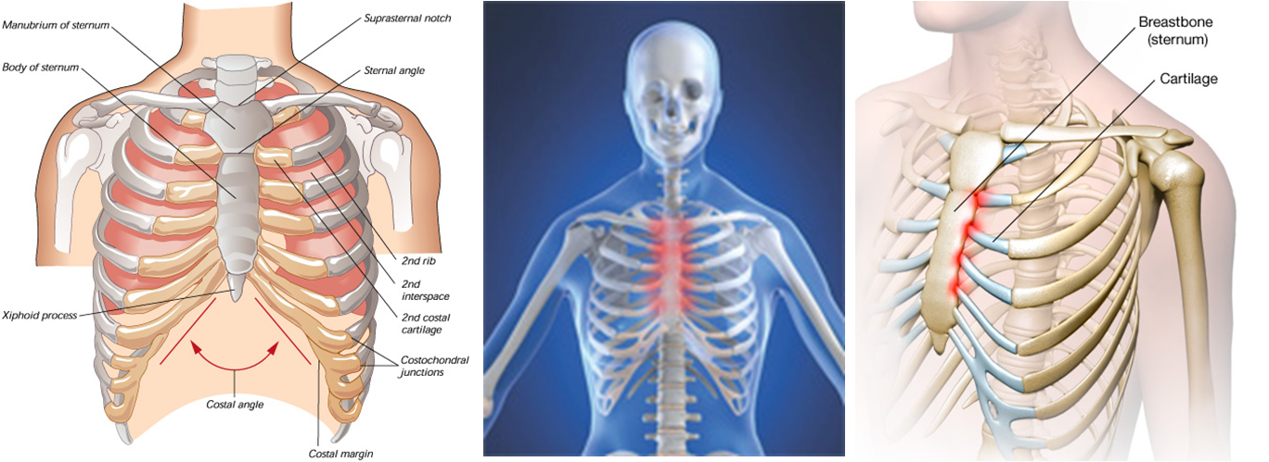

- is an inflammation of the cartilage that connects a rib to the breastbone (sternum) — a junction known as the costosternal joint.
- Pain caused by costochondritis may mimic that of a heart attack or other heart conditions.
- Your doctor might refer to costochondritis by other names, including chest wall pain, costosternal syndrome and costosternal chondrodynia.
- When the pain of costochondritis is accompanied by swelling, it's referred to as Tietze syndrome.
- Costochondritis often resolves on its own if the root of the problem is addressed. However, it can be a recurring condition if individuals
- Do not consistently address the nutritional deficiencies
- Are consistently inactive
- Do not overcome the virus or bacteria that may be the root cause

Causes:
- Many cases of costochondritis are caused by nutritional deficiencies:
- Lack of Minerals
- Lack of Vitamin D3
- Lack of Essential Fatty Acids
- Lack of Vitamin C
- Lack of Glucosamine Hydrochloride
- Constochondritis may be caused by:
- Injury (a blow to the chest)
- Physical Strain (heavy lifting & strenuous exercise)
- Physical Strain (when a person has a very sedentary lifestyle, simple lifting or pulling can irritate cartilage and cause inflammation)
- Severe Coughing
- Poor healing due to fibromyalgia
- Arthritis (either osteoarthritis, rheumatoid, or inflammatory)
- Ankylosing spondylitis
- Joint infection (due to virus, bacteria or fungi, including candida)
- Tumors (either noncancerous or cancerous)
Traditional Medical Treatment
- physical therapy (including ultrasonic, TENS, with or without nerve stimulation)
- Anti-inflammatory drugs (usually nonsteroidal anti-inflammatory drugs [NSAIDS] such as ibuprofen or other pain relief medications)
- Corticosteroids may be recommended for cases that are unresponsive to NSAIDS
Natural Health Recommendations .... It is CRITICAL to address the cause, not just the symptoms!
- STEP 1:
. Supplement generously with Alfalfa (mineral smorgasbord) ... 1 or 2 for every 10 pounds of body weight
(DAILY)
. Optimize Vitamin D3
. Optimize Vitamin C
. Provide intentional Essential Fatty Acids daily ... Examples:
. Eat 2 to 4 tablespoons of ground flaxseed or chia seed
. Eat a heaping teaspoon of unrefined, organic coconut oil every day
. Supplement generously with OmegaGuard Fish Oils
. Optimize vegetable protein intake (it is less inflammatory than animal protein). Soy Protein Smoothees
are recommended.
. increase your “raw” food intake substantially
- STEP 2:
. provide nature’s support herbs & spices for inflammation & pain: ginger, turmeric, cinnamon, garlic
- STEP 3:
. if your pain is related to an infection, choose Garlic and Echinacea (nature’s natural antibiotics)
- STEP 4:
. supplementing with glucosamine hydrochloride can help to repair cartilage ... many people have
benefited by choosing Shaklee Joint Health Complex

