Trinity Times
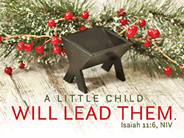
Volume 11-12, Issue 8
November & December 2020

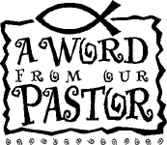

The Essence of Christmas
Christmas is going to be different this year. We are not going to be celebrating it the way that we always have. The virus has forced us to change a lot of things and the way we celebrate Christmas is yet another. But Christmas is always a wonderful time of the year! It has been a time when families get together and share memories and laughter. It is a time when children get to take a break from school and look forward to presents under the tree and a visit from Santa. It is a time to shop and to travel. It is a time for reconnecting to distant relatives and friends. Some of that may be curtailed a bit this year. But no matter how we celebrate Christmas in 2020, it will continue to be a joyous time of the year.

Even if our celebrations will not be exactly the same this year, I would suggest that we all remember that none of what I mentioned above has anything to do with the essence of Christmas. Not really. I would suggest that the essence of Christmas can be summed up in a single passage from the Gospel of John: “For God sent his only begotten Son so that all who believe in him shall not perish but have everlasting life” (John 3:16). That’s why we celebrate Christmas. God loves us so much that he sent his Son to die so that we might live. That is the

essence of Christmas. It has nothing to do with trees or gifts we give to each other. He has little to do with visits from Santa or shopping malls. It has nothing to do with family meals or with college bowl games. The essence of Christmas is the celebration of the love that God has for us, his children. We celebrate that love; a love so profound and so boundless that he gave his only Son so that we might have everlasting life.

Can there possibly be a more profound act of divine love than that? Isn’t that why Christmas should always be so memorable? It reminds of this baby, the Christ, sent by a loving God to save us all? No matter who we are; no matter where we may live; no matter how we worship; no matter what we call this season of the year; no matter what political point of view we might hold; no matter what race, gender or social status might describe us; no matter any of those things, the essence of Christmas is to celebrate God’s love for all of his children and the promise of God who gave his only Son so that all of his children might have eternal life. So, no matter how our celebrations this year have changed, let us all celebrate that divine gift and love each other in Christian unity.

Merry Christmas and blessings to all,
Charles

. Pastor – Charles Wilbanks

Trinity United Methodist Church

1160 Trinity Church Road
Newberry, SC 29108
803-276-1245 Office
803-206-4623 Pastor Cell

clwilbanks@bellsouth.net
trinityumcnewberry@gmail.com
www.trinityumcnewberry.net
PLEASE VISIT OUR WEBSITE
AS OFTEN AS YOU CAN!

Peggy Bogart, Church Secretary
Head Usher: Harry Longshore
Choir Director: Jane Pollard
Organist: Eddie Welborn
Video Board: Josh Pitts, Caroline Senn, Bryan Waldrop
Acolytes/Cross Bearers Coordinator: Eli Martin
Newsletter Editor: Harriet Stevenson

We are a caring church and want to share your concerns. Let us know if you or someone you know would like to share a prayer request with us. We will be happy to pray for you. Contact Peggy Bogart, Church Secretary, or Pastor Charles, to add or remove names from the list.
Trinity Church Members: Jane and Robert Pollard, James and Jeanette Poag, Shirley Berry, Cheryl Longshore, Gloria Brehmer, Rebecca Bundrick

Family and friends of Trinity: Sandra Kenney, Robert Duffie, Kerry Franklin, Blake Hendrix, Jennie O’Shields, Phillip Sanders, Neal and Irene Whatley, Eddie Sisk, Family of Joye Irons, Patricia Motley, Charlotte Boleyn, Kathy Fails

3 - Jane Woodward
6 – Michael Morris
8 – Michael Bouknight
9 – Janet Davenport
11 – Jim Waldrop
18 – Myrtle Longshore
19 – Crystal Waldrop
27 – Jeannette Poag
27 – Noah Waldrop
28 – Gloria Brehmer
30 – Kruz Bouknight

4 – Donna Davenport
11 – Craig Kesler
11 – Becky Poag
15 – Charleigh Armstrong
18 – Kim Hendrix
19 – Betsy Black
20 – Keith Hendrix
22 – Boyd Hendrix
23 –Phyllis Sanders
24-David Hendrix
27-Johnny Marlowe
27 – Dalton Morris
28- Gene Thomas

Christian Symbol for November
St. Andrew's Cross
This cross is a symbol of humility and suffering. It first came into use during the Middle Ages. According to tradition, St. Andrew was crucified while preaching in Greece. He felt unworthy to be crucified in the same way as Jesus, so he begged that his cross be made differently. St. Andrew’s Cross is the national cross of Scotland. It is also called the Cross Saltire.

Christian Symbol for December
Advent Wreath
The Advent wreath is a symbol of watchfulness and increasing joy as we anticipate Jesus’ birth. The wreath’s circular shape symbolizes eternity, or life without end. The candles remind us that Jesus is the Light of the World — he brought light and life to a dark world (see John 1:4-5). On each of the four Sundays of Advent, we light a new candle. As the light grows, so do our hope and joy.

Each of us is an innkeeper who decides if there is room for Jesus.”
—Neal A. Maxwell

Bible Quiz
Which of the four Gospels name(s) Bethlehem as the place of Jesus’ birth?
A. Only Luke
B. Matthew and Luke
C. Mark and John
D. All four
Answer: B (See Matthew 2:1; Luke 2:1-7.)
On November 8, 2020, the Trinity-New Chapel Charge Conference was held in the sanctuary at Trinity. It was an unusual conference this year in that, for the first time, a large attendance was not encouraged. Because of the safety precautions due of the virus, the Pastor’s Report was the only oral presentation given (other than the District Superintendent, Rev. Dr. Stephen Love). Pastor Charles expressed his gratitude to the congregations of Trinity and New Chapel for their remarkable faithfulness during the pandemic. He reported that not only has several people stepped up to make certain that we could open up to in-person worship for those who feel comfortable enough to return, but at Trinity the congregation joined together to make it possible to offer livestreaming of our worship. Pastor Charles pointed out that both congregations continued to faithfully support the church with their financial gifts and both Trinity and New Chapel have done much better than many of our community churches in that regard. During the conference Dr. Love presented each congregation a certificate for paying 100% Apportionments in 2019. All reports and submissions were endorsed and accepted. Although an unusual one, it was certainly a successful conference.

METHODIST YOUTH FELLOWSHIP (MYF) – Josh and Erin Pitts, Leaders

The MYF will begin meeting again in December. The first meeting will be December 6th at 5:00 p.m. A new president will be elected for 2021. The youth will also be making Christmas/holiday crafts at this meeting and will be having a virtual MYF fundraiser. The crafts will be posted on the Trinity FB page for purchase. You can arrange a scheduled pick up time to take place at the church.

The second meeting will be December 20th at 5:00 p.m. We look forward to seeing all of our youth again. Please wear a mask for these meetings.

Continue to Support the Church
During this time of lockdowns and shutdowns, continue to support the church with your offerings and tithes. If you are not worshipping in our sanctuaries, please send your support to the church (1160 Trinity Church Rd., Newberry). For New Chapel, provide your offerings and tithes in the manner which has been previously suggested. If you have any questions call the pastor at (803) 206-4623.
Budget for 2020 - $142,011.50
Weekly Offering Needed - $2,730.99
2020 Avg. Weekly Offering YTD - $2,290.00
Thank you for your faithful giving

Keep in Touch
During this time of social distancing and the shutdown of church activities, it is important for us to keep in touch with each other. If there is a prayer concern or other pastoral need, do not hesitate to reach out to Pastor Charles (803-206-4623). We will continue to have in-person services, as well as live streaming, each Sunday at 11:00 a.m.
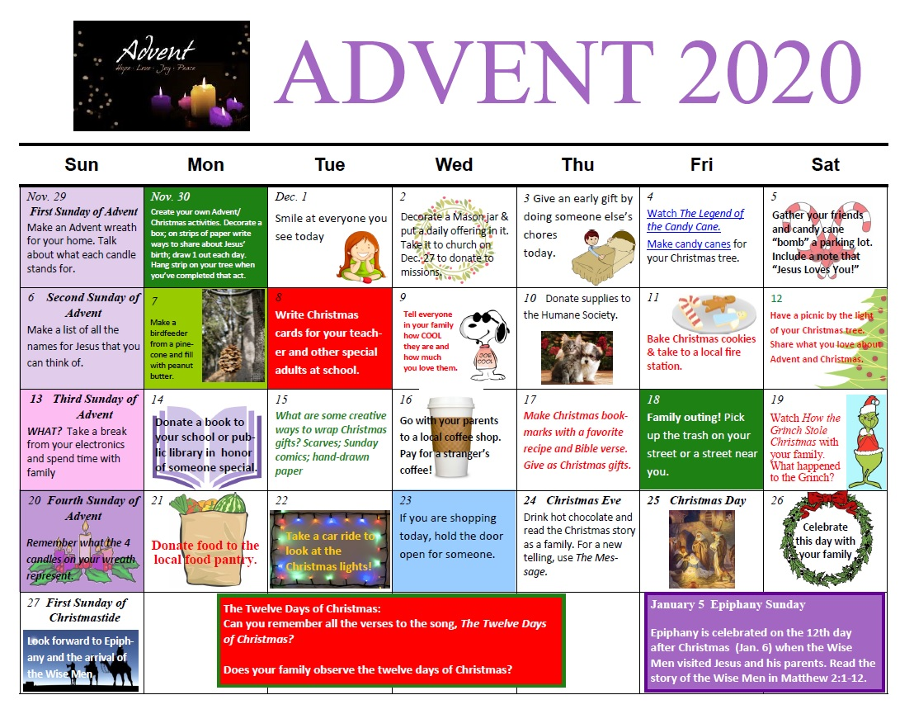
We hope this Advent calendar will bring you inspiration and reflection this season.
Enjoy the many tips and suggestions for Advent.

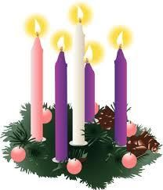
ADVENT
The season of Advent, which comes from the Latin word adventus meaning "coming" or "visit," begins four Sundays before Christmas and ends on Christmas Eve. Advent is the beginning of the church year for Christians.

During Advent, we prepare for and anticipate the coming of Christ. We remember the longing of Jews for a Messiah and our own longing for and need of forgiveness, salvation, and a new beginning. Even as we look back and celebrate the birth of Jesus in a humble stable in Bethlehem, we also look forward anticipating the second coming of Christ as the fulfillment of all that was promised by his first coming.

Although we are accustomed to celebrating Christmas on a single day, in both Christian tradition and on the church calendar, the Christmas season lasts from sundown on Dec. 24 (Christmas Eve) through Epiphany of the Lord (Jan. 6). This is sometimes referred to as "the 12 days of Christmas."

Advent begins with the fourth Sunday before Christmas Day. In 2020, Christmas falls on a Friday, and Christmas Eve on Thursday night. Thus, in 2020, Advent begins Sunday, Dec. 3, and ends at sundown on Sunday, Dec. 24 three weeks plus a portion of an additional day. If Christmas comes on a Sunday, Advent will begin on Nov. 27 and last four full weeks.

The color for Advent has traditionally been purple, although some churches have adopted blue. In practice, however, as churches increasingly incorporate the symbols and decorations of Christmas during Advent, more and more red, green, and gold are appearing. The United Methodist Book of Worship upholds the traditional color of purple for Advent, signifying penitence and royalty, but also allows blue, the color of hope."

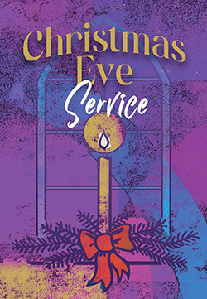
CHRISTMAS EVE SERVICE

Trinity will hold a Christmas Eve Service to include the lighting of the Christ candle on Thursday, December 24, 2020 at 5:30 p.m. Come as you are. All are welcome in the house of the Lord.

A FEW PHOTOS FROM OUR JURASSIC PARK HALLOWEEN DRIVE-BY

A few photos from our Jurassic Park Halloween Drive -by at Trinity. Thanks to Josh, Erin,
and Wyatt for the set up and to all those folks who attended. Everyone had a great time!

Trinity United Methodist Church
1160 Trinity Church Road
Newberry, SC 29108

