Today is World Toilet Day: Why is it a big deal?

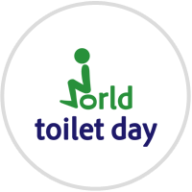
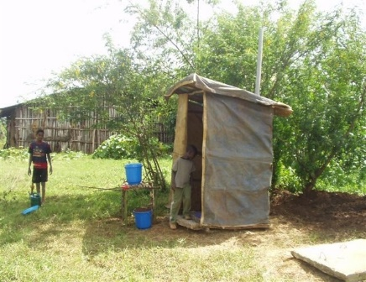

Compiled by: Admassu Mitiku, PhD

1. World Toilet Day is a global advocacy day for toilets and sanitation celebrated annually to raise awareness of the challenge and need for action to end sanitation and toilets crisis.
2. It was created by the World Toilet Organization on its founding day, 19 November 2001 and the organization advocates for safe and clean toilets for everyone and everywhere.
3. Since its foundation in 2001, World Toilet Day has been celebrated worldwide by members of the international community, civil society organizations, UN agencies, NGOs, governments and corporates.
4. In 2013, a joint initiative between the Government of Singapore and the World Toilet Organization tabled a resolution entitled “Sanitation for all” before the UN's General Assembly of 193 members calling for collective action to address the global sanitation crisis through the commemoration of World Toilet Day. The resolution was adopted thereby designating November 19 as an official UN Day.
5. Currently, 2.5 billion people (63% of world population) have access to improved sanitation facilities – defined as a sanitation facility that ensures hygienic separation of human excreta from human contact. Sadly, more people have access to mobile phones than toilets.
6. At present, only 8% of rural Ethiopians use any latrine or are just practicing open defecation. According to Federal Ministry of Health (MoH), sanitation coverage of Ethiopia is 54.8%. The country is working hard to half the current population without access to sanitation by 2015 as the Millennium Development Goals (MDG).
7. Sanitation and proper hygiene are crucial to the prevention of diarrhea and other infectious diseases such as typhoid, polio and hepatitis. Diarrhea is the second leading cause of death (next to cardiovascular diseases) in the world. Around 1.5 million (nearly one in five) deaths each year are caused by diarrhea.
8. It kills more children under the age of five than malaria, AIDS, and measles combined. According to the U.N, a child dies every 20 seconds because of poor sanitation. In 2013, 1,000 children died every day due to diarrheal disease because of poor sanitation. These deaths are preventable.
9. It is estimated that improved sanitation facilities can result in an average reduction in cases of diarrhea of more than one-third. Washing hands with soap has been found to reduce diarrhea by more than 40%.
10. Moreover, those without access to safe and clean toilet also suffer from the indignity of defecating in the open and women and girls are being assaulted while going to defecate in the open or in the bushes. Sustainable sanitation is a matter of dignity, equality and safety and is crucial to improving the health and wellbeing of one-third of humanity.

SANITATION FOR ALL!

TOILETS FIRST!

