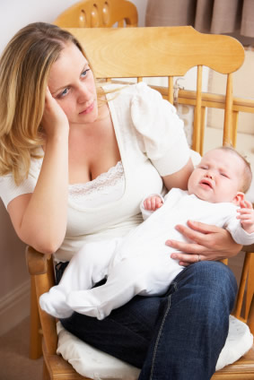
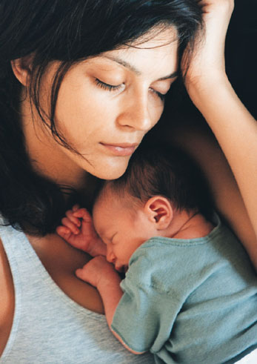

Postpartum Depression
Postpartum depression is moderate to severe depression in a woman after she has given birth. It may occur soon after delivery or up to a year later. Most of the time, it occurs within the first 3 months after delivery.

Causes, incidence, and risk factors
Women commonly have mood changes during pregnancy, especially after delivery.
- These mood changes are frequently caused by changes in hormone levels.
- Many non-hormonal factors may also affect mood during this period:
Changes in your body from pregnancy and delivery
Changes in work and social relationships
Having less time and freedom for yourself
Lack of sleep
Worries about your ability as a mother

Postpartum or “Baby Blues” - Feelings of anxiety, irritation, tearfulness, and restlessness are common in the week or two after pregnancy.."

Postpartum depression - may occur when the baby blues do not fade away or when signs of depression start 1 or more months after childbirth. You may have a higher chance of postpartum depression if you:
- Are nutritionally deficient (especially protein & B Complex)
- Had severe PMS before you got pregnant (due to being progesterone deficient)
- Are hypothyroid
- Are under age 20
- Currently abuse alcohol, take illegal substances, or smoke (these also cause serious medical health risks for the baby)
- Did not plan the pregnancy, or had mixed feelings about the pregnancy
- Had depression or an anxiety disorder before your pregnancy, or with a previous pregnancy
- Had a stressful event during the pregnancy or delivery, including personal illness, death or illness of a loved one, a difficult or emergency delivery, premature delivery, or illness or birth defect in the baby
- Have a close family member who has had depression or anxiety
- Have a poor relationship with your significant other or are single
- Have financial problems (low income, inadequate housing)
- Have little support from family, friends, or your significant other

Symptoms
The symptoms of postpartum depression are the same as the symptoms of depression that occurs at other times in life. Along with a sad or depressed mood, you may have some of the following symptoms:
- Agitation or irritability ... significant anxiety
- Changes in appetite
- Feelings of worthlessness or guilt ... Feeling withdrawn or unconnected
- Lack of pleasure or interest in most or all activities
- Loss of concentration ... Problems doing tasks at home or work
- Loss of energy
- Negative feelings toward the baby
- Thoughts of death or suicide
- Trouble sleeping
A mother with postpartum depression may also:
- Be unable to care for herself or her baby
- Be afraid to be alone with her baby
- Have negative feelings toward the baby or even think about harming the baby. If you are thinking of harming yourself or your infant, seek immediate help.
- Worry intensely about the baby, or have little interest in the baby

Treatment
A new mother who has any symptoms of postpartum depression should take steps right away to get help.
Here are some other helpful tips:
- Ask your partner, family, and friends for help with the baby's needs and in the home.
- Don't hide your feelings. Talk about them with your partner, family, and friends.
- Don't make any major life changes during pregnancy or right after giving birth.
- Don't try to do too much, or to be perfect.
- Make time to go out, visit friends, or spend time alone with your partner.
- Rest as much as you can. Sleep when the baby is sleeping.

Natural Support:
- Shaklee Vitalizer ... a smorgasbord of supplements for overall wellness
- Extra B Complex ... every 2 hours from waking until approximately 5 p.m.
- Eat optimal protein ... have some form of protein every couple of hours throughout the day. For example ... start the day with a Shaklee 180 Smoothee. In a few hours eat a handful of nuts ... in a few hours have a yogurt ... in a few hours have another Shaklee 180 Smoothee ... in a few hours have a Shaklee Cinch Snack Bar ... in a few hours have a scoop of cottage cheese. Then in a few hours have your evening meal.
- Shaklee GLA ... two with each meal to support healthy hormonal production
- Optimize Calcium/Magnesium levels ... if you are nursing, your calcium needs are even higher than when you were pregnant.

