ACROSS: 1, Tabernacle. 7, Absalom. 8, Incas. 10, Roes. 11,

Captured. 13, Fright. 15, Cavell. 17, Cyclonic. 18, Herb. 21, Sonar.

22, Amazing. 23, Settlement.

DOWN: 1, Taste. 2, Bold. 3, Ramiah. 4, Abiathar. 5, Lucerne. 6,

Sacrifices. 9, Saddlebags. 12, Theocrat. 14, Incense. 16, Pilate. 19,

Exist. 20, Save.

C:\Users\Staples-Display\Downloads\pp_dec_2013_intersudokusolution.tif**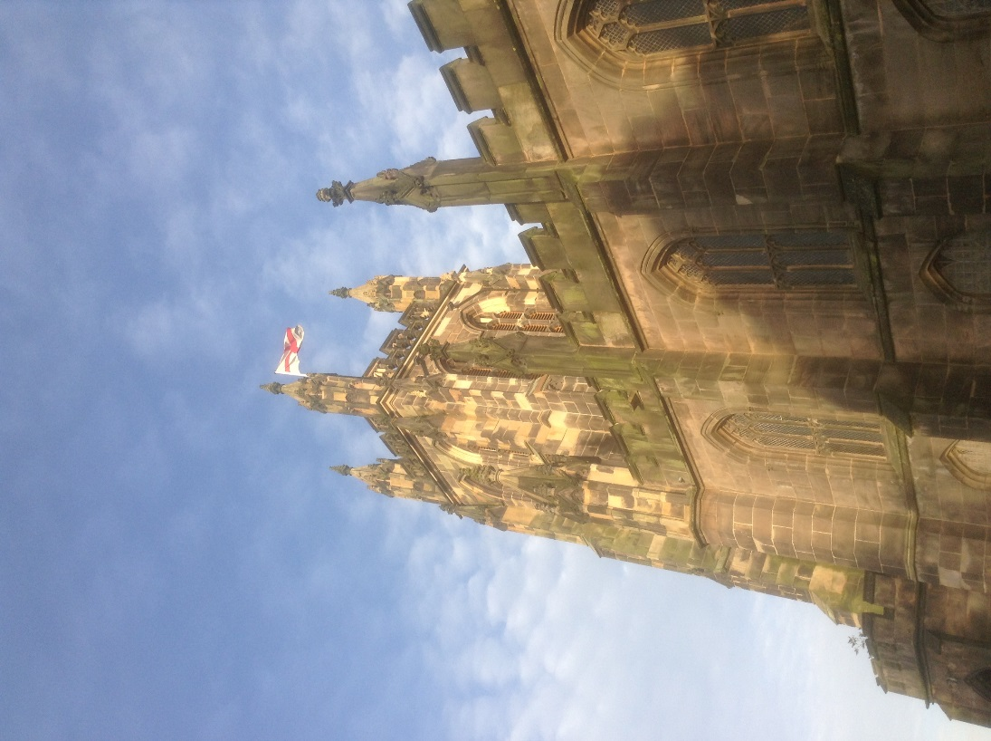**C:\Users\Staples-Display\Downloads\pp_dec_2013_wordsearch_answers.tif

Readers contributions to the magazine are always welcome. Hard copy (hand written if easier) to the Rectory address or by email: to : [**st.marysstockport@gmail.com**](mailto:st.marysstockport@gmail.com)

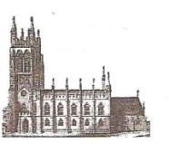Editorial discretion with regard to content and space available will apply.

**St Mary’s in the Marketplace**  
St Mary’s Rectory, 24 Gorsey Mount Street,  
Stockport, SK1 4DU.   
0161 429 6564 [www.stmarysinthemarketplace.com](http://www.stmarysinthemarketplace.com).



St Mary’s in the Marketplace   
50p



Parish Magazine  
December 2013



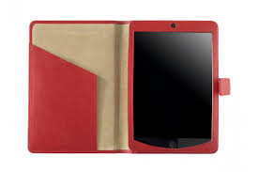**From the Rector’s “ i-pad”**

**Dear Reader**

May I begin by wishing you "a very happy Christmas "! I tend to forget to say it at the end of my letter, which is the meaning of writing to you, after all!  
  
Isn't that the reality of life today, though ? We are so busy getting ready for CHRISTMAS that we forget the meaning of it all. Over the years I have been quite surprised to see how little priority CHRISTMAS DAY is given, as a church- going day,  by those good folk,  who come regularly to church throughout the year, Sunday by Sunday,  week by week ! CHRISTMAS DAY is always a happy service, of course, with carols and readings about CHRISTMAS, because we are celebrating Jesus's birthday! And yet, I've noticed over the years, how few of His " friends" come to the celebration on the day!  
  
This is even more striking on CHRISTMAS EVE when the church is full of wonderful new and happy faces  from midday onwards, really. The family Carol Service at 6pm has become so popular in recent years  that  I wonder why we waited so long before starting to hold it! In truth, I had heard that my  then-neighbouring parish priest, Rev. Ken Kenrick was holding a similar service at an earlier hour, and how much it was appreciated; so I thought we could do the same! Some  of the children who first came to that happy occasion are quite grown up now, and still coming back to make CHRISTMAS EVE a very special day of preparation for themselves and for their families.  
  
What is surprising to me on that day ,is that those who come through the doors of the old church are nearly all visitors and strangers, although

**Loaves and Fishes**

Loaves and Fishes is the name for the Chelwood Foodbank Plus ‘Street Kitchen’ which serves hot and tasty food and drinks every Sunday evening in Stockport Town centre.

Since the weather turned colder we have been delighted to have been able to open the doors of St Mary’s for use by the “Loaves and Fishes” team. Food is served from the Tower (between 6.15pm and around 7.30pm) with clients able to sit in church to eat and take the opportunity to spend time in the warmth, use our facilities and just to talk to us.

It’s early days, but we all hope that the work being undertaken here will grow from strength to strength – as will the ministry offered from St Mary’s – working in the community for the community.

“Loaves and Fishes” support homeless and disadvantaged people from Stockport and the surrounding area.  They also provide sleeping bags and warm clothing especially during the winter months.

.

From the website of   
Chelwood Baptist Church, Adswood Road, Cheadle Hulme, Stockport SK8 5QA.

We are very pleased to announce that the 'Loaves & Fishes' street kitchen project which meets every Sunday night is moving to a more permanent home at St. Mary's in the Marketplace Church from Sunday (Nov 3rd). The Rector Revd Roger Scoones has kindly agreed to open the church and to provide access to toilets and seating in case of inclement weather

**The exhibition at St Mary’s has closed, but Neil’s splendid works will be shown again in the future and at other locations around the Borough, and who knows they may come back to us on day!**

In celebration of the work of Neil Dimelow it was a pleasure to invite back to St Mary’s the Mayor and Mayoress of Stockport, Cllr Chris Murphy and Dot Murphy to view the exhibition before it was dismantled and packed away ready to be moved to a new location.

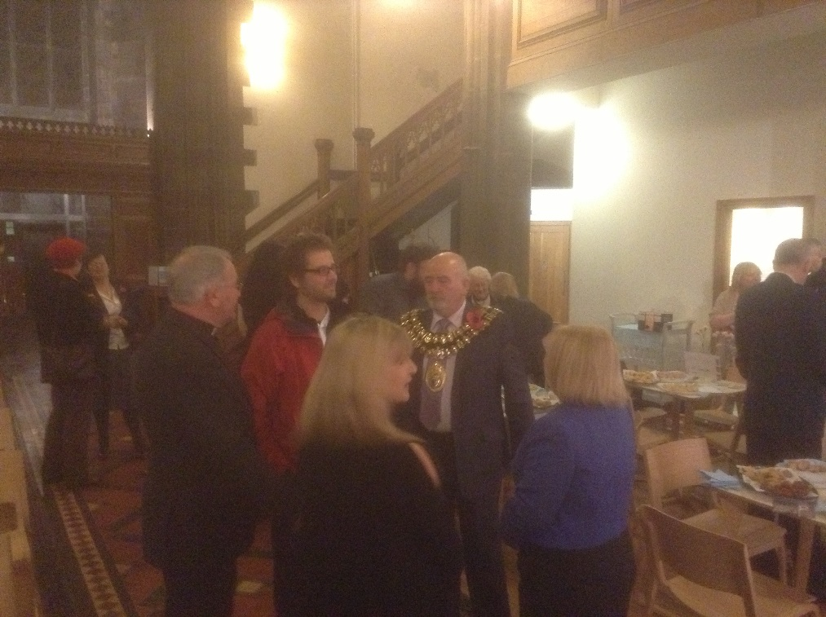

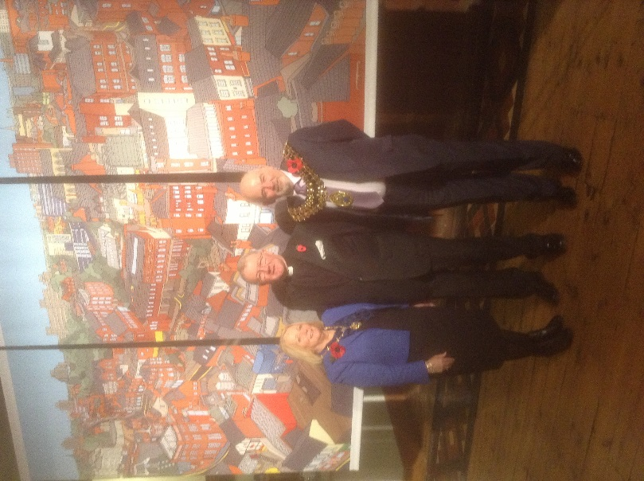

Drinks, nibbles and speeches – it was an enjoyable evening for all attending (including Eamonn Boylan - Chief Executive of Stockport Council and Cllr Sue Derbyshire (Leader of the  
Council). Many thanks to all who contributed funds to our new appeal for the refurbishment of the vestries –  
in particular to The Arden Arms for a most welcome donation and the gift  
of flowers from Sainburys.

there are some faces who appear regularly, year after year, which is lovely! But where are the Sunday folk? Of course, to be honest and realistic, there is much  to-ing and froing at this  "holiday time of year" , and in truth some people may visit other churches, hopefully! So where will you be this CHRISTMAS? You are most welcome to join us on CHRISTMAS EVE or CHRISTMAS DAY at St. Mary's !  
  
Personally speaking,  my memories of CHRISTMAS EVE night and CHRISTMAS DAY, of growing up in the family, are full of Church services, with candles and soft organ music playing melodious and familiar carols, of smiles and renewed friendships , and wishing one another  " a happy Christmas" in the chill of the cold night air,  as one tumbled out of a tiny country parish church which had already seen 800 Christmas Days! And memories too ,of surprising jollity in church on CHRISTMAS DAY morning, when churchgoing was always such a serious affair during the year, in my experience, at least !  
  
You and I are a tiny, tiny part of the story of humanity, and yet God cared enough about YOU AND I to send His Son into the world, to be born in a stable in Bethlehem, to be worshipped and adored by His parents, by visiting shepherds, by wise men and countless millions ever since. As someone once said," Wise Men followed the star; wise men still do!"  
  
This month of December is, without any doubt or fear of contradiction, a very busy time of year for many of us, not least of all, those of us who are involved in the day to day life of this ancient Parish Church, in the Marketplace .The danger is that in this helter-skelter existence, this sudden burst of activity, especially at St. Mary's ,which rejoices  in welcoming so many hundreds of people of all ages, to church for this very reason, to celebrate Christmas in words and music; the danger is, of missing the point of it all!  
  
And that's where CHRISTMAS DAY comes in, and CHRISTMAS EVE come to that. Everything stops. Everything closes, eventually! A chance to sit and think, and pray, and sing a carol, or listen to others singing, to come close to God. This year will be a very special one for those with babies, who've arrived in recent months; a time to celebrate their first Christmas with their infant child.  Couples just like Prince William and Kate will be doing that. And we can share their happiness with that family, in the gift of a son to them, Prince George "a son and heir” no less!

How much more can we thank God for The Gift of His Son, Jesus Christ, born on CHRISTMAS DAY and remembered on December 25th by Christians throughout the world. I hope that wherever you may be on CHRISTMAS DAY , be it near or far away,  be it in the comfort of your home, be it in the bosom of your family, in company of friend or be it alone, or even in church,  you will be aware that you are being blessed by God. It is He who loves YOU, and longs to bless you with a  
  
 VERY HAPPY CHRISTMAS AND A PEACEFUL NEW YEAR!  
  
I remembered, the meaning of it all!

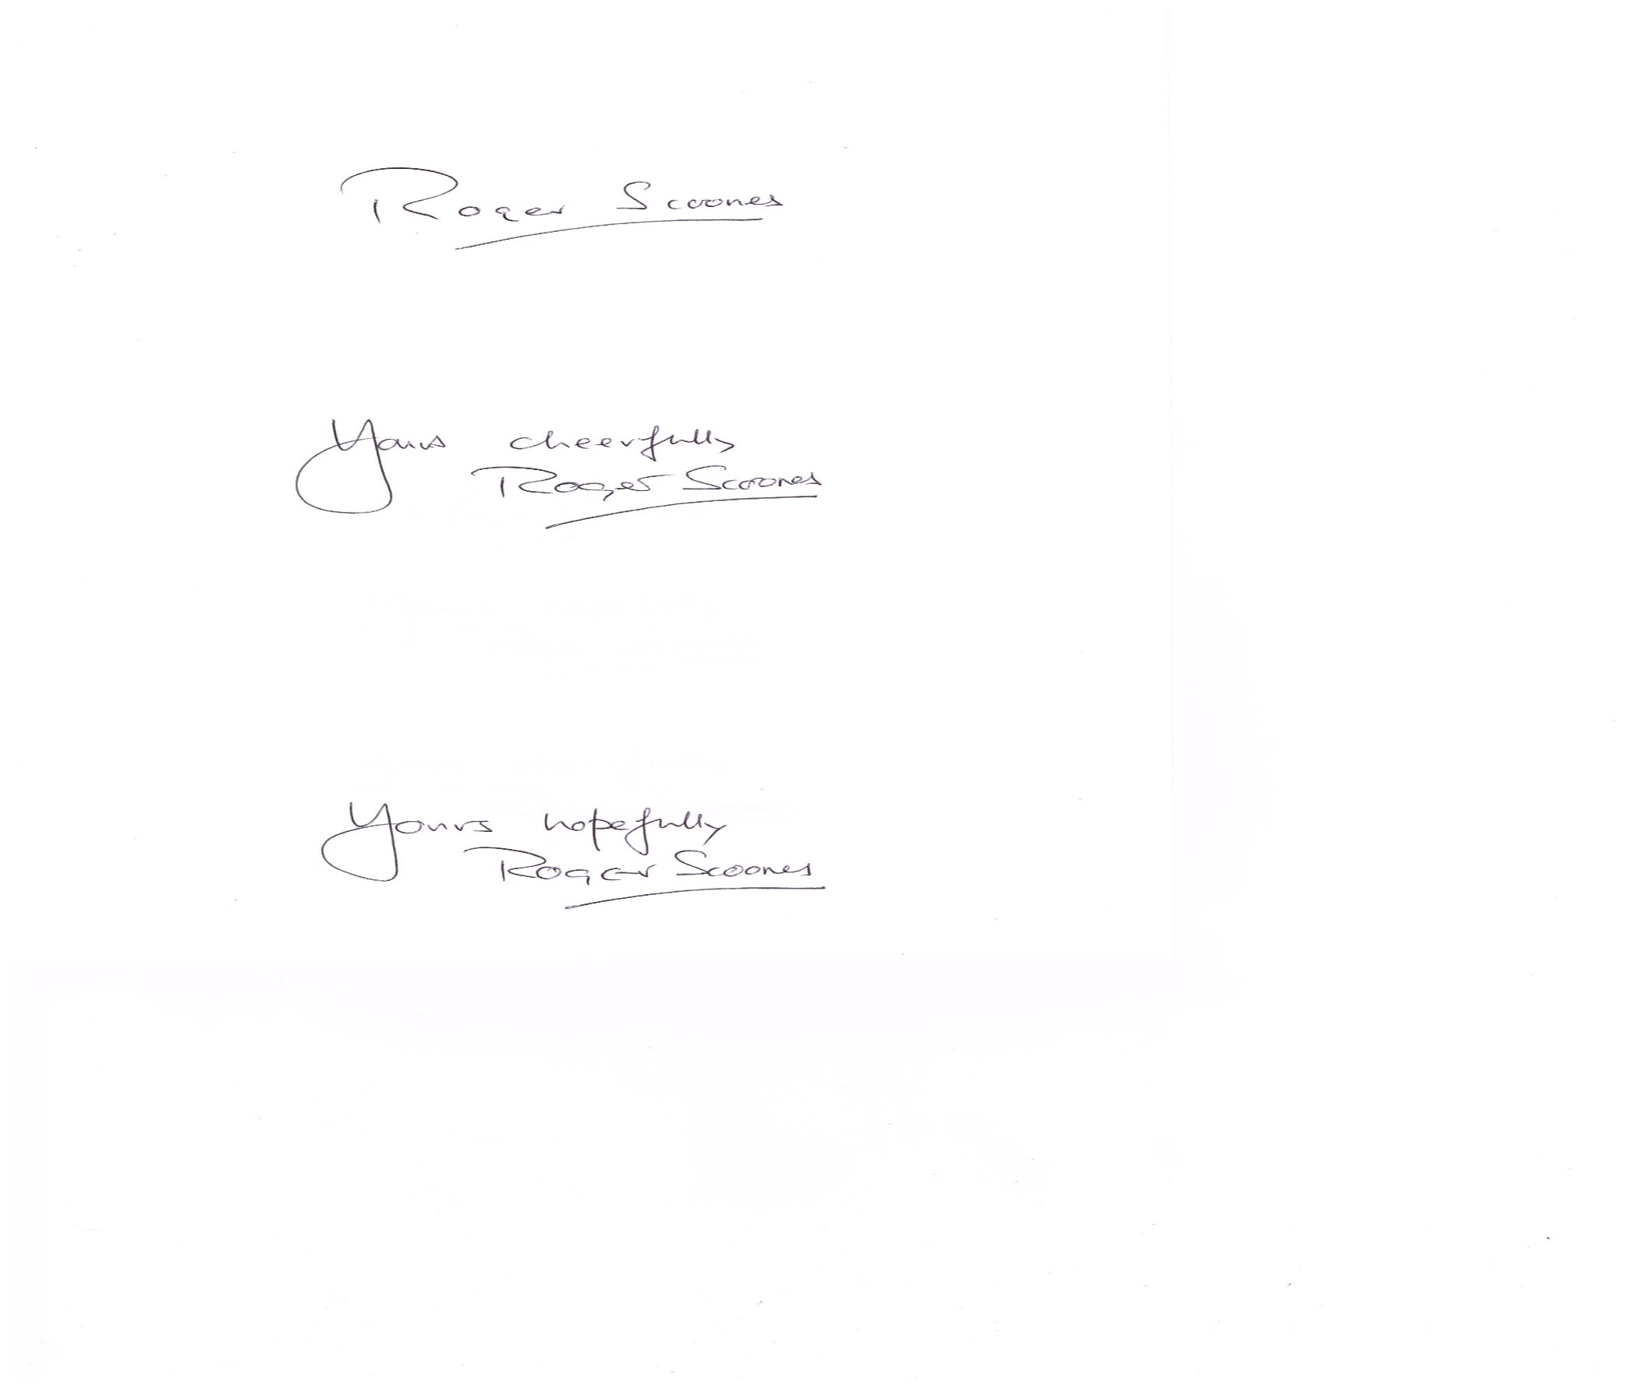

**And…… qualified as “Chief Washer-up-er……**

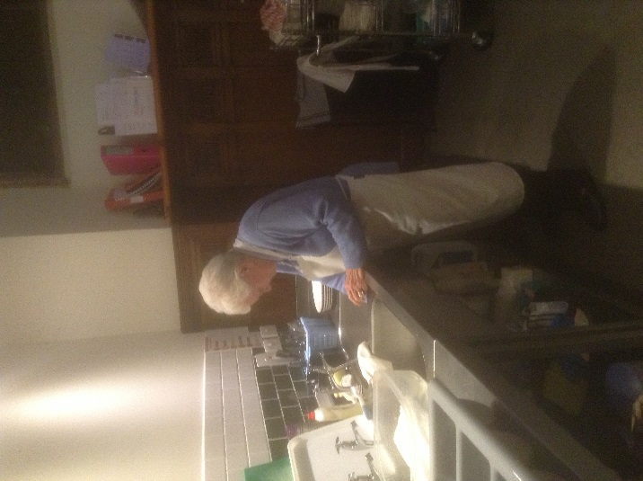Yes, we do indeed have a dishwasher  
but we “double wash” to remove plate waste before finishing off in the steamy depths of the dish washer. At the kitchen sink, Isobel Clarkson, organist, churchwarden and now Chief in Charge of washing up!

The Catering Team were at the time hosted the “Not Quite Bonfire Night Pie and Pea Supper which obviously consisted of slightly more than pie and peas – and although numbers attending were small, it was an enjoyable evening.

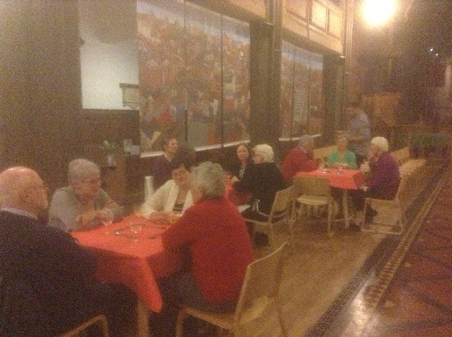It’s always nice to hold social evenings at The Nave Café, a chance to sit and relax and enjoy the fellowship aspect of life at St Mary’s. Also for the Catering Team to keep their hand in, preparing and serving – as well as clearing away afterwards.

Join us at our next event – we intend to hold something on a monthly basis.

**The Christmas Crossword**

C:\Users\Staples-Display\Downloads\pp_dec_2013_xwordblank.tif

Across

1 Provisional meeting place of God and the Jews (Exodus 25:9) (10)

7 David’s third son, killed when his head got caught in a tree during

a battle with his father (2 Samuel 18:14–15) (7)

8 They ruled much of the west coast of South America in the 15th

and early 16th centuries (5)

10 Small deer of European and Asian extraction (4)

11 Seized control of (Numbers 21:25) (8)

13 Terror (Luke 24:5) (6)

15 First World War heroine shot by the Germans in Brussels, Nurse

Edith — (6)

17 Stormy (8)

18 A bitter variety of this, together with lamb and unleavened bread,

was the Passover menu for anyone ‘unclean’ (Numbers 9:11) (4)

21 Arson (anag.) (5)

22 How John Newton described God’s grace in his well-known hymn

(7)

23 Habitation (Isaiah 27:10) (10)

Down

1 ‘ — and see that the Lord is good’ (Psalm 34:8) (5)

2 ‘The wicked man flees though no one pursues, but the righteous

are as — as a lion’ (Proverbs 28:1) (4)

3 One of the exiles, a descendant of Parosh, who married a foreign

woman (Ezra 10:25) (6)

4 He escaped from Nob when Saul killed the rest of his family and

joined David (1 Samuel 22:19–20) (8)

5 City and lake in Central Switzerland (7)

6 ‘Offer your bodies as living — , holy and pleasing to God’

(Romans 12:1) (10)

9 Pouches carried by horses (Genesis 49:14) (10)

12 One who accepts government by God (8)

14 Aromatic substance commonly used in Jewish ritual (Exodus 30:1)

(7)

16 He asked Jesus, ‘What is truth?’ (John 18:38) (6)

19 Are (Romans 13:1) (5)

20 ‘You are to give him the name Jesus, because he will — his people

from their sins’ (Matthew 1:21) (4)

C:\Users\Staples-Display\Downloads\pp_dec_2013_wordsearch_grid_0.tif**Wordsearch**

**C:\Users\Staples-Display\Downloads\pp_dec_2013_maze.tif**

**The Maze Game**

**Christmas Sudoku**

C:\Users\Staples-Display\Downloads\pp_dec_2013_intersudokugrid.tif

**Christmas unwrapped – take care….**

You may welcome your Christmas presents this year, but will you be able to unwrap them? A recent report from Which? magazine reveals that four in 10 of us have hurt ourselves while trying to open the packaging on everyday household items.

Brillo Mr Muscle soap pads, Listerine mouthwash, Warburtons crumpets and WH Smith rounded blade scissors are named and shamed, but top of the list comes the Oral-B Vitality electric toothbrush and all things wrapped in moulded plastic packaging. Opening those can end in bloodshed.

No wonder, for 89 per cent of us use scissors, eight per cent of us get out the Stanley knives, and four percent of us use a razor blade. The remaining two per cent of us seemingly go berserk - and resort to smashing the thing with a hammer. Whatever you use, be careful: in the last two years, a million Britons ended up at their GP or in A&E, just because they were trying to open a tin can.



December   
   
Sunday, 1st 06.30pm Advent Carol Service   
 with the Maia Singer  
Tuesday, 3rd 12.15pm Christmas Lunch-time  
 service  
Wednesday, 4th 07.30pm St Mary’s Appeal   
 Concert with the Affinity Show Choir   
Thursday, 5th 07.00pm Stockport Secondary   
 School Carol Festival

Sunday, 8th 03.00pm Ex-Services   
 Associations Carol Service/Hazel Grove Brass Band  
Monday, 9th 01.00pm Stockport MENCAP  
 Christmas Celebration  
Tuesday, 10th 12.15pm Lunch-time Service  
 with the St Mary’s Tuesday Choir  
Wednesday, 11th 07.00pm Banks Lane Junior  
 School Carol Service  
Thursday, 12th 12.30pm The Mayor’s Carol  
 Service  
 07.00pm Beechwood “Tree of  
 Light” Remembering Service  
Friday, 13th 01.30pm Age UK Carol Service   
 with Warren Wood Primary School Band & Choir

Saturday, 14th 10.30am A Christmas  
 “TREAT” incorporating St Mary’s Christmas Fayre

**The Global Light Revival Church**

#### New to St Andrews - We are pleased to welcome shortly Minister Eric Goodwin-Armah and the Global Light Revival Church

The Global Light Revival Church is a growing international, multi-cultural Church. A community of diverse Christians drawn from different nationalities with the vision to win souls to the Kingdom of God and to assist individuals to discover their destiny on earth and to fulfil that destiny with the help of Christ and also to love people no matter whatever background they come from. The aim of the Church is to take the good news of Christ into the community and to help build a better world for generations to come. With the believe that Jesus Christ is the only true way to eternal life, comes the desire for the GLR Church to reach out to all nationalities, ages and groups who are lost in faith or seeking to know Christ and to have him as their personal Saviour and to all who are seeking reconciliation and tranquillity in our troubled world.

For more information see [www.globallightrevival.com](http://www.globallightrevival.com)

### The Stockport Evangelical Church will continue to meet each Sunday morning at 10.30am

## St Andrews



### Happy Christmas and a Prosperous New Year to all our regular users:

|  |
| --- |
| Affinity Show Choir |
| Manchester Bach Choir |
| Mums and Dads at Home (MADatHome) |
| Slimming World |
| Stockport Central Children’s Services |
| Stockport Evangelical Church |
| Stockport Field Club |
| Stockport Operatic Society |
| Stockport RC Drift ClubPure Insight |

We still have gaps in our bookings to take one-off events and St Andrews is an ideal party venue – with plenty of room and private off-street parking.

Our present hire rates are £15.00 per hour, an organisational session rate (3 hrs) of £3 0.00 (regular users) and our party rate is just £75.00. We have a good sized kitchen - including cooker, fridge, water boiler, microwave and toaster complete with crockery and cutlery. Large Hall, Small Hall, Toilets.

Sunday, 15th 10.30am Advent Service   
 Preparing for Christmas  
 03.00pm Tree of Light Preparing  
 for Christmas without a   
 loved one  
Tuesday, 17th 01.30pm The Wellspring  
 Carol Service  
Thursday, 19th 02.00pm Vernon Park Primary  
 School Carol Service  
 06.00pm “Marketing Stockport”  
 Carol Service  
Friday, 20th 01.00pm “Shopmobility  
 Stockport” Carol Concert   
 with Offerton Methodst   
 Choir  
Saturday, 21st 07.00pm “Sing Christmas”  
 Concert with the Maia   
 Singers  
Sunday, 22nd 10.30pm Advent Service  
 03.00pm Carols with the Market  
  
Christmas Eve  
Tuesday, 24th 01.00pm Carols for all  
 06.00pm Family Carol Service  
 11.00pm Midnight Holy Communion  
 with Carols  
Christmas Day  
Wednesday, 25th 10.00am Family Celebration of  
 Christmas

**Dick Whittington**

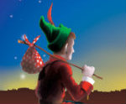Is the Pantomime this year at The Plaza, Stockport and so your annual invitation to attend with St Mary’s (as a group) and to return to the Rectory for afternoon tea. If you are interested in coming – please see Rita Waters.

We have chosen Friday, 3rd January – afternoon performance starting at 2.30pm. Tickets will need to be booked well in advance and paid for in advance of booking.

Schedule of charges: Wheelchair user £14.00 / Student £15.40 / Family Ticket (2 adults and 2 children) £13.25 per ticket / Children £11.25 / Senior Citizen £15.40 / Adult £17.60 / Friend of The Plaza £15.40 / Job Seeker £15.40 / Disabled £15.40. Prices include fees where appropriate/known. A group rate may be available IF sufficient numbers (min 20) wish to attend.

Join us afterwards for tea/cakes at St Mary’s Rectory.

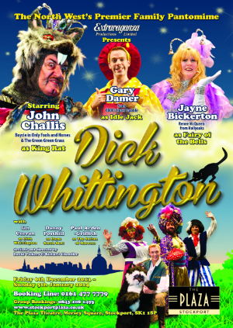

* **Wheelchair User - Adult £14.00***(No Ticket Fee)*
* **Student £15.40***(£14.00 ticket price + £1.40 fees)*
* **Senior Citizen £15.40***(£14.00 ticket price + £1.40 fees)*
* **Adult £17.60***(£16.00 ticket price + £1.60 fees)*
* **the Plaza £15.40***(£14.00 ticket price + £1.40 fees)*
* **J£15.40***(£14.00 ticket price + £1.40 fees)*

**Saturday, 25th January 2014**

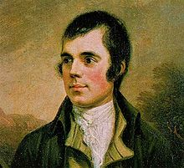**Burns Night at the Nave Café**

Cock-a-Leekie Soup

Haggis (neeps and tatties)

Cranachan

Tickets available early January.

**Level 1 Food Safety Training**

Are you interested in helping us in the kitchen preparing food for the café and/or events?

You will need to hold a certificate for Level 1 Food Safety. Training for this qualification will be offered to those interested in January (in liaison with St Matthews, Edgeley).

Dates will be made available shortly, most likely on a Saturday with the session lasting around 3 hours.

The course will be run by an external trainer, cost £35 plus VAT.

Children’s Society Collection Boxes

Many thanks to everyone who contributed to the Children’s Society collect boxes. We were able to forward a cheque to the value of £211.00 gratefully received by the Charity.

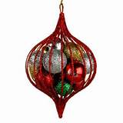Rita’s Page

As we come into the time of Advent it’s made me think of the word HOPE and how it affects us all here at St Mary’s.

2000+ years ago Mary and Joseph were told about the forth-coming birth and that the child would be called Jesus. Jesus would be the hope or the light of the world.

Here at St Mary’s you were told of new plans for the re-ordering of the church. This was the hope of new life for St Mary’s that many had prayed for and waited for.

On a more personal note I started attending St Mary’s lunchtime service and as time went by I began to take some of the services on Tuesdays and also morning prayer on Sundays. I felt at home and very welcomed and encouraged here. My hope was that I could become part of the life of St Mary’s on a permanent basis. I talked with my incumbent David Brewster at St Matthews and Roger about my transferring as Reader to St Mary’s and it was agreed this could be done. And the rest is history so they say.

My hope has started to be fulfilled as I begin my new ministry here among you and I thank God for that and pray that it will continue for many years to come.

Finally I would like to thank all of you for your welcome and encouragement over the last year, it has been very much appreciated.

As we begin our journey through Advent let hearts and minds be open, not only to God’s holy word but also to what God is telling us He wants us to do with our lives. May God’s blessing surround us all as we prepare to celebrate the birth of God’s only Son, Jesus, together.

Yours in Christ Rita Waters

St Mary’s Christmas Fayre A Christmas Treat

Come and join us

Saturday, 14th December 2013

An invitation has been sent to Santa Clause to come and join us in his grotto at St Mary’s. We hope he accepts our invitation!

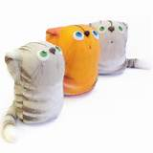Join the Christmas Tree Trail – and it will lead you to St Mary’s and The Nave Café where we will be offering special Christmas treats.

**St Mary’s Craft Staff**

Traidcraft items

The Organist Entertains….

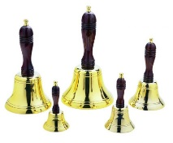**Norbury Handbell Ringers**



**Mini Flower Festival**

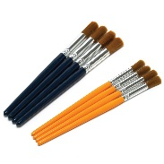Book Stall

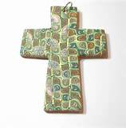 **Miscellaneous Items Stall**

**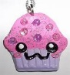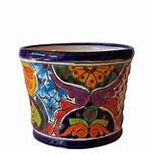   
 Paint Your Own Ceramics**

**And much much more…**

**As most of you are aware the majority of the pews from St Mary’s were sold** during the summer  **– well this is the story of three of them…..**

**Catronia’s Story - New from old! Recycling at St Mary's**

In our desire to be eco-friendly and make good use of items that are surplus to requirements, a lot of the Victorian pews from St Mary's have been sold. I bought one for my garden (to be altered into an L-shape) and two for my son, Simon.  You may well wonder what he would want with two pews?  The answer lies in his hands, literally.  Simon works as a full-time chainsaw carver, sculptor and creator of beautiful things usually made from wood that would otherwise have been wasted. You can see pictures on his website [www.treecarving.co.uk](http://www.treecarving.co.uk/)

His plan with the two pews is to make a table and benches.  I wanted my pew to be shorter to fit into my garden, and in the middle of the night, as you do, I had a few ideas.  Why not use some of the spare wood to make unique souvenirs of St Mary's that we could sell in the Church shop? I had rosy visions of pendants, book marks, key ring tags, crosses and other items which may have been a tad fanciful...  As reality set in and I realised my son had a lot of other work to do as well, we made a start with book marks. Simon has taken some of my pew to create the little cubes which Sue and Ann and the craft group have transformed into book marks.  **For £1 or so, you too can own a unique little piece of St Mary's history**.

Recently Simon has launched a new line in his business, creating beautiful items out of wood, that people can wear. The web address is [www.woodenwearables.com](http://www.woodenwearables.com/)  The items can be made from lots of different woods including lime, oak, sycamore, yew, or bog oak which has lain buried in a field for centuries, **and also pitch pine from St Mary's pews of course**! **So you could own and wear something made from wood from St Mary's pews- a truly unique purchase! *For men :*** Bow ties on hand-made leather straps will create a stir at your next black-tie do! Cuff links in a square or tear-drop shape. Rings made of single or multiple layers of different woods.  ***For women:*** Bangles and ring; Leaf-shaped brooches; Feather-shaped hair clips - Each piece is hand-carved and finished and a demonstration of this is shown on the website. These are investment pieces, but I hope that in future we can also have crosses, pendants and other items made from the St Mary's pew so that everyone can share in our history. Catriona Smith

Operation Christmas Child

A big thank you to everyone who has made-up a shoe box, given items to be included in a box, or made a donation towards the cost of transportation.

It was a wonderful sight to see so many boxes at our morning service and to be able to reflect on just how far those boxes would travel and to imagine the joy on the faces of the children when they receive them. They are in transit and we look forward to an update from Margaret Forster in due course as to where they were sent. Where-ever that is we know they will be well received and give a little joy this Christmas.

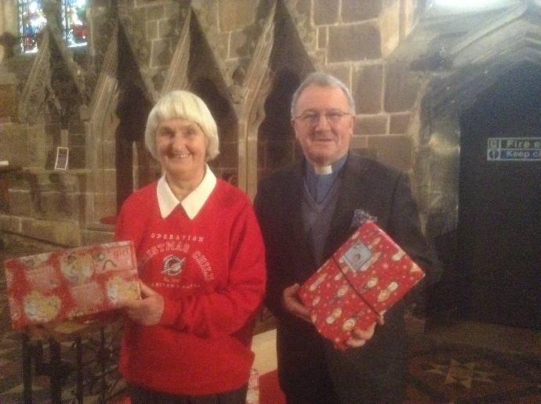



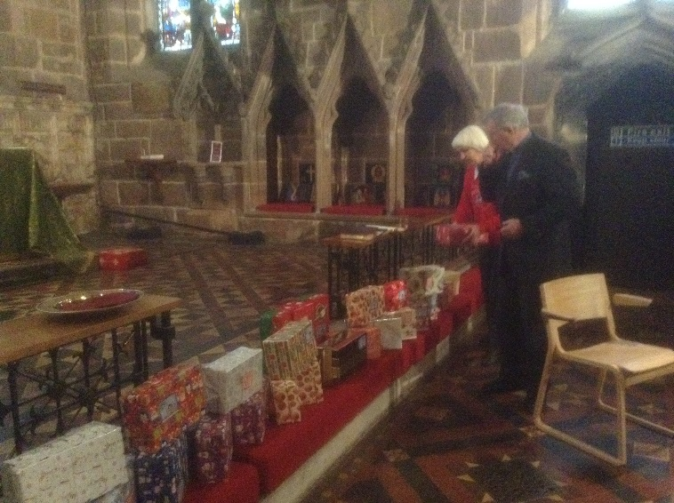



A Donkey

I carried sweet Mary  
Over desert and sand,

With her small infant Son

To a faraway land;

And again when a Man  
Through the crowd’s happy cheers;

As the palm branches waved

It brought joy to my ears.

Now small children I bear,

And men call me an ass,  
But my brown hairy back

Bears the mark of a Cross!

A gift for St Mary’s

### Please think of your Church this Christmas, as we open our doors over the days and weeks ahead - it may be for worship, a concert, a special event, it may be to host the “Loaves and Fishes” soup kitchen or just to welcome visitors coming into Stockport.

The daily costs of keeping our doors open are high – details to be made available in the New Year after the books are balanced, following year-end BUT we all know how expensive it is to run our own home. Think of St Mary’s (please) as we put on the heating to welcome our guests, provide hospitality to visiting school children and prepare/print our service sheets and other items of publicity. As we pay the insurance, replace the light bulbs and loo rolls – it all adds up.

Frank Hamnett has kindly agreed to make-up the Planned Giving envelopes for 2014 which will be available before January. There are too few people using this system now to have these printed externally (where a minimum order of 50 is required). Envelopes will however be available for those who wish to give cash on a regular weekly basis, bringing their contribution to Church. Those wishing to Gift Aid their contribution need to complete a separate form (available on request).

Of course we encourage anyone able to give on a regular basis to commit a set sum each month and set-up a standing order with the Bank. This is a sure way to ensure that St Mary’s receives your contribution on a fixed date each month and considerably aids budgeting.

Ordinary gift aid envelopes are available in Church for a one-off receipt. These of course are printed externally with the prescribed wording, so we ask that they are not used for none gift-aided contributions – which can be placed either on the collection plate or in the donations box. Single and regular donation forms are also available in the office area (south aisle).