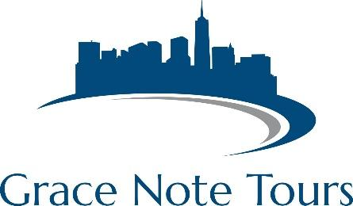

*The easiest trip-planning experience ever….guaranteed!*

**Myrtle Beach, SC – Sample Proposal**

**Package Inclusions:**

2 nights lodging

2 breakfasts

2 dinners

Broadway at the Beach

Shopping at Barefoot Landing

$1,000,000 tour liability insurance

1 free director package

Director Resource Binder

**Options:**

Ripley’s Believe It or Not

Ripley’s Aquarium

Performance at Alabama Theatre

Wild Water and Wheels Waterpark

Transportation is NOT included in this proposal.

**Not what you want? Let’s customize to suit YOUR needs and educational requirements!**

**Myrtle Beach Sample Itinerary**

**Day 1**

Arrive in Myrtle Beach/Check-in to hotel

Free time on the beach

Dinner at House of Blues

Free time at Barefoot Landing

**Day 2**

Workshop/Clinic/Performance in the morning

Wild Water and Wheels Waterpark

Ripley’s Aquarium

Dinner at Hard Rock Café

**Day 3**

Beach time in the morning

Lunch at Broadway at the Beach