Holiday Club Booking Form. 1st – 4th June 2021
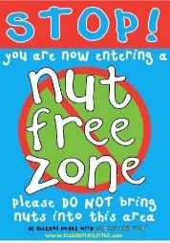
Costs; Full Day; £30. Early Bird Rate; £33 Normal rate.
Half Day; £17 Early Bird Rate; £19 Normal rate.
Early Bird Rate; given to bookings received before Friday 14th May.

Child/ren………………………………………………………………………………………………………… Year group:…………………………………………
BANK HOLIDAY | Tuesday 1st June | Wednesday 2nd June | Thursday 3rd June | Friday 4th June

 |  |  | 8am-  5.30pm | 8am-1pm | 1pm-5.30pm | 8am-  5.30pm | 8am-1pm | 1pm-5.30pm | 8am-  5.30pm | 8am-1pm | 1pm-5.30pm | 8am-  5.30pm | 8am-1pm | 1pm-5.30pm

Terms and conditions
PLEASE ENSURE PACKED LUNCHES DO NOT CONTAIN ANY FOODS THAT CONTAIN NUTS. You will be invoiced and expected to pay for all sessions that are booked regardless of whether your child attends.
Please note: bookings are subject to minimum numbers.
We are planning to open for the summer however, we may have limited spaces due to group sizes.
We will be keeping up to date with GOV information and following their guidelines.
Signed (parent or carer) ……………………………………………email address…………………………………….………………....Date received…………………………

