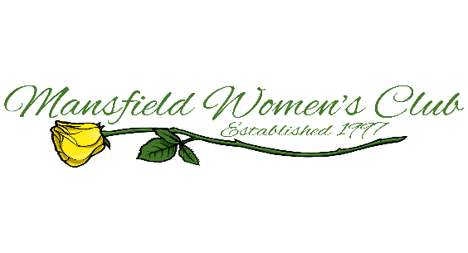
REQUEST FOR PHILANTHROPIC GRANT
Please answer all questions and mail original form to address below.
Agency Name: ___________________________________________Tax ID# ___________________________
Address: _________________________________________________________________________________
Phone #: _______________________________Email Address: ______________________________________
Name of Executive Director: __________________________________________________________________
Are you a non-profit 501 (c) (3) organization? ___________________________________________________________
If not, supply charitable category identification: _________________________________________________________
How long has your organization been established? _______________________________________________________
If the contact making the request is not the Executive Director, please provide:
Name: ______________________________________________________Title: _________________________
What percentage of your yearly income is administrative overhead? _________________________________________
How many people receive your service? ________________________________________________________________
What areas and counties do you serve? ________________________________________________________________
Are any limitations placed on who can receive your services? Yes __________ No _________ If yes, explain:

Explain the objectives of your organization:

____________________________________________________________________________________________________________________________________________________________________________________
Dollar amount requested: $____________________Have you received a grant before from MWC? __________________
If request approved, how would the donation from Mansfield Women’s Club be used?
________________________________________________________________________________________________________________________________________________________________________________________________________________________________________________________________________________________________________________________________________________________________________ Return completed form to: Mansfield Women’s Club, ATT: Philanthropic Committee, P.O. Box 1212, Mansfield, TX 76063
GRANT REQUESTS MUST BE RECEIVED by March 15, 2021 TIMELINE FOR AWARDS TBD DUE TO CURRENT PANDEMIC CONDITIONS
FOR MWC USE ONLY: Referred by: _________________________MWC Liaison: _______________________
Date Approved by MWC Philanthropic Committee: ________________Amount Approved: $_______________
Requires Board approval 2020-2021

