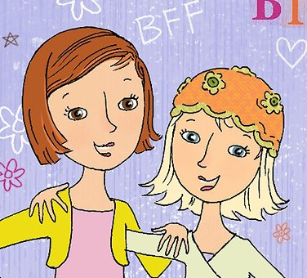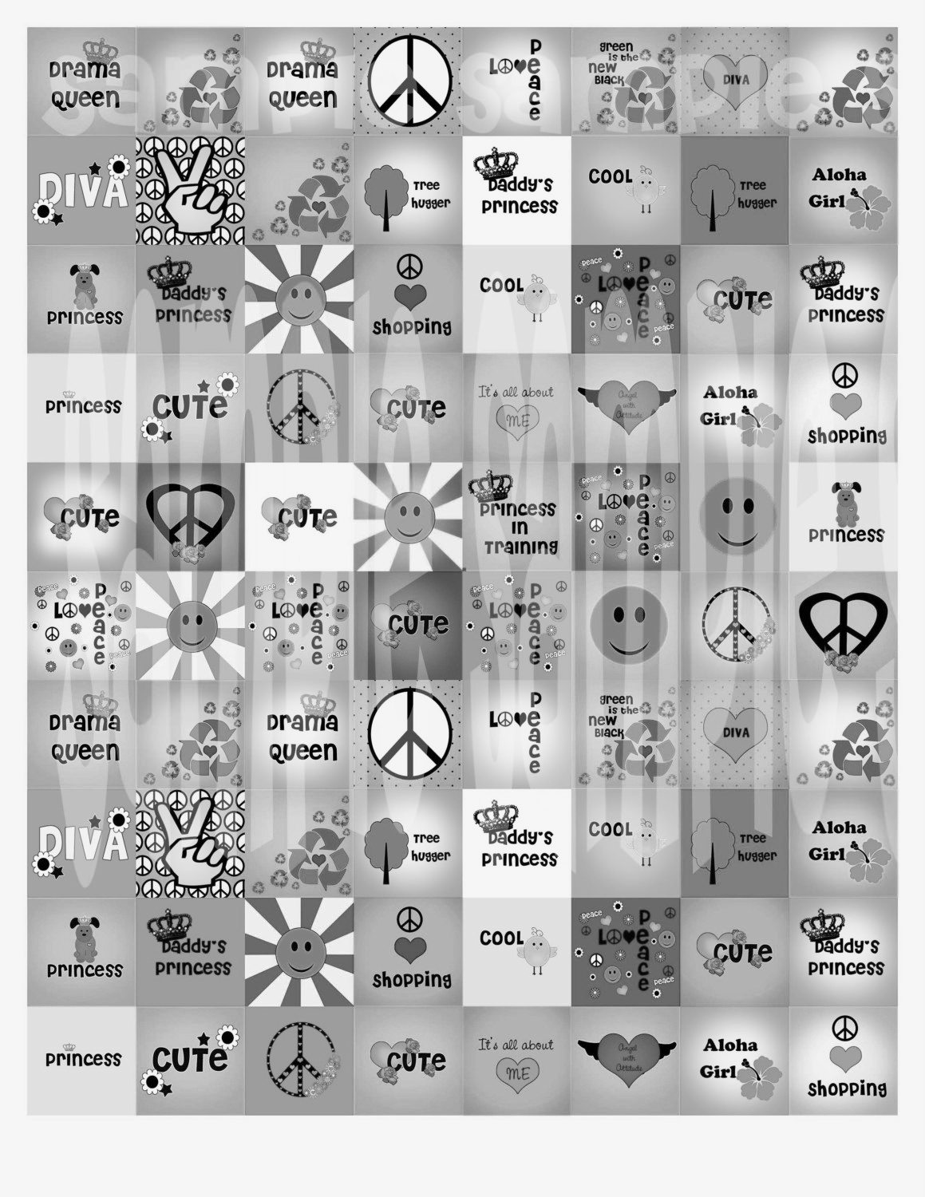

**Tween Social Skills Group**

Ages: 10-12

Tuesdays 6-7 p.m.

Beginning January 13th (8 Week Session)

Your daughter’s middle school experiences can certainly be a complex and challenging time. Many girls, even with good friendship skills, find these years to be socially and emotionally turbulent. The focus of this group is to provide social support for your daughter in order to learn the skills necessary to cope and navigate through some of the academic and social pressures they may be feeling.

Some of the Following Topics will be Discussed

Encourage Self-Esteem

Expressing Feelings and Fitting In

Dealing with Exclusive Groups & Peer Pressure

Navigating Relationships at Home and In-School

Establishing Boundaries

Building Friendships

Deciding Yes/No to Social Media & How to Manage Safely

Managing & Regulating Academic Demands

For Further Information & to Set-up Initial Consult (required) and Intake

Call: Cara L. McCloud, LCSW at (973) 220-2352

Office Location: 100 E. Hanover Avenue ~ Cedar Knolls, NJ

**GIRLS ONLY**