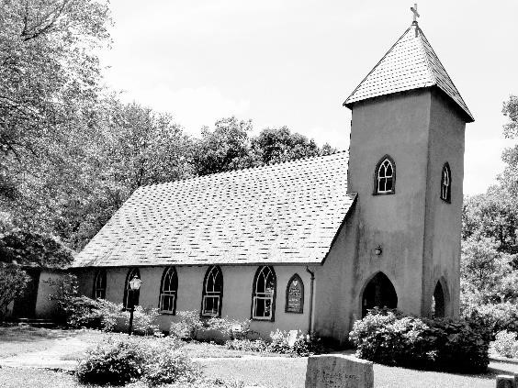
Grace Episcopal Church
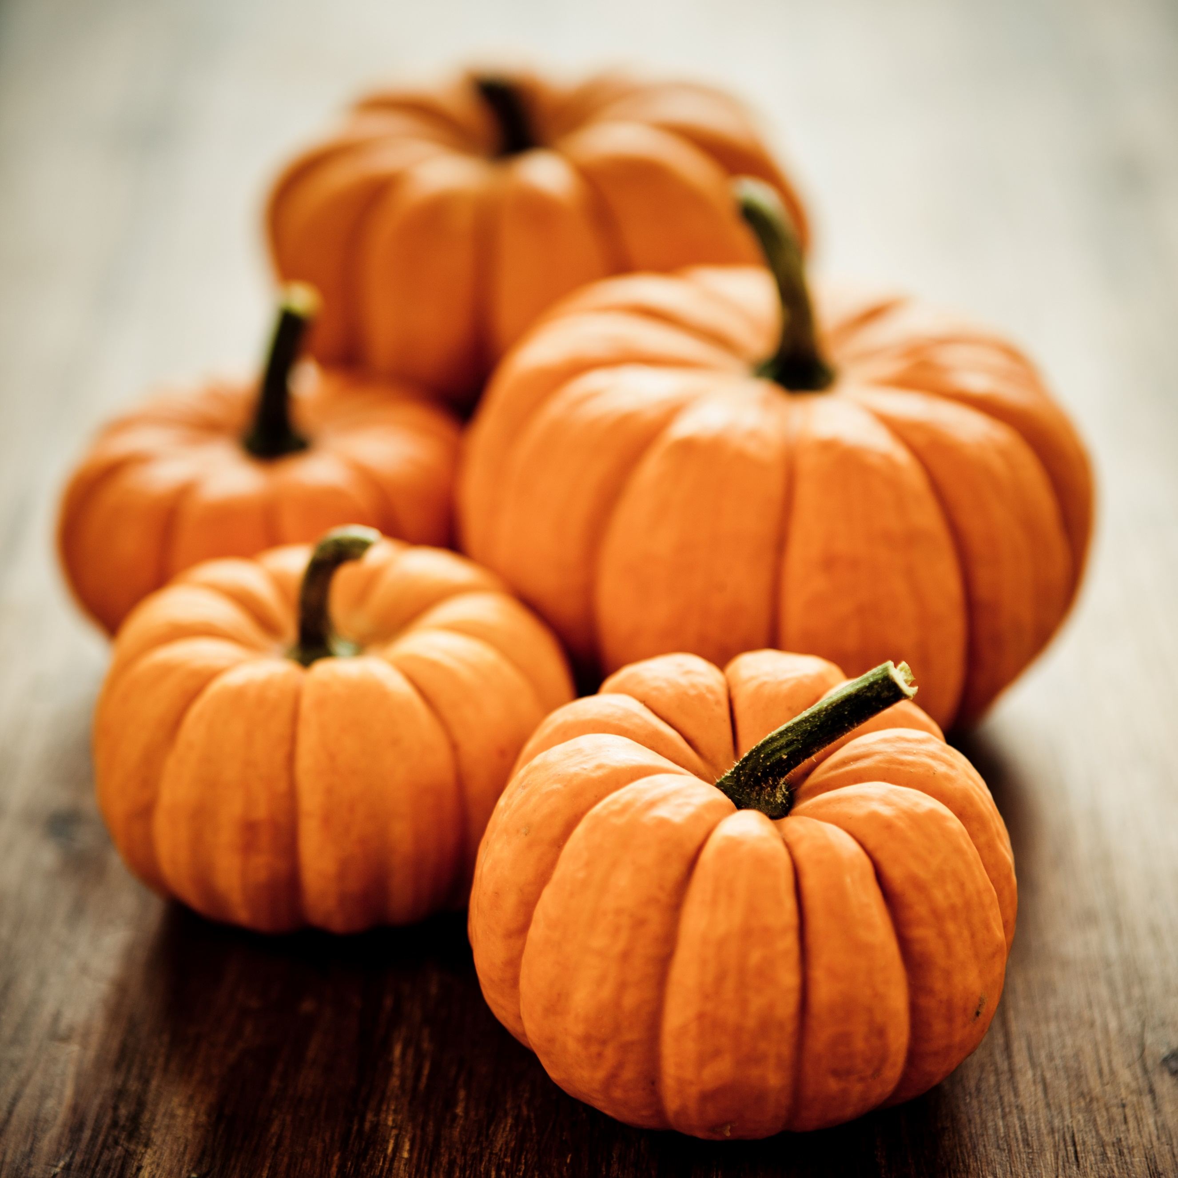
5096 Grace Church Lane
Casanova, Virginia 20139
e-mail: gracechurchcasanova@gmail.com website: www.gracechurchcasanova.org

My sisters and brothers,

I greet you in the name of the Father, and of the Son, and of the Holy Spirit.

In a few months the Church will enter the festival and solemnity season. On those days Grace
and St. Luke’s will celebrate jointly. This is necessary due to resources and logistics as these
worship services require more elements. The evening worship will be held at St. Luke’s as they
have a lighted area and parking lot. The day worship will be held at Grace. I write this with true
love and respect; we are here to give thanks to God and not the buildings he has provided for us.
This is the joint schedule for the upcoming year:

06 November All Saints Sunday Grace (day light savings ends)
24 December Christmas Eve St. Luke’s
25 December Christmas Day Grace (Christmas is on Sunday this year)
2023
01 January The Name of Jesus Grace
22 February Ash Wednesday 11:00AM Grace 7:30PM St. Luke’s
02 April Passion Sunday (Palm Sunday) Grace
06 April Maundy Thursday St. Luke’s
07 April Good Friday St. Luke’s
08 April Easter Vigil St. James
09 April Easter Grace
28 May Pentecost Grace

The Mass at St Luke’s will start 7:30 PM.
The Mass at Grace will start 10:00 AM.
The Easter Vigil will start 8:00 PM.
Please come and let us give thanks to the Lord our God.

The peace of the Lord is always with you, Fr. Michael B. Guy Sr., S.T.S. 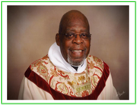
SR WARDEN’S NOTES
Happy Fall Grace Family!
As the seasons change, we will usher in a new procedure prompted by the “COVID-19 years” we have just experienced. Grace will begin using a pouring chalice for Holy Communion. Fr. Michael will walk us through the procedure, and you will now have more than a dot of wine when partaking!

Also on the horizon is the official consecration of the newly elected Bishop, E. Mark Stevenson, on December 3, 2022. Grace members may attend the ceremony which will be held in Henrico, Virginia. Church banners will be included in the ceremony and currently, we believe they will be a part of the procession. If you would be interested in being a “banner carrier” for the event, please discuss with Fr. Michael as we need to notify the Diocese by October 15, 2022.

Vestry Saints at work…
“Saint” Mignonne Spellmeyer is hard at work organizing her calendar in preparation for the next “Operation Soup” and for our adoption of a shelter family for Christmas. Stay tuned!!
“SAINT” HOWARD CHARNOCK has his nose to the grindstone, preparing a ramp to the altar to alleviate the sometimes “invisible” and dangerous step. You may also notice the plaque we received from the Fauquier County Architectural Review Board, as a Historic Preservation award, displayed on the wall in the church. Thanks Howard!

Thankfully, Fr Michael’s cataract surgeries were successful, and he is back. During October, however, he will be out of town on October 9, 2022. But never fear, Bishop Ted will be here!

Fall Camp at Shrine Mont is on the horizon. Please take a look at the Workshops included at the event and if you love Fall leaves, the trip to Shrine Mont alone offers the most beautiful view!

Happy Fall, Y’all!!!
Mary
Sr. Warden
TREASURER’S REPORT – AUGUST 2022

Income for the month of August was $7,709.18 (budget $8,464.00); expenditures totaled $16,912.22
(budget $8,464.00), resulting in a loss for the month of $9,203.04. Of the $16,912.22 expended in
August, $10,400.00 was paid to H&H Mechanical for replacement of the two air conditioning units in the
Family Center. Since the damage was caused by lightning, we will receive a check from our insurance
carrier for $9,400.00 – the cost less our $1,000.00 deductible.

The book value of our endowment fund is $62,847.24; market value as of August 31 is $62,474.21, a loss
for the month of $1,831.79.

Please continue to pray for Grace Church that it will grow spiritually, financially and numerically. If you
have any questions about this report or any financial matter, please contact me.

Judy Ball, Treasurer

FEED MY SHEEP (FMS)
….The Greatest of these is love…
1 Corinthians 13:13
We are moving into the cool days of fall. A welcome relief from the ‘dog days‘ of summer. We have just experienced a ‘day of service’ to honor the fallen on 9/11. FMS continues with a ‘day of service’ 365 days a year. Our faithful volunteers buy, sort , pack and deliver groceries to our families every week - rain, snow, sleet or hail. Much of the necessary funds that are needed to support this are provided by Grace Church. With the difficulty economy that we are all experiencing, please continue to be faithful in your sharing.
Carol Grove

AMAZON SMILE FOR GRACE CHURCH
Don’t forget to sign up with Amazon Smile to have 0.5% of the purchase price of eligible items given to Grace Church at no cost to you! You can also go to the Grace Church website home page and click on the link there.

*******AmazonSmile Shopping App for Android Users Now Available******

You can now support Grace in the Amazon shopping app on your Android device! Simply follow these instructions to turn on AmazonSmile and start generating donations to Grace from your Android device.
- If you have the latest version of the Amazon Shopping App, open the App on your Android device.
- View Settings and select AmazonSmile.
- Follow the in-App instructions to complete the process.
AmazonSmile is not currently available for IOS users – we’ll let you know when it becomes available.

Birthdays for October

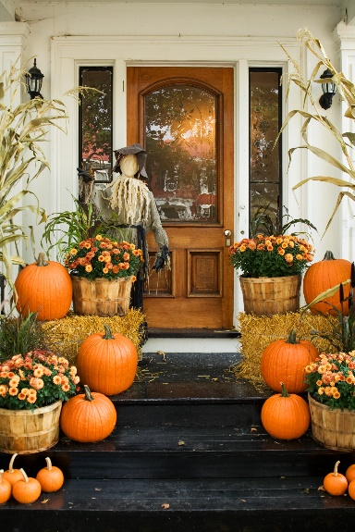

Ashley O'Meara | 5-Oct
TJ Johnson | 12-Oct
Pamela Ruffner | 12-Oct
Jackie Shipe | 17-Oct
Logan Shipe | 17-Oct
Julie Brewer | 27-Oct
Corey Butler | 29-Oct
Barbara McLeod | 29-Oct
Weekly events:
- Yoga at Grace Parish Hall on Tuesdays at 4PM and Fridays at 10AM.
- Sew What? and any other creative tasks you would like to bring will be held at St. Luke’s Parish Hall in Remington this month on October 29, 2022 (rather than the usual second Saturday) from 9:30 to 12:30.
- The Center lunch held each Wednesday at noon, Grace Parish Hall. Bring a dish to share!

OCTOBER SCHEDULE
If any dates do not fit your schedule, please arrange to trade with someone else.

DAY  2022 | READINGS | ALTAR/FLOWERS | ACOLYTE/READER | OFFERTORY PRESENTER | COFFEE HOST
Oct 2  Seventeenth Sunday after Pentecost | Lamentations 1:1-6  Lamentations 3:19-26  or Psalm 137  2 Timothy 1:1-14  Luke 17:5-10 | Mary Neal/  Diane Gulick | Judy Ball | Howard Charnock | Mignonne Spellmeyer
Oct 9 Eighteenth Sunday after Pentecost | Jeremiah 29:1, 4-7  Psalm 66:1-11  2 Timothy 2:8-15  Luke 17:11-19 | Barbara Jacobs/ Mignonne Spellmeyer | Mary Neal | Judy Ball | Sharon Sweeney
Oct 16  Nineteenth Sunday after Pentecost | Jeremiah 31:27-34  Psalm 119:97-104  2 Timothy 3:14-4:5  Luke 18:1-8 | Betsy Anderson/ Sharon Sweeney | Bryan Jacobs | Mary Neal | Sue Ballentine
Oct 23 Twentieth Sunday after Pentecost | Joel 2:23-32  Psalm 65  2 Timothy 4:6-8,16-18  Luke 18:9-14 | Mary Neal/ Mignonne Spellmeyer | Betsy Anderson | Mignonne Spellmeyer | Judy Ball
Oct 30 Twenty-first Sunday after Pentecost | Habakkuk 1:1-4; 2:1-4  Psalm 119:137-144  2 Thessalonians 1:1-4, 11-12  Luke 19:1-10 | Barbara Jacobs/ Sharon Sweeney | Howard & Diana Charnock | Susan Payne | Marilyn Ottevaere

http://www.lectionarypage.net/#october

We need you! Please join in! Available openings:

Altar preparers
Flower arrangers
Acolytes
Readers
Offertory Presenters
Coffee Hosts
Vestry Members

