Turkesterone Premium (1 POUCH: 60 DOUBLE STRENGTH 20% CAPSULES / 60 DAY SUPPLY)
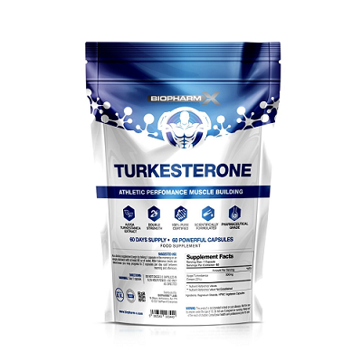
THESE PILLS HAVE THE ABSOLUTE MAXIMUM POTENCY CONCENTRATION RECOMMENDED FOR CONSUMPTION
20:1 EXTRACT

Turkesterone belongs to a family of naturally occurring steroid hormones called ecdysteroids - which are found within the Leuzea or Maral Root plant. The impressive anabolic activity of these powerful bioactive compounds has been confirmed in clinical studies, where they have been proven more effective at building muscle and enhancing performance then illegal anabolic substances such as dianabol and trenbolox - WITHOUT THE ASSOCIATED SIDE EFFECTS!
Clinically proven benefits
- Increase Lean Muscle Gains & Strength: Turkesterone significantly improves and accelerates lean muscle mass by directly stimulating the PI3K/Akt signalling pathway to increase muscle protein synthesis (MPS). MPS is a metabolic process that incorporates amino acids into skeletal muscle proteins, by far the most important physiological factor and driving force behind the muscles adaptive response to exercise. Enabling you to truly maximise muscle growth and strength while accelerating muscle recovery!
- Prevents Muscle Breakdown: Turkesterone naturally increases nitrogen retention in the muscles (similar to anabolic steroids). Keeping the muscles saturated in nitrogen is said to be one of the most important variables for any aspiring bodybuilder or athlete. During a workout, skeletal muscle metabolizes proteins in response to stimuli, it is when protein synthesis exceeds protein breakdown that nitrogen prevents muscle breakdown and promotes growth.
- Reduces Fatigue During Exercise: Turkesterone enables the body to sustain the demand on energy producing pathways. This includes maximising the rate of adenosine triphosphate (ATP) regeneration; ATP is the primary carrier of energy in cells. This enables the muscle cells to continue to contract and resist fatigue keeping your body poised for peak athletic performance!
- Side Effect Free: Turkesterone does not interact with the androgen or glucocorticoid receptor, therefore it will not cause any of the unwanted side effects commonly found with AAS usage - but is clinically proven to be just as effective!
Ingredients: Ajuga Turkestanica Extract (20%)
Directions
Adults: Take 1 capsule per day with 8fl oz of water in the morning
Precautions
• Do not exceed recommended daily dose
• Suitable for vegetarians
• Suitable for vegans
• Keep out of sight and reach of children

†This product is not intended to diagnose, treat, cure or prevent any disease.
Individual results may vary.

