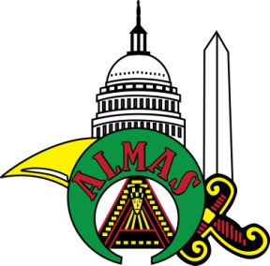Petition for Initiation and Membership in
Almas Shriners
1315 “K” Street, N.W., Washington, DC 20005
UNITED KINGDOM SHRINE CLUB
To the Potentate, Officers, and Nobles of Almas Shriners, situated in the Oasis of Washington, Desert of the District of Columbia: I, the undersigned, hereby declare that I am a Master Mason in good standing in:
________________________________ Lodge # _______, located in ______________________________,
________, which is a Lodge recognized by or in amity with the Conference of Grand Masters of North
America. Furthermore, I have resided at my current address for not less than six months, as required by the
Bylaws of the Imperial Council. I respectfully pray that I may be made a Noble of the Mystic Shrine, and
become a member of your temple. If I am found worthy, and my request is granted, I promise to conform to the Articles of Incorporation and Bylaws of the Imperial Council and the Bylaws and Ceremonies of your temple.

Birthplace _______________________________ , _________ Date of Birth ______ / ______ / _______
Were you ever in the DeMolay? ___
If so, name of chapter and location _____________________________________________________________
Occupation _______________________________________________________________________________
Have you previously applied for admission to any temple of the Order? ___
If so, in what location? ____________________________________________________________________
When? _________________________________________
Residence: ________________________________________________________________________________
(Street Address)
__________________________________________________ , ____________________ , ________________
(City) (State or Country) (Zip Code)
Lady’s Name: _____________________________________________________________________________
E-Mail: __________________________________________________________________________________
Home Phone (_______) _________ - _____________
Business Phone (_______) _________ - _____________ FEZ (Hat) Size: _______________
Mobile Phone (_______) _________ - _____________
________________________________________ ______________________________ ____ / ____ / ____
(PRINT name in FULL – initials are not sufficient) (Signature) (Date)

Recommended and vouched for on the Honor of:

(Noble’s PRINTED Name) (Shrine #) (Noble’s PRINTED Name) (Shrine #)
Return to S J Turner, 54 Birkdale Road, Abbey Wood, London, SE2 9HX or preferably Email to AlmasAmbassador@ukshriners.co.uk

