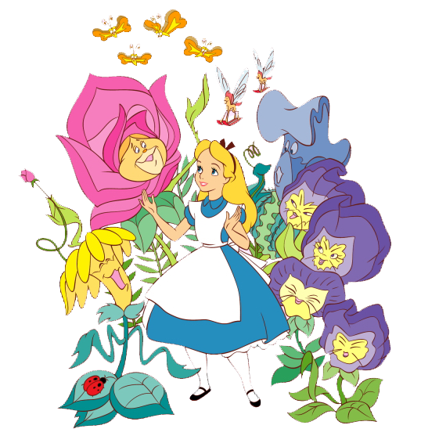

The Wonderland of China Painting

OKLAHOMA WORLD ORGANIZATION OF CHINA PAINTERS, INC.
2016 Three-Day Painting Seminar Retreat

April 8, 9 and 10, 2016
Crown Plaza Southern Hills Hotel
7902 South Lewis Ave, Tulsa, OK 74136
FOR HOTEL RESERVATIONS CALL: (918) 492-5000
REGISTRATION FORM

Please mark your first, second and third choice of seminar.

ARTISTS SUBJECT
___ Cherryl Meggs Roses on a tray and modern ink work
___ Paula White Lighthouse scene on 10” X 13” tile
___ Ann Zitterkopf Violets, scrolls and enamel on box
___ Susan Thumm Pears and Bird on a tray

COST OF SEMINAR $ 280.00 $____________
(Includes 3 days of class, lunch, Friday night Reception, porcelain piece and firing)

SATURDAY NIGHT BANQUET $ 35.00 $____________
Please indicate if you have any special dietary needs:

FRIDAY NIGHT MADHATTERS RECEPTION,
PAJAMA PARTY and Contest $ 15.00 $____________
If you attend 3-day seminar the reception is FREE

TOTAL DUE: $____________

Total Paid $_____________________ Balance Due $____________________
A nonrefundable deposit of $ 140.00 is required at time of registration and the balance is due by February 28, 2016.

NAME: _____________________________________________________________________

Address: _____________________________________________________________________
CITY:_______________________________STATE___________________ZIP___________

Telephone ________________________ Cell Phone _______________________

Email _____________________________________________________________

Make Check Payable to: OK WOCP, INC.
Mail to: Sharan Amend
OKLAHOMA WORLD ORGANIZATION OF CHINA PAINTERS INC
4213 NW 146th Terrace
Oklahoma City, OK 73134
Telephone #: 405-749-1966 Cell #: 405-535-8066
Email: cgamend@earthlink.net SEE NEXT PAGE FOR COLORED ART

CHERRYL MEGGS – ANN ZITTERKOPF –
Roses on a tray and modern ink work Violets, scrolls and enamel on box

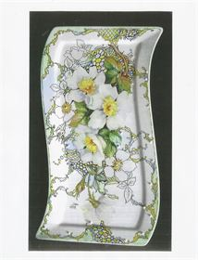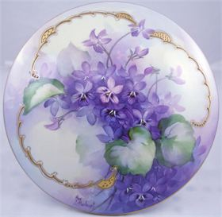

SUSAN THUMM – Pears and a Bird on a Tray (different tray than pictured)
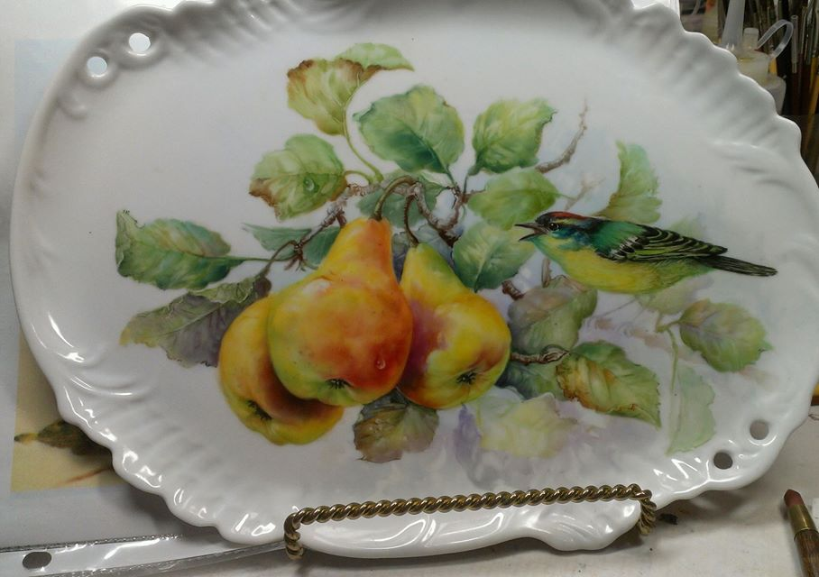

PAULA WHITE – Lighthouse scene on 10” X 13” tile

