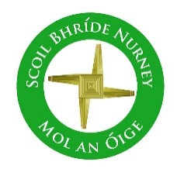
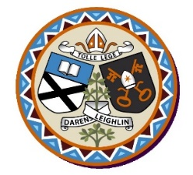
Scoil Bhríde Nurney
Annual Admission Notice
in respect of admissions to the 2022/2023 school year

Admission Policy and Application Form
A copy of the school’s Admission Policy and the Application Form for Admission for the 2020/2021 school year is available as follows: –
To download at: www.nurneyns.com
On request: By emailing sbnurney@gmail.com or writing to Scoil Bhríde, Nurney, County Kildare, R51YC66

Part 1 - Admissions to the 2022/2023 school year

Application and Decision Dates for admission to 2022/2023
The following are the dates applicable for admission to Junior Infants

The school will commence accepting applications for admission from | February 5th
The school shall cease accepting applications for admission after | February 23rd
The date from which applicants will be notified of the decision on their application is | March 11th
The date by which applicants must confirm acceptance of an offer of admission is | March 31st

Note: the school will consider and issue decisions on late applications in accordance with the school’s Admission Policy.

Special Class Application and Decision Dates for admission to [2022/2023]
The following are the dates applicable for admission to the school’s Special Class which caters for children with [N/A] -
The school will commence accepting applications for admission to the special class on | N/A
The school shall cease accepting applications for admission to the special class on | N/A
The date by which applicants will be notified of the decision on their application for admission to the special class is | N/A
The period within which applicants must confirm acceptance of an offer of admission is | N/A
*Failure to accept an offer within the prescribed period above may result in the offer being withdrawn
Number of Places being made Available in School year [2022/2023]

The number of places being made available in junior infants | 23
The number of places being made available in the special class* catering for children with [insert category or categories of SEN catered for in the special class is | N/A

Part 2 - Admissions to the school year [2021/2022]
(This section should only be completed if your school intake group/special class was oversubscribed in the previous school year)
Information regarding the admission process for the Intake Group for Junior Infants/Special Class for the (2021/2022) school year

In respect of the 2021/2022 school year, the total number of applications for admission received by the school was______23____
Breakdown of places allocated for the 2021/2022 school year:
Number of places available: | 24
Number of applications received: | 23
Number of Offers made and accepted under each criteria: | Criterion One: Applicants living in the catchment area – ? places offered, ? places accepted.  Criterion Two: Applicants with siblings attending the school – ? places offered, ? places accepted.
Total number of offers made | 23
Number of names placed on waiting list for the school year concerned. | 0

