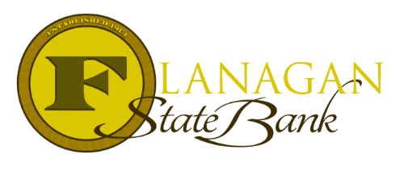
Mortgage Tidbits

Keeping you informed and in the know….
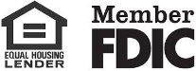

Home Possible Mortgage – Freddie Mac’s Specialty 3% Down Payment Loan

Program Guidelines:
- 1 unit 97% LTV; 2-4 unit 95% LTV; MFH 95%
- 95% LTV for 2–4-unit properties (must be owner occupied!)
- To be used for: 1 unit, condos, and PUD’s
- Manufactured Homes allowed but LTV reduces to a max of 95%
- NO ADUs (accessory dwelling unit) permitted
- Down payments more than 3% permitted. Acceptable sources include family, employer-assisted program, and secondary financing. 105% CLTV with affordable second.
- Various fixed rate terms available
- Purchase & Rate/Term Refinance
- 620 minimum score - some borrowers may benefit from FHA financing due to MI pricing if score is below 680
- 80% median income limits
- Homeownership Education required when ALL borrowers occupying the property are 1st time homebuyers. 1st time homebuyers are defined as anyone that has not owned a property in the last 3 years.
- Max mortgage amount = current conventional loan limits

Call us today for the best answers to the mortgage questions!
Insert photo here or delete box when ready to use
~ Provided to you by ~
Name: Phone:
Title: Email:
Address: City, State, Zip
Apply Now Link:

