Herpes Zoster (Shingles)
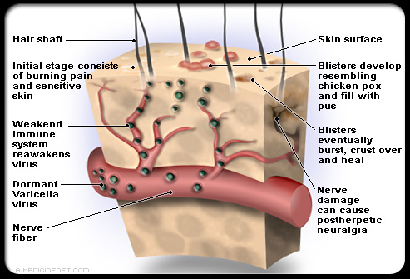
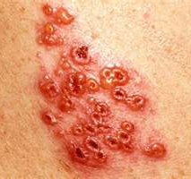

Shingles is a disease from the same virus (Varicella Zoster) that causes chicken pox.

It is often preceded by a few days of pain in the affected area.
- Then acute, painful inflamed blisters form on one side of the trunk, neck, or face along a peripheral nerve.
- These blisters usually last two to three weeks before they crust over and heal.
- If shingles develops near the eyes, the cornea can become affected and blindness may result.

Immediately consult a doctor. Singles usually affects the elderly or people with:
- prolonged stress
- compromised immune function from toxicity
- prescription drugs
- or nutritional deficiencies.

Nerve pain that persists after other symptoms have cleared is called post-herpetic neuralgia and may require electro-acupuncture to restore the nerve.

Follow this diet:
- An outbreak can also be associated with eating excessive amounts of L-arginine-containing foods such as wheat products, dairy products, rice, nuts, seeds, chocolate and corn. Citrus will slow healing, so eliminate all these foods.
- Keep the body well hydrated with pure water, herbal teas, vegetable soups and juices.
- Avoid soft drinks, processed foods, sugary foods, caffeine, and high-fat or fried foods to reduce toxins and build the immune system.

Have a full “nutritional evaluation” with a qualified natural health professional to receive a program to build the immune system.

To reduce toxins and build the immune system, the following supplements would be beneficial: (The supplements marked in red are the most important).

Anti-Viral:
- Shaklee DR
- Garlic
- Optiflora
For the Immune System:
- B Complex
- Nutriferon
- Soy Protein
- Vitamin C 500
- Vita-E
- Vita –Lea
- Zinc
- Vivix

For Detoxification
- Liver DTX
For Pain & Sleeping:
- Gentle Sleep Complex
- Joint & Muscle Pain Cream
- Pain Relief Complex

Traditional Treatment is “Anti-viral Drugs”:
The most commonly prescribed drugs are:
- acyclovir
- valacyclovir
- famcyclovir

Side effects of these drugs:
- Acyclovir: The most common side effects are nausea, vomiting, diarrhea and headache. Other reported side effects include agitation, confusion, rash, anemia, and muscle pain. Hypersensitivity reactions, seizures, agitation, confusion, anemia, hepatitis, and muscle pain have also been reported.

- Valacyclovir: The side effect profile of valacyclovir is similar to that of acyclovir. The most commonly reported side effects are headache, nausea, and vomiting. Less common side effects are diarrhea, abdominal pain, and dizziness.

- Famcyclovir: The side effects include headache, diarrhea, dizziness, nausea; unusual tiredness or weakness; vomiting

