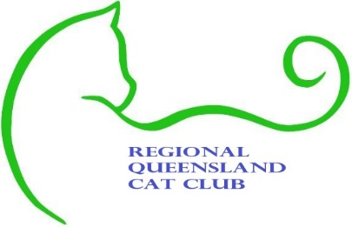
Regional Queensland Cat Club

MEMBERSHIP APPLICATION
ANNUAL SUBSCRIPTION
(PLEASE CIRCLE THE APPROPRIATE SELECTION)
Family Membership (2 adults 2 children) $40
Breeder Membership - $30-00
Social Membership - $20-00
Junior Membership - $15-00
(NOTE JUNIOR MEMBERS UNDER 16 YEARS OF AGE)
TO PAY ONLINE: BSB -
ACCOUNT NUMBER –
REFERENCE: YOUR SURNAME
Name:

Address:

Home phone:
Mobile:
Email:
Website:
Prefix
Breed/s:
1.
2.
3.

Cat council you are registered with:

BREEDER Please initial your acceptance.
I request to apply for membership of the Regional Cat Club Queensland, If I am accepted, I agree to abide by the constitution of Regional Cat Club Queensland.

I agree to abide by the code of ethics as set out by the Regional Cat Club Queensland.

I AM NOT SUSPENDED BY ANY AUSTRALIAN CONTROLLING BODY

Signed

Date
IF ACCEPTED, DETAILS TO BE HELD IN THE CLUB SECRETARY’S MEMBERSHIP REGISTER
ENQUIRIES: 0407696377 EMAIL: regionalqldcatclub@gmail.com
Please forward this application to: 3 Josephine Crescent, Rasmussen 4815.
OFFICE USE ONLY: DATE RECEIVED……../……../…….. AMOUNT:$..................
CASH OR BANK TRANSFER
DATE ACCEPTED:
RECEIPT NUMBER:
Membership Number.

