How we grow and process our hemp CBD:
Our high-CBD plants are grown outside, with natural sunlight, wind, and rain, to produce higher quality plants than those grown indoors under grow lights. Our hemp plants are grown in a soil that is enriched with compost and we use organic fertilizers through the growing season. The outdoor environment discourages some insect and disease infestations that may occur on indoor plants and would be treated with pesticides and fungicides. Our CBD does not have the residual pesticides and fungicides you might find in other CBD products sourced from non-organic growers.
We harvest our plants in the fall, remove the fan leaves, and air dry them in our barn. Once dried we remove the buds and store them in glass jars to cure for a month, using silica gel bags in each jar to remove excess moisture and prevent mold. Then our hemp buds are slowly heated in coconut oil for many hours, accomplishing the decarboxylation that converts CBD acid to CBD (cannabidiol), a more biologically active form of the cannabinoid. While the oil and buds are heating up, terpenes, phenolics, and a range of cannabinoid substances are infused into the coconut oil. We add sunflower lecithin as an emulsifier and lecithin may help the body to utilize the CBD more efficiently. Our hemp buds and oil infusion are both tested at a VT lab.
Our CBD products are available at the Northfield and Waitsfield Farmers’ Markets and can be ordered for shipping by calling 802-485-7444.
What is Full-spectrum CBD and what are the benefits:
There are three categories of CBD products: full-spectrum, broad spectrum, and isolates. Full-spectrum (pure-spectrum) CBD products are processed less than cannabinoid isolates. They contain all the cannabinoids from hemp, not just CBD. Along with cannabinoids there are terpenes, phenolics, and sometimes THC in the full-spectrum version. Broad spectrum CBD products have the THC removed. Isolate products contain nothing but pure isolated CBD.
Our full-spectrum CBD products contain a full range of cannabinoids, as well as phenolics, terpenes, and sunflower lecithin. Phenolics are phytochemicals that have antioxidant activity, including flavonoids. Terpenes are aromatic compounds that are used in aromatherapy, including pinene and limonene, and each one of the terpenes have potential benefits.
Research on the synergistic effect of consuming cannabinoids and terpenes together was published in 2011 by Dr. Ethan Russo in the
British Journal of Pharmacology. Russo coined the term ‘entourage effect.’ Pure CBD has a bell curve effect and is only useful at medium doses. The effect tapers off at lower and higher doses. Experiments with full-spectrum CBD show that the bell shape response disappears. A lower dose of full-spectrum CBD can be more effective than the same amount of CBD isolate. Terpenes (in essential oils) may help move CBD through the skin and make it more bioavailable.
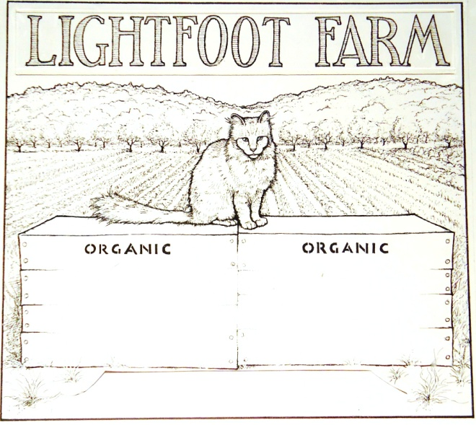

540 Davis Ave. Extension
Northfield Falls, VT 05664
802-485-7444
www.LightfootFarm

CBD Products
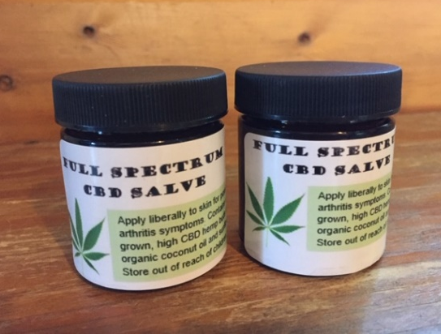

Full Spectrum CBD Salve, for arthritis and psoriasis.

2020/2021 Prices
CBD Salve Plain $11 per 1.7 oz. jar
CBD Salve with Essential Oils $12 per 1.7 oz. jar
CBD Salve with St. John’ Wort $12 per 1.7 oz.
CBD Salve with Arnica $12 per 1.7 oz. jar
Check out our website at www.lightfootfarm.com
Lightfoot Farm, P.O. Box 31, Northfield Falls, VT 05664
Research on Full-Spectrum CBD:
A 2015 study was done by Lautenberg Centre for General Tumor Immunology in Jerusalem. They conducted research with mice on the anti-inflammatory effect of CBD and discovered that the full-spectrum CBD gives better relief than CBD isolate. Greater doses of full-spectrum CBD gave higher relief than increasing amounts of CBD isolate.
Preliminary research has shown that full-spectrum CBD may help reduce inflammation, improve sleep, promote bone growth, clear psoriasis, reduce pain, reduce anxiety, and inhibit the growth of bacteria. An article was published on Jan. 7, 2019 in Permanente Journal called Cannabidiol in Anxiety and Sleep: A Large Case Series. The conclusion in that study was that cannabidiol may benefit patients with anxiety or sleep disorders.
Immune Modulating Effect:
Arthritis and psoriasis, and several other problems that hemp products help to alleviate, are often auto-immune disorders, involving over-reactions of the body’s immune system. Cannabinoids can have a modulating effect on the immune system. The endocannabinoid system (ECS) and the immune system work together. The ECS was only recently discovered in the early 1990’s. There are EC receptors on cells throughout the body. The body can make its own cannabinoids, which are called endocannabinoids because they are produced internally. When under stress a person produces fewer ECs and may need to ingest cannabinoids from external sources. The ECs help modulate immune responses, including the production of cytokines. When a person is attacked by a pathogen or reacting to an allergen, the body produces cytokines, which can be inflammatory. Consuming CBD or absorbing CBD through the skin, can ensure that the immune system does not overreact and does not produce too many cytokines.
Benefits of Coconut Oil:
We infuse the cannabinoids and other medicinal ingredients from our hemp buds into a base of coconut oil. There may be many benefits to ingesting coconut oil, including boosting good cholesterol, fighting diabetes and alzheimer’s, helping to reduce heart
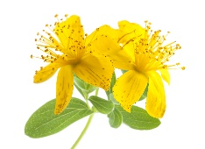
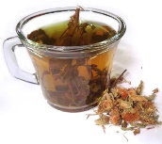
disease, aiding liver health, boosting energy, and killing harmful microorganisms. Coconut oil also moisturizes the skin and reduces inflammation.

New for 2021
Precautions:
Our full-spectrum CBD products do contain small amounts of THC, the psychoactive component of cannabis. Persons working at jobs with random testing of THC might want to avoid our products. We make sure, through our lab testing and computations, that our products contain less than 0.3% THC, which is required by federal law.

We are adding our wild gathered St. John’s
Wort and our farm grown arnica to our CBD salves this year. St. John’s Wort has anti-inflammatory and pain-relieving properties. It has been used for centuries to treat nerve damage, sciatica, and back pain. Two phytochemicals in the herb, hyperforum and hypericin, help to restore nerve health. A third phytochemical, pseudohypericin, affects viruses, bacteria, wound healing, and immune function.
Arnica has been used to relieve pain from osteoarthritis, sore muscles, and joint aches. It may also help to reduce swelling and bruising from injuries. Arnica contains an anti-inflammatory compound called helenalin. Some people may have a mild allergic reaction to arnica, especially those allergic to plants in the Asteraceae family. Arnica can have anti-clotting effects, so avoid use with blood-thinning drugs.
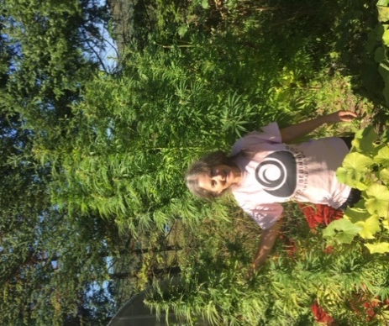

Carol Noyes, owner of the farm, is pictured here with the hemp plants

