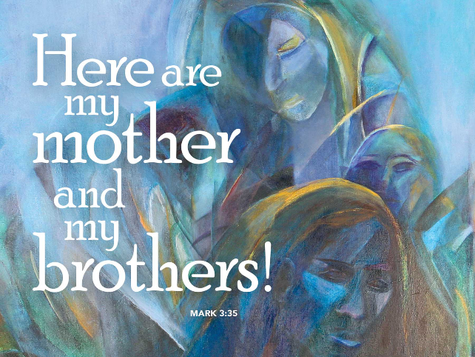
One Big Crazy, Loving Family
June 10,2018
Mark 3:20-35

Grace and peace to you from God Our Father and from our Brother, Jesus Christ, amen.
How do you define crazy? Is mental illness becoming more prevalent in society today than it was, say when Jesus walked the face of the Earth? In Jesus time people attributed most types of mental illness to demonic possession. It must have been a strangely weird experience to witness Jesus performing exorcisms and casting out demons. When I came across stories like this one we’re considering this morning I have to wonder how the people could have misunderstood Jesus so completely that they accused him of being out of his mind and even being possessed, not by just your run of the mill demon, but by the king of demons Beelzebub himself. On the other hand, perhaps labeling him as crazy or possessed is just one easy way of discounting, not just his radical message of inclusive love, but also the demands he makes in order to follow him.
Let’s first consider his radically inclusive message of love. Jesus came for the lost and the broken. He ate with sinners and others that most “normal” people would never be caught dead associating with, such as tax collectors, women, Gentiles, and every other outcast you can think of. If Jesus were here today I wonder who he would break bread with. My guess is we would be the ones shocked by the people Jesus would choose to associate with. I can only speculate, but when I think about the types of people Jesus might include as his family today it makes me almost cringe. I want to think I’d be open to Jesus’ radical inclusiveness, but there’s still plenty of people I judge as being unworthy. I struggle with trying to be accepting of all, but my own ego and arrogance still gets in the way. I’m not going to try to come up with a list of all those whom I consider “others”. I’m sure if you take even a short time to consider your own attitudes towards people who are different from yourself you can come up with your own list. After you’ve done the mental checklist, now ask yourself, if Jesus returned today, where would the people on your list be seated. Would they be the ones crowding around Jesus so close he can’t even get a bite to eat? Where would you be in that picture? I’m afraid I’d be outside with his mother and his siblings asking him to leave those other strangers and come home with us to the safety and comfort of our own little house. I mean it’s crazy for Jesus to like the company for “those people” more than all of us who are his family, right?
Well, that’s one reason people might think of Jesus as out of his mind or possessed, but there’s an even greater issue at play here. Jesus doesn’t call people into a lifestyle of ease and comfort. He never promises being a Christ Follower will be a bed of roses. Think about just a few of the things Jesus says are required and I can easily see why people might say, “What, are you crazy, Jesus!” For example, if you want to follow me, Jesus says, you must take up your cross. Wait, what… You must lose your life to follow Jesus? No thanks, what are you crazy? Or the corollary, what, do you think, I’m crazy? I like my life just the way it is, thank you very much, Jesus. What about all that wealth we like to accumulate? Jesus says it’s easier for a camel to pass through the eye of a needle then for a rich person to get into the Kingdom of God and he instructed a rich young ruler to give all his wealth to the poor and then come follow. Of course, we know the rich young man was not able to part with all his stuff, which he loved more than Jesus. Another time someone asked Jesus if they could just go back home and bury his father before following and Jesus replied let the dead bury their own dead. Jesus said he came to divide families.
When we think about what it means to be a Christian today, many people would list family values as being high on the list. I think if you place family at the top of your hierarchy of needs, you’ll be on the outside of the house with Jesus’ mother and siblings wondering if Jesus is out of his mind. Jesus calls his followers not just to a radical love of others, but to a radical renunciation of everything we hold dear to our hearts that crowds out God. I know this is a hard lesson for those of us who really love of children and especially our grandchildren, but I didn’t make the rules, I just preach the Gospel… At this point you’re probably thinking, Pastor this is way too hard, you’re crazy to even think I’m going to skip my child’s baseball tournament, or dance recital, or soccer game, or, well you fill in the blank just to come to Church. Besides, I can pray from home or the baseball diamond just as easily as I can at Church…
I’m not going to judge your decisions, I am going to publicly state when you’re absent from the Body of Christ, gathered around God’s Word and the Sacraments, you are showing where your priorities lay. You can decide for yourself if you’re okay being outside the house wondering if these radical, uncompromising all inclusive and highly demanding requirements are crazy or whether you want to be gathered around the table with Jesus doing the will of the Father.
When I think about my own life, there are times when I’m outside looking in and then other times I have forsaken all others to be right there with Jesus doing God’s will. A long time ago, when I was still on active duty I took leave to go with our Youth Group to Bay City Michigan on a mission trip. We worked on people’s houses and stayed in the local high school for the week. Not only did I have to pay the registration fee, but we also had to purchase the tools and paint brushes and everything we would need to do the work we were assigned while there. After I got back from the trip I was pretty excited about all our kids had done and when I told one of my co-workers about the trip. I’ll never forget his reaction. He was totally flabbergasted that not only would I “waste” an entire week of vacation, but that I would pay money to go and help other people I didn’t even know. Now this man would do anything for his friends, but this was beyond the pale for him to imagine. He called me crazy for the extravagant way I wasted my time and money on people who probably didn’t deserve nor appreciate our efforts. I couldn’t argue with his logic. The woman whose home we worked on seemed to have been able to afford having the repairs bone herself and she lived right next to her two sons who were both healthy and could have helped their mother keep up the repairs of her home. On the other hand, as we talked with her over the week we were there we found out she lost her husband when he had been outside trimming the tree in the backyard and the branch he was cutting fell and hit him in the head. As we were doing the repairs on her home we were able to share God’s love and pray with her about her husband and her family. She had been very angry with God for taking her husband, but because of our unconditional love, she was able to reconnect with God and perhaps for the first time since losing her husband understand his accident wasn’t God’s plan or God’s fault.
I think that’s the point Jesus was making in this story from Mark’s Gospel this morning. Yes, we are Jesus’ brothers and sisters when we act as little Christ’s for our neighbors, near and far, those like us and those different from us, those in obvious physical need and even those whose needs can’t be visibly seen. We are Jesus’ family when we do the will of God by radically including all people into our family and love them as we love ourselves. None of us does it all the time. At best we make good faith attempts and trust God to take our small offerings of time, talent and treasure and make great things happen. I don’t know if that lady in Bay City ever got over being angry with God and I’ll never know if our example helped to show her sons what it means to honor their mother, but I know for those days we were at the table with Jesus and not outside wondering if he was out of his mind.
May this Congregation and the ministries we support enable us to be used by God as agents doing God’s will right here in Pitsburg Ohio. May you be blessed when you participate in doing God’s work. May we lose ourselves in God’s love so radically and so completely that we simply have no time to judge other people. For all those times in our own lives when we find ourselves prioritizing things, our stuff, our hobbies, our jobs, our children, whatever it is, and when those choices land us outside looking at Jesus and his true family, may we rest in the promise that Jesus came for us, even when we turn our backs and place Him as a lower priority. May God forgive us all our trespasses and bring us together as one big crazy, but loving family, amen.

