The Angel of Light
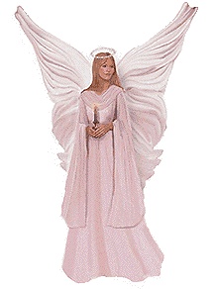 I am the Angel of Light and I carry a candle. I hand this candle to you that you may place it within your heart and allow God to bring the winds of Love to ignite the candle into a torch for all the world to see."
"You live in this world of so much mistrust; I am here to rescue you, My beloved, from all the worries and fear. Do not dismay when others do not understand how to respect you, for I have given to you the keys to unlock the door to love. Love will send a message of hope to all those who create challenge for you. You will be strong as you view each person from My eyes. You will overcome the feelings of hurt and ego by the knowledge of who you truly are. You are blessed and holy because I am Holy. You are rich and secure because I am Your security. You are a Light to the world because I am the Light from which you came and the Light and Love to which you always shall have within you. You are a worthy and blest being on the planet. You have chosen this time in history, to prove to the world and to yourself that love can conquer all mistrust and feelings of pain and sorrow".

