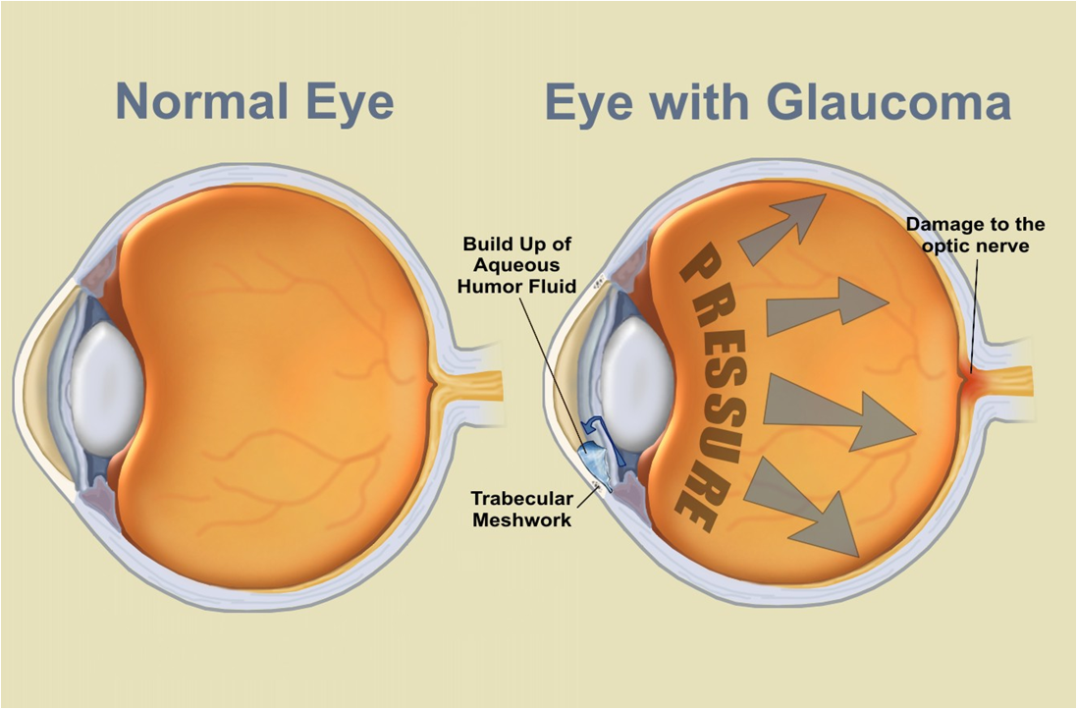

Glaucoma is a serious eye disease characterized by abnormally high intraocular pressure, which is the pressure that the fluids within the eyeball exert on the other parts of the eye. If this pressure is unrelieved, it damages the retina and ultimately destroys the optic nerve, resulting in vision loss and even total blindness.
Glaucoma is one of the leading causes of blindness, and is more common in people with diabetes, high blood pressure, anyone taking corticosteroid preparations, etc.
There are two categories of glaucoma:
- Closed-angle glaucoma (10%) – very severe
- Chronic open-angle glaucoma (90%)
Damage due to glaucoma to vision is irreversible … therefore, it behooves an individual to be very proactive in prevention or reducing the symptoms by addressing causes.

Causes:
- Stress
- Nutritional Deficiencies
- Diabetes
- High Blood Pressure
- Toxic overload

Traditional Treatment
- Medicated eye-drops
- Beta blockers
- Alpha-adrenergic agonists
- Carbonic anhydrase inhibitors
- Miotic or cholinergic agents
- Laser or Filtering Surgery

Drug-Free Treatment
First of all, because the eye tissue is so fragile, it is imperative to eliminate avoidable toxins wherever we can … we recommend switching to Shaklee’s non-toxic cleaners and laundry products, and personal care and skin care products.
A diet optimal in protein (especially vegetable protein) is essential for building and repairing cellular tissue. Shaklee Soy Protein is recommended daily (a minimum of 3 tablespoons) … Shaklee 180 Smoothees are also a great choice.
Step 1:
- Vitalizer Gold: Essential for overall body health (including 26 antioxidants)
- Lecithin - used in more than average amounts
- Vivix – a powerful antioxidant tonic that protects the cellular tissue
- GLA – Omega-6 fatty acid complex that is known in nature as a “natural steroid”, to reduce the pressure
- Alfalfa – a natural anti-inflammatory and fluid balancer
Step 2: Other supplements of benefit
- Additional Vitamin D3 – essential to down-regulate swelling
- Additional OmegaGuard – essential for repairing the cellular tissue of the eye (there is some in Vitalizer)
- Additional B Complex – the anti-stress group of vitamins (there is some in Vitalizer)
- Additional Vitamin C & Bioflavonoids – helps to lower intraocular pressure (Shaklee Vitamin C 500 contains 120 mg of bioflavonoids)
- Additional CarotoMax – a carotinoid complex essential in protecting the delicate eye tissues (there is some in Vitalizer)
- Additional Zinc – very beneficial in glaucoma treatment
- Additional Vitamin E – to support more efficient circulation
- FlavoMax (available in Shaklee U.S.) – additional flavinoids to support healthy eye tissue
Step 3:
- Mental Acuity – contains Gingko Biloba and Bilberry, both of which support better circulation to the brain and eye area: improved blood flow will support overall eye wellness.

