Amelia-Nottoway Technical Center News 3/5/2021
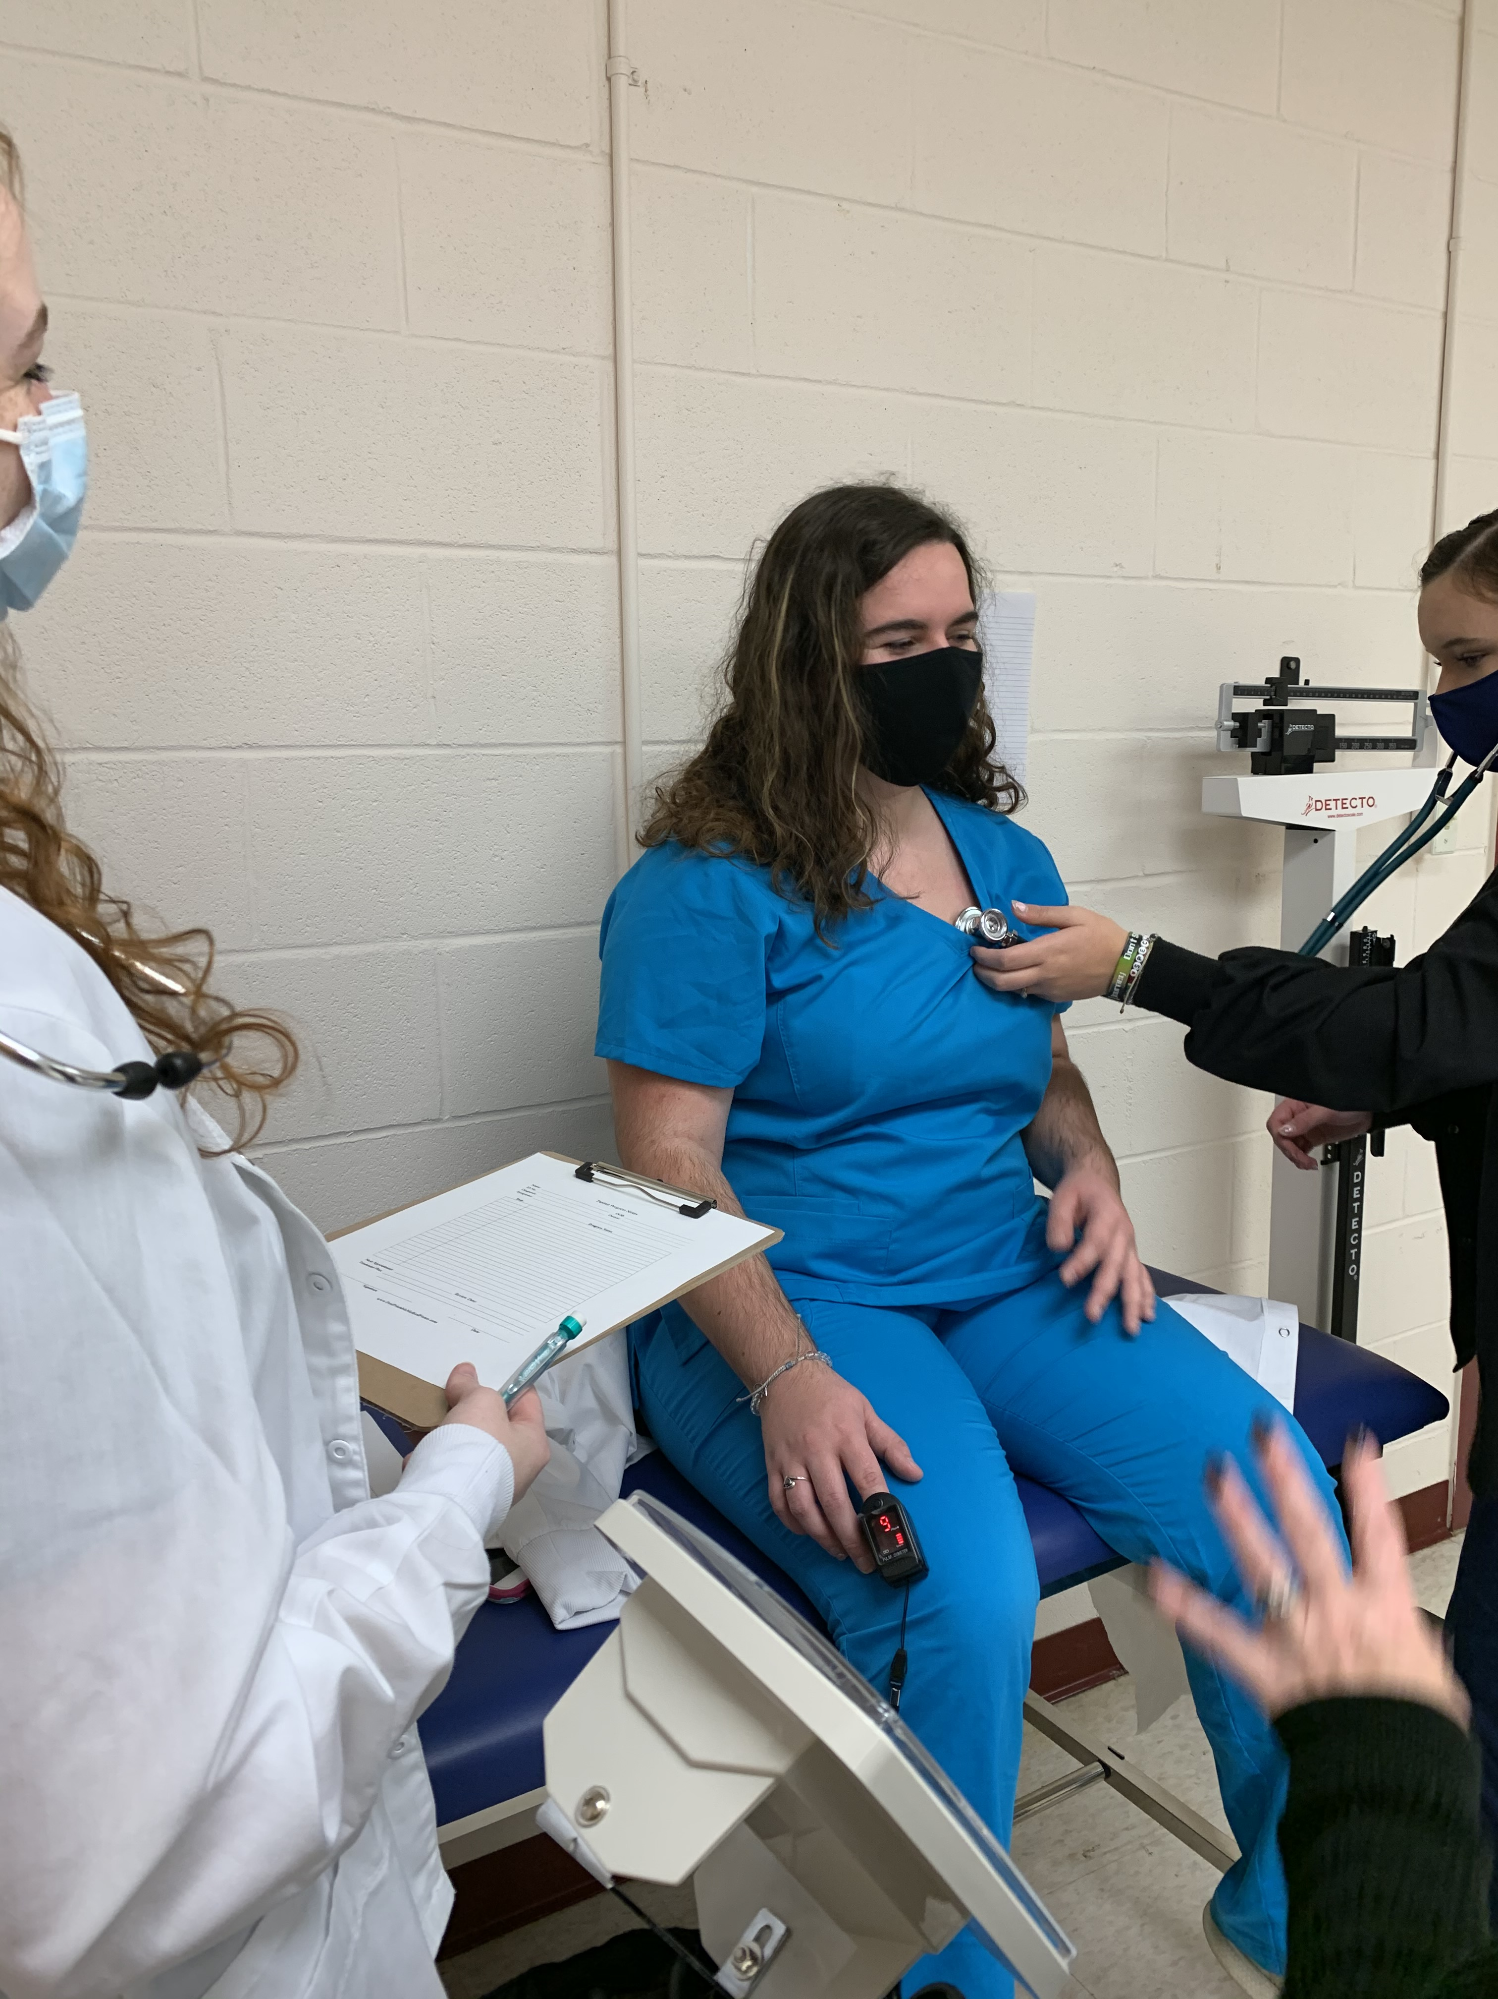
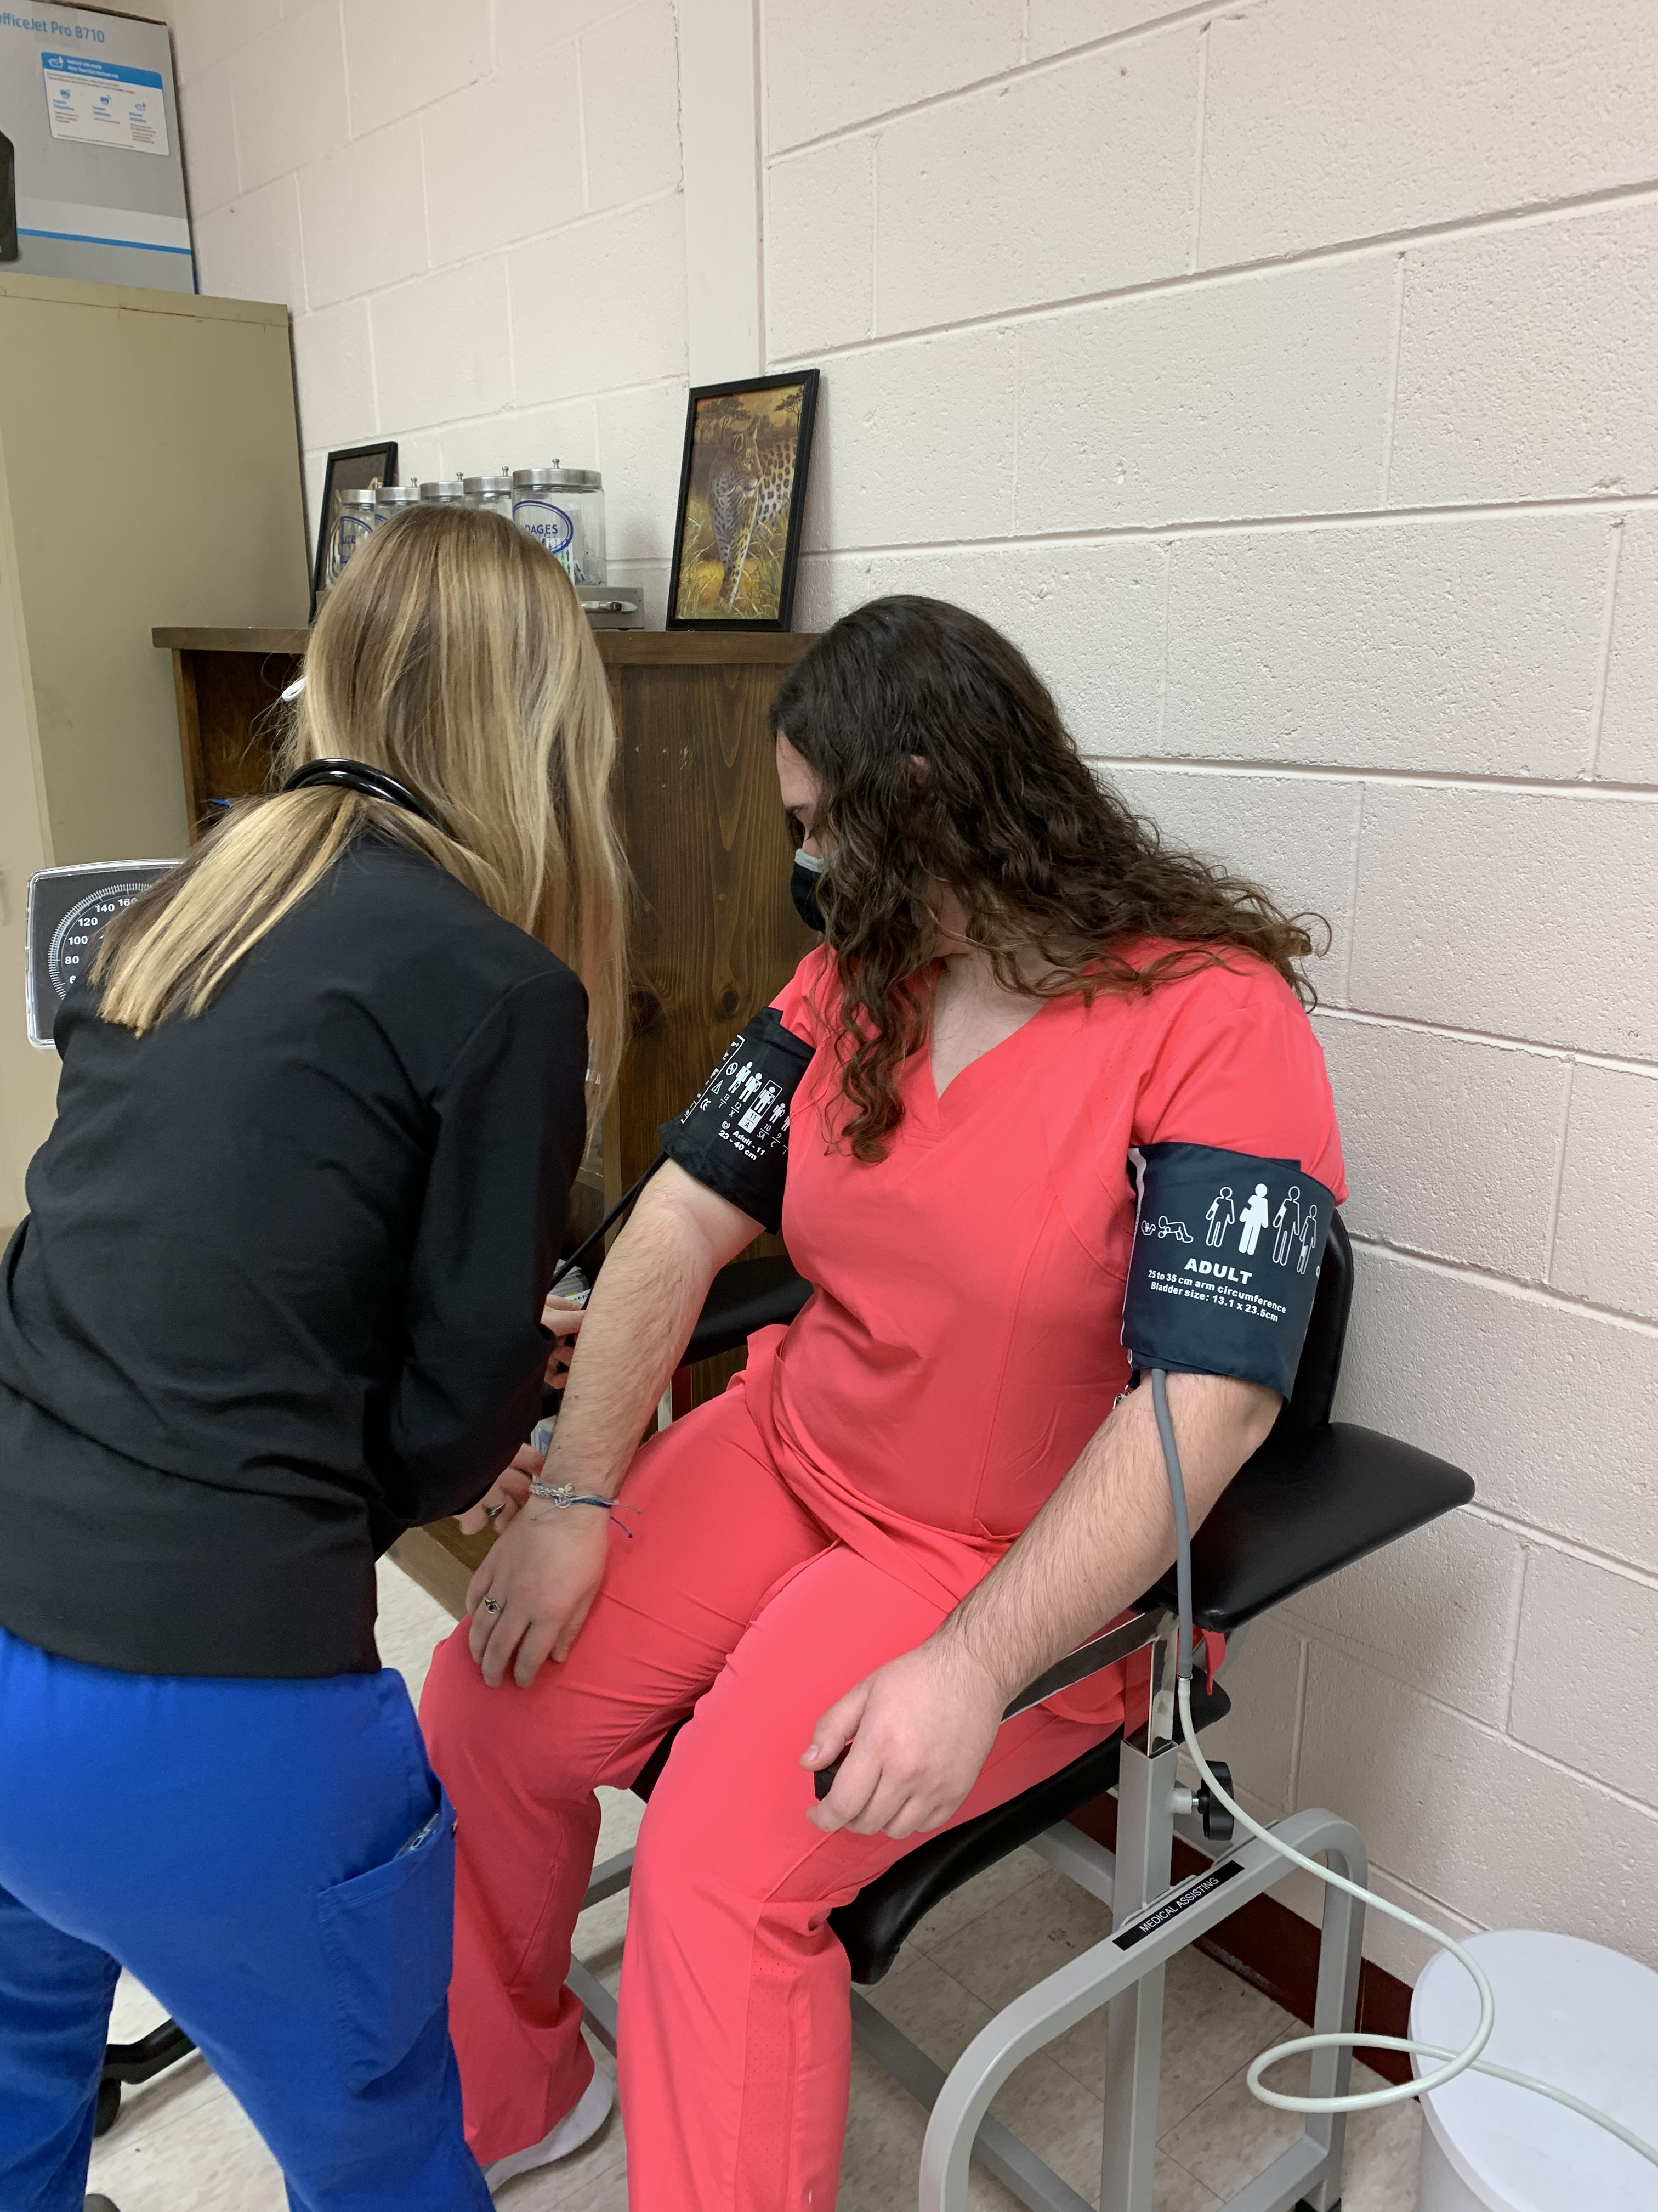
ANTC STUDENT SPOTLIGHT!
Brianna Lee, ACHS Senior
Medical Assistant II

What brought you to ANTC? I came to ANTC for the Medical Assistant Class.
What is your dream job? I plan to become an Anesthesiologist.
What is your favorite class that you have taken so far? Why? Medical Assistant, it gets me one step closer to my dream job.
What is the best advice you have been given by your instructor at ANTC? Follow my dream, no matter what happens.
What is your favorite memory at ANTC? My favorite memory is how nice and welcoming everyone is at ANTC.
What was the first feeling you had when you attended ANTC? At first I was nervous, but after the first day, I loved it.
What words of wisdom do you have for other students? My advice is even when you feel nervous about trying something new, go for it, give it your all, and don't give up!
DID YOU KNOW?
Cosmetology Partnerships
Great Clips Hair Cuttery Ulta
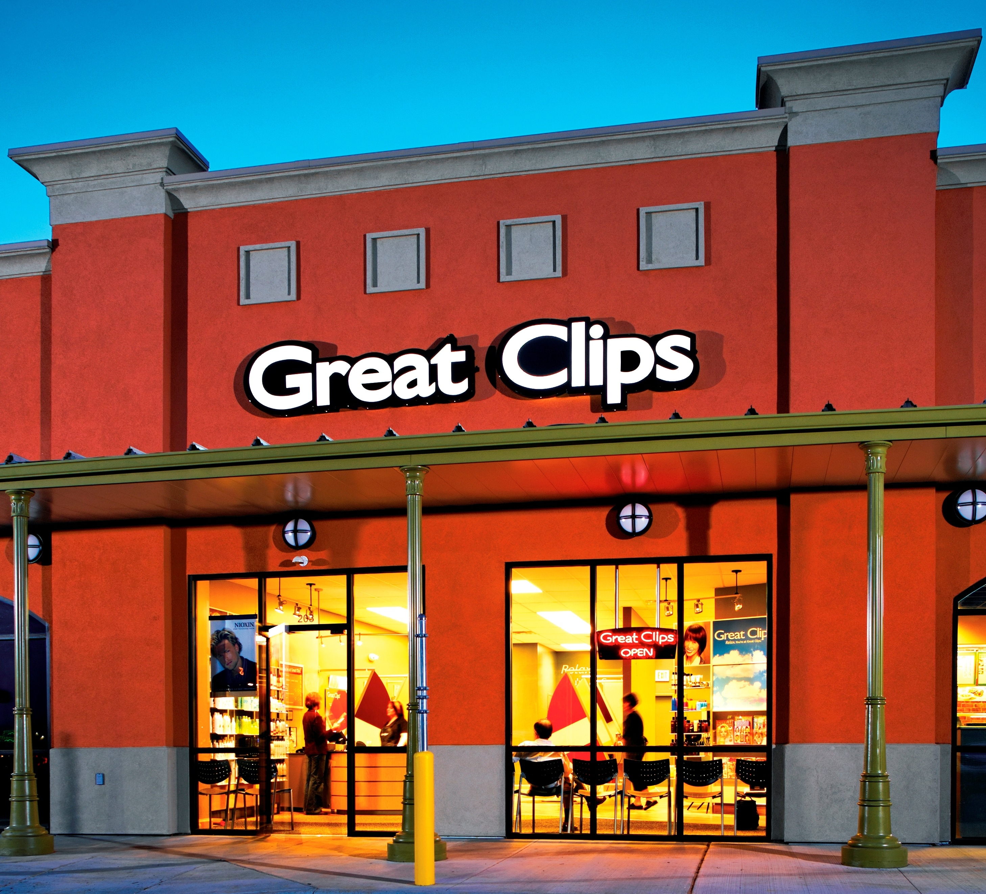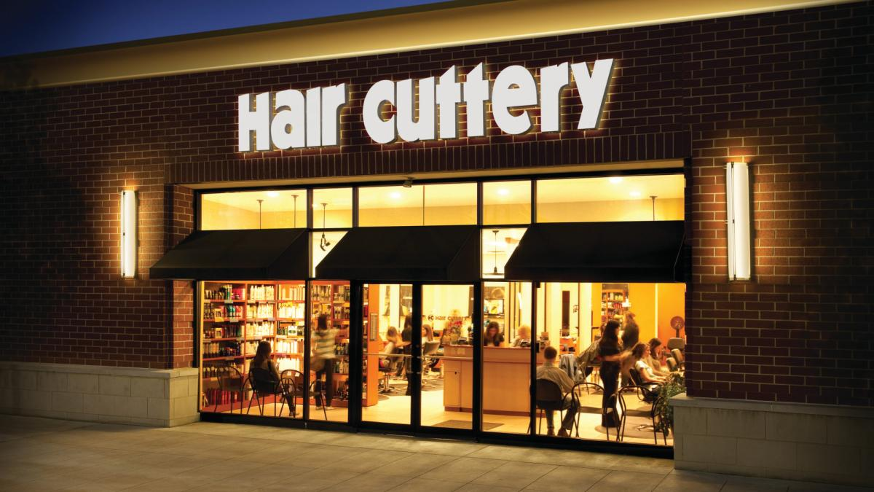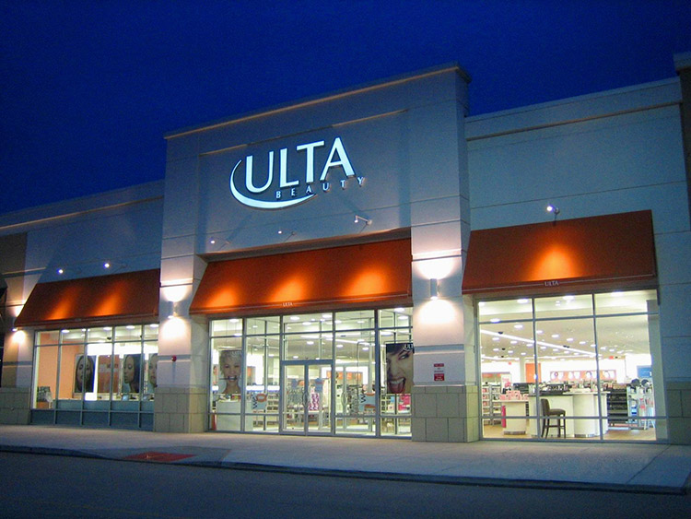

Medical Assistant Partnerships
Heritage Hall Bryant and Stratton College Patient First

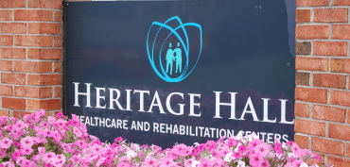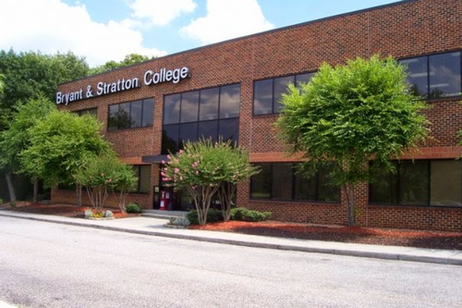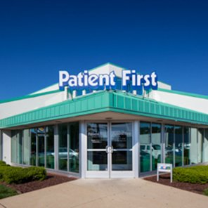

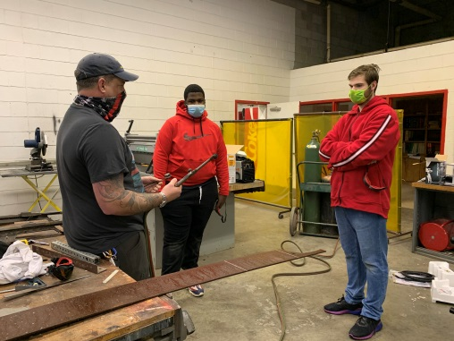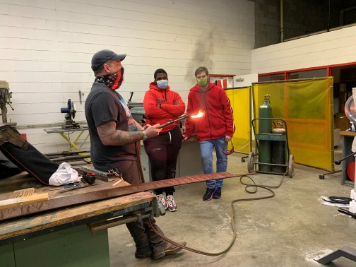
Program: Auto Body l & II; Amelia and Nottoway

Skill: Shop Safety and Fabricating

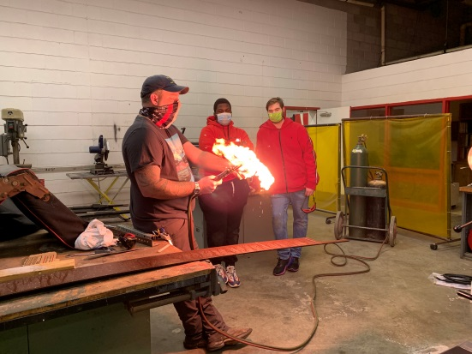

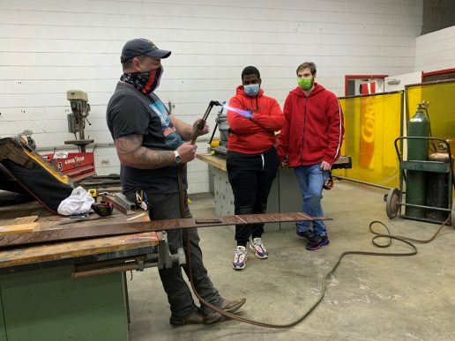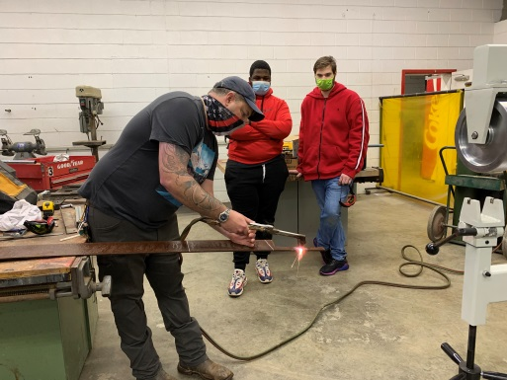
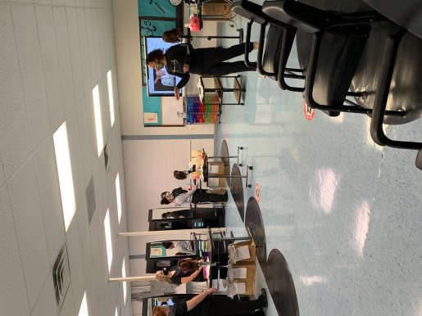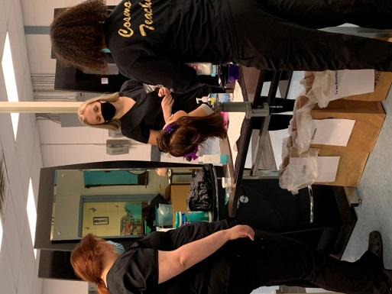
Program: Cosmetology l & II; Amelia, Cumberland and Nottoway

Skills: State Board Drills & Proctor Simulation, and Braiding

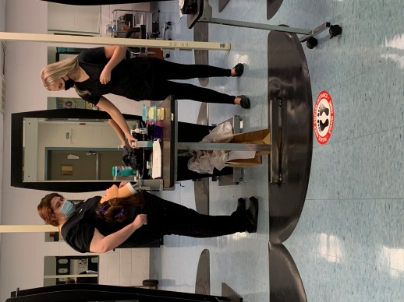
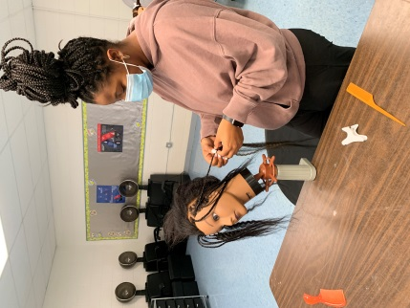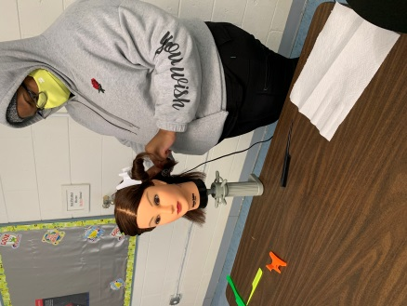
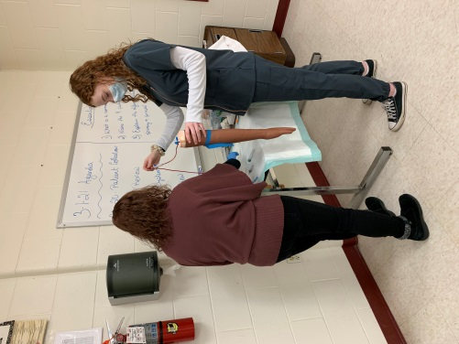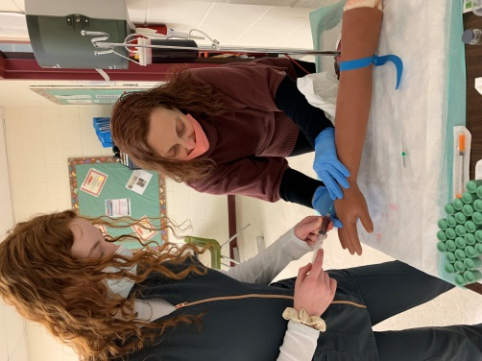
Program: Medical Assistant I & II; Amelia and Nottoway

Skills: Collecting Specimens (Blood), and Vital Signs (Blood Pressure)

