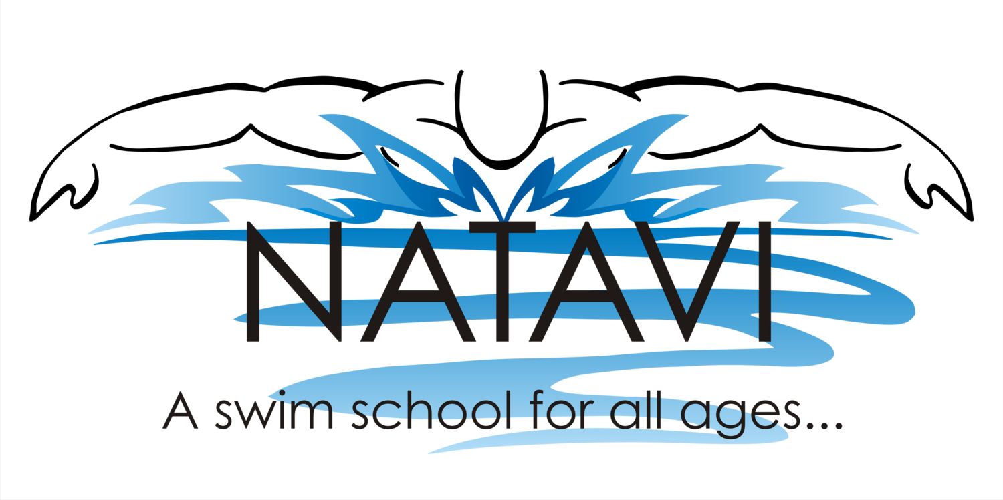
Monday | Tuesday | Wednesday | Thursday | Friday | Saturday
Water Aerobics:  9:00-9:50am |  | Water Aerobics:  9:00-9:50am |  | Water Aerobics:  9:00-9:50am | **Precompetitive swimming clinic**  9:00-9:50am
Water Walking/ Lap swimming:  10:00-11:00am  12:00-1:00pm  Family Swim:  11:00am-12:00pm  2:30-3:30pm  Swim Lessons:  4:10-4:40 L1/L2/L3  4:50-5:20 L1/L2/L4/L5  5:30-6:00 L1/L2/L3/L4  6:10-6:40 L1/L2/L3/L6  ASD Lessons:  4:10-4:40pm  4:50-5:20pm  5:30-6:00pm  6:10-6:40pm  BOGA PILATES  7:00-7:50pm | Water Walking/ Lap swimming:  10:00-11:00am  1:00-2:00pm  Express Aquatic Aerobics:  12:00-12:30pm  Family Swim:  11:00am-12:00pm  2:30-3:30pm  Swim Lessons:  4:10-4:40 L1-L5/PT  4:50-5:20 L1-L5/PT  5:30-6:00 L1-L5/PT  6:10-6:40 L1/L2/L3/PT  **Precompetitive swimming clinic**  6:00-6:50pm  Water Aerobics:  7:00-7:50pm | Water Walking/ Lap swimming:  10:00-11:00  12:00-1:00pm  Family Swim:  11:00-12:00pm  2:30-3:30pm  Swim Lessons:  4:10-4:40 L2/L3  4:50-5:20 L1/L2/L4/L5  5:30-6:00 L1/L2/L3/L4  6:10-6:40 L2/L3/L4/L5  ASD Lessons:  4:10-4:40pm  4:50-5:20pm  5:30-6:00pm  6:10-6:40pm  Express Yoga: **  7:00-7:40pm  Aqua Meditari™ **  8:00-8:45pm | Water Walking/ Lap swimming:  10:00-11:00am  1:00-2:00pm  Express Aquatic Aerobics:  12:00-12:30pm  Family Swim:  11:00am-12:00pm  2:30-3:30pm  Swim Lessons:  4:10-4:40 L1-L5/PT  4:50-5:20 L1-L4/PT  5:30-6:00 L1-L4/PT  6:10-6:40 L2-L5/PT  Water Aerobics:  7:00-7:50pm | Water Walking/ Lap swimming:  10:00-11:00  12:00-1:00pm  Family Swim:  11am-12pm | Swim Lessons:  10:40-11:10  L1-L4/PT  11:20-11:50  L2/L3/L5/PT  Family Swim:  12:00-1:00pm
Fall/Winter 2020/2021 - Effective September 8th 2020 – May 27th 2020

**Check Facebook for events and dates

