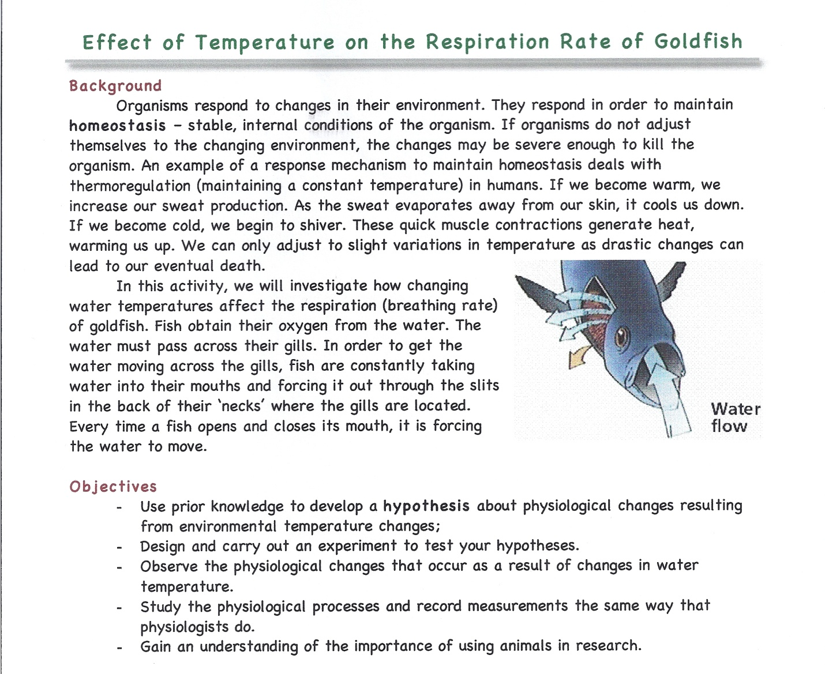
Life Science Class fish respiration rates
Lab will be experiments with fish breathing rates using living goldfish. Prior to class, please answer these questions:
- Look up the normal resting breathing rate of a fish (we will use goldfish in class) ___________

Without looking at any sources, answer the following questions as to what you think will happen. After experimenting in class, you will see if your hypothetical guess is correct!

- What do you think will happen to the breathing rate if the water is warmed up 10 degrees? Will the breathing rate go up or down? _____________________

- What do you think will happen to the breathing rate if the water is cooled 10 degrees from where we started? ________________________________

