

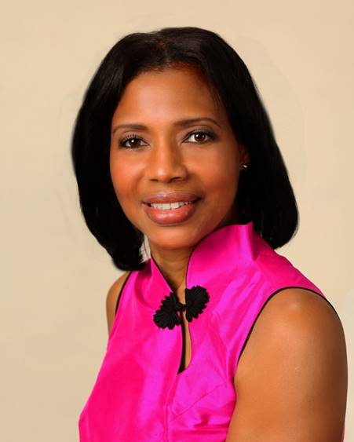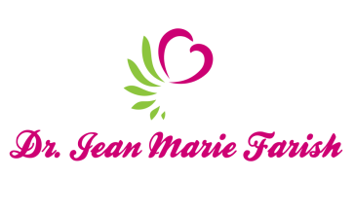

LOVE LIGHT NewsLetter

***I am excited to host my VoiceAmerica Empowerment Show-LOVE LIGHT with amazing Guests to cultivate a lifestyle of love and wholehearted connections through worthiness. My show is aligned with my mission to live an altruistic and heart centered life.***

**MEET LOVE LIGHT GUEST**

**RANA AL-FALAKI**

**Light Changes Coaching Founder**

**Life and Business Coach, Speaker, Author, Periodontist**

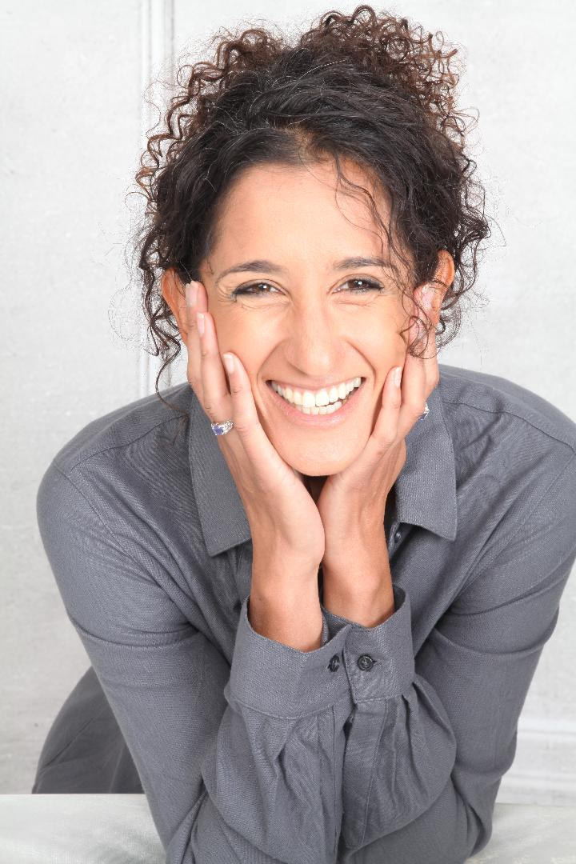

**May 15, 2020**

***Recover Your Losses….A Journey to Re-Connection***

**ABOUT Rana Al-Falaki**

**BeFree*,* BeFun*,* BeFearless expert, Dr. Rana Al-Falaki, has had over twenty years’ experience as a world leader, is an international speaker, trainer and coach, a pioneering researcher, writer, and at the same time a mother of three and friend to many.**

**She manages to balance it all with an underlying belief that everything you do in life should have purpose, be fun, and that by being conscious you give yourself choice and the ability to create whatever it is you want.**

**She has redirected her expertise from physical health to a more holistic one of self-mastery and empowerment, using techniques that shift energy to help us heal and manifest a life with no need for compromise or settling. She is the author of the #1**

**International bestseller *Women* *Who* *Want* *More:* *How* *to* *Create* *a* *Balanced* *&* *Fulfilled* *Life*. She is a certified professional life coach, an energy leadership index master practitioner, a Rahanni healer, a Law of Attraction mentor, and founder of Light Changes Coaching**

[**www.lightchangescoaching.com**](http://www.lightchangescoaching.com)

[**https://www.facebook.com/lightchangescoaching**](https://www.facebook.com/lightchangescoaching)

[**https://twitter.com/ChangesLight**](https://twitter.com/ChangesLight)

[**https://www.youtube.com/channel/UCDh7t5s571**](https://www.youtube.com/channel/UCDh7t5s571)

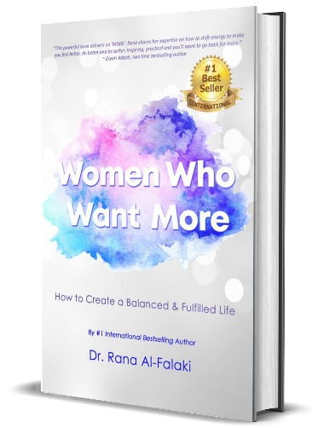

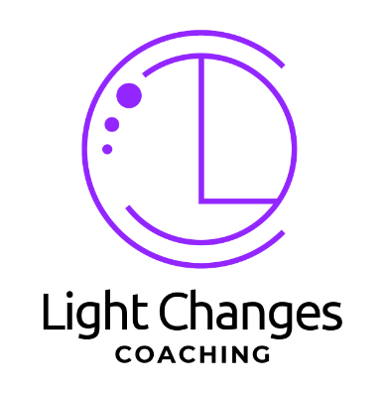

***“An empowered self is a loving self, and keep your love light shining.”***

***“An empowered self is a loving self and keep your love light shining.”***