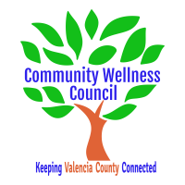
Board Meeting
April 1, 2020
1:00pm-3:00pm
Virtual Meeting

1:00PM-1:15PM

- Call Meeting to Order
- Welcome Guests
- Agenda
- Consent Agenda
  - Minutes of 3/4/20
  - Treasurer Report
  - Coalition Reports
- Social Media/Website Report
- Consent Exemptions
Business
- Coordinator’s Report/Grant Deliverable Activities Update (Noelle) 1:15PM-1:30PM
- Financial Management Update/Monthly Match (Noelle) 1:30PM-1:35PM
- Anna Age 8/Book Club Update 1:35PM-1:45PM
- KAH update 1:45PM-1:55PM
- Priorities Calendar review 1:55pm-2:05PM
- CWC Executive Board Meeting Format (Ginny) 2:05-2:15
- Handling scheduling/rescheduling of CRUNCHs: OSAP/Opioid and Census 2:15-2:25PM
- OSAP/Strategic Plan and Core Team Planning Update (Linda) 2:25PM-2:40PM
- MRGDA Update/SHARENM Planning Grant (Noelle/Diana) 2:40-2:45PM
- LED Sign update (Diana) 2:45-2:50
- Review of Action Items: 2:50 PM-3:00PM

Additional Items of Discussion
- Adjourn

