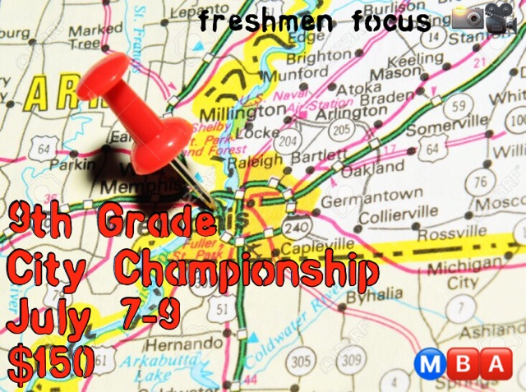

Location
Gym | Address
Fairley High School | 4950 Fairley Rd

Teams
Pool A | Pool B
Memphis Hawks | DMG
Memphis Pharoah Elite | M33M (Applewhite)
Memphis Showtime | Mississippi Spartans
Team Development | Team Tarheel

Schedule
Date | Day | Time | Home Team | Away Team
7-7 | Fri. | 5:50pm | Memphis Showtime | Memphis Pharaoh Elite
7-7 | Fri. | 6:40pm | Team Development | Memphis Hawks
7-8 | Sat. | 10:30am | Memphis Pharaoh Elite | Team Development
7-8 | Sat. | 11:20am | Memphis Showtime | Memphis Hawks
7-8 | Sat. | 12:10pm | Memphis Pharaoh Elite | Memphis Hawks
7-8 | Sat. | 1:00pm | M33M | Team Tarheel
7-8 | Sat. | 1:50pm | Memphis Showtime | Team Development
7-8 | Sat. | 2:40pm | M33M | Mississippi Spartans
7-8 | Sat. | 3:30pm | DMG | Mississippi Spartans
7-9 | Sun. | 12:00pm | DMG | Team Tarheel
7-9 | Sun. | 12:50pm | DMG | M33M
7-9 | Sun. | 1:40pm | Mississippi Spartans | Team Tarheel
7-9 | Sun. | 2:30pm | Pool A #1 | Pool B #4
7-9 | Sun. | 3:20pm | Pool B #1 | Pool B #4
7-9 | Sun. | 4:10pm | Pool A #2 | Pool B #3
7-9 | Sun. | 5:00pm | Pool B #2 | Pool A #3
7-10 | Mon. | 5:50pm | Winner of 2:30pm Game | Winner of 5:00pm Game
7-10 | Mon. | 6:40pm | Winner of 3:20pm Game | Winner of 4:10pm Game
7-10 | Mon. | 7:30pm | 3rd Place Game  Loser of 5:50pm Game | 3rd Place Game  Loser of 6:40pm Game
7-10 | Mon. | 8:20pm | City Championship Game  Winner of 5:50pm Game | City Championship Game  Winner of 6:40pm Game

*Sunday’s Bracket Play times may change due to some teams playing in another tournament.
If you have any questions or concerns please feel free to contact Coach Von at (901)289-8097

