Budgerigar Association of America

Patronage Application
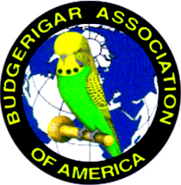
THIS IS FOR PATRONAGE (SHOW INFORMATION) ONLY

Please Print All Information

NAME OF CLUB:

Type of Club (ie, All Bird Club, Budgie Club, etc):

CONTACT PERSON

Name:

Address:

City: State: Zip Code:

Email Address:

Phone No #1: Phone No #2

NAME OF SHOW:

Show Date:

Show Hall:

BAA Judge: Other Judge:

Show Hall Address:

City: State: Zip Code

Contact at Show Hall: Phone #:

Proof of Insurance Sent To:

Please include all information that is available. Specific show information must be sent in at least 4 months prior to your show.

Additional medals may be purchased for $17.50 each. Additional CCs may be purchased for$20.00 per set.
.
Make checks payable to B.A.A.

Send Application & payment for awards to:

Steve Higgins
16058 County Road 355
Terrell, TX 75161
713-819-8769
E-mail- higgins3023@yahoo.com

