INTRODUCTION

One Step Cassette Style Anti-HIV 1+2 Test is a rapid direct binding screening test for the presence of antibodies to HIV 1 and HIV 2 viruses. The test is based on the principle of double antigen sandwich immunoassay for detection of Anti-HIV in serum. Purified recombinant antigens are employed to identify Anti-HIV specifically. This one step test is very sensitive and only takes about 10-15 minutes. Test results are read visually without any instrumentation.

SPECIMEN COLLECTION

The One Step HIV 1+2 Test can be run on serum. The test works best on fresh samples. For serum, collect blood into a container without anticoagulant. Allow the blood to clot and separate the serum from the clot. Use the serum for testing.

If the specimen cannot be tested on the day of collection, store the serum specimen in a refrigerator (at 2 to 4°C) for up to 3 days. If testing cannot be done within 3 days, serum should be stored in a freezer (at -20°C or colder). Make sure to bring the serum specimen to room temperature before testing. Do not freeze and thaw the specimen repeatedly.

MATERIALS PROVIDED
1. Test kit 2. Specimen diluent in dropper bottle 3. Plastic Pipettor to dispense sample

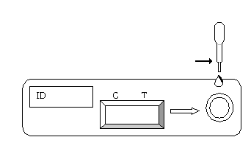TEST PROCEDURE
- When you are ready to begin testing, open the sealed pouch by tearing along the notch. Remove the test device from the pouch.
Fill Line

- Using the plastic pipettor provided, draw the sample into the pipette until the level is at the bottom of the first bulb (do not draw sample past the Fill Line). Dispense this amount of sample onto the sample well of the cassette. (3ul of serum)

- Add about 2-3 drops (100μL) of diluent provided onto the sample well. Use the dropper bottle provided, not the sample pipette.

- Wait for 10-15 minutes and read results. Do not read results after 20 minutes.

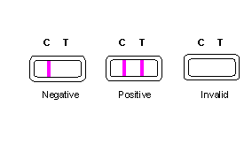INTERPRETATION OF RESULTS

- Negative: Only one colored band appears on the control (C) region. No apparent band on the test (T) region.

- Positive: In addition to a pink colored control (C) band, a distinct pink colored band will also appear in the test (T) region. Please consult your physician to perform a much more detailed exam.

- Invalid: A total absence of color in both regions is an indication of procedure error and/or the test reagent has been deteriorated.

STORAGE AND STABILITY
The test kit should be stored at room temperature (18 to 30°C) in the sealed pouch to the date of expiration. The test kits should be kept away from direct sunlight, moisture and heat.

PRECAUTIONS
- For in vitro diagnostic use only.
- Do not use test kit beyond expiry date.
- The test device should not be reused.
- For samples that test positive by the One Step ANTI-HIV Test, a more specific confirmatory test should be done. A clinical evaluation of the patient’s situation and history should also be made before a final diagnosis is established. The use of a rapid test is not sufficient to diagnose AIDS even if antibodies are present. Also, a negative result does not preclude the possibility of infection with HIV.
- The instructions for use and reading of the test must be followed exactly in order for the test to perform properly.

Latest revision 09.05.2011

ATLAS LINK, INC USA Headquarters:
No. 811 Zeyang Plaza, No.166 Fushi Road 10758-A Ambassador Drive
Shijingshan Dist., Beijing 100043, China MANASSAS, VA 20109 USA
Tel: 86-10-88909112 Fax: 86-10-88909115 Tel: 703-3663851

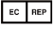
CIRIANO GLOBAL S.L. (UNILATEX GROUP)
CIF: B50927532 C/Blancas 4-6, 1 B Oficina 1
50001 Zaragoza Spain
Tel: 34-976910399

