GREAT EXPECTATIONS
So you are thinking about doing a project or applying for a position in the Cator Lab?
Research shows again and again that most issues in the workplace (and really probably in life) come down to miscommunications about expectations. This document has been created to provide you information about what I expect from students and researchers working within the group and what you can expect from me.
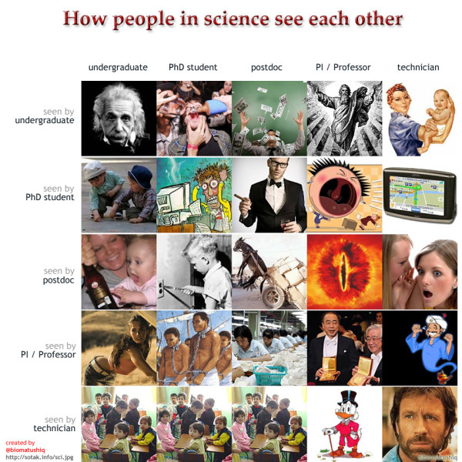
Figure 1. Pictorial explanation of common interlab dynamics. Most of these are not applicable to our group……..right?
General Expectations (everybody!)
Science generally is pretty fun. It is even more fun when there are nice people around to discuss it with.
- Everyone in this group has a right to feel safe and respected regardless of career position, gender (or lack of gender), phenotypic characteristics, sexual orientation, or country of origin. I expect you to treat everyone in the lab with the same way you would like to be treated by them. Everyone’s time is valuable and no one here is better than anyone else (that goes for the PI too). I have put this expectation first because it is non-negotiable. If you can’t do this, don’t come work here. If you’ve been made to feel uncomfortable tell Lauren. If Lauren has made you feel uncomfortable contact Dr. Julia Schroeder (office down the hall from Lauren’s) and she will speak with Lauren (anonymously if you wish).
- Lab members are expected to work collaboratively. We each have our own questions and projects, but at the end of the day this is team. I expect lab members to be supportive and communicate directly and openly with one another. Everyone has access to lab documents via dropbox and should email the group with questions or concerns. You may be asked to deposit your data or SOPs into this dropbox folder. This is to be sure we never lose data or SOPs.
- Sounds silly but: clean up after yourself! This is a no brainer. Leave all lab spaces in better shape than you find them. Don’t leave messes for others to find. As a general guide line everyone (this includes Lauren) should plan on spending 1 hour a week cleaning common spaces.
- Follow health and safety rules. These are both posted around the lab and detailed in lab SOPs and documents accessible on dropbox. When in doubt ask! (and since we are friendly you can always ask!).
Expectations specific to UG project student and UROPs
Whether you are joining us for a final year project or a UROP we are excited to have you here! For many of you this will be your first experience in a lab research setting:
- You are going to be learning many new things. I expect that you will have questions. I also expect that instead of “winging it” you will ask those questions.
- Following that: I expect you to understand that we might not always have answers. This is the exciting part of research! We are often doing things that have never been done before.
- I have been lucky to have excellent 3rd year project students. I expect you to work with me to design an experiment for your project and I expect you to take the lead on organizing and executing that project. It is fine to ask for help from fellow lab members with executing an experiment, but you need to do so well in advance. In the end you are responsible for your data and your project. I expect you will need feedback and assistance with this from me, Masters/PhD students in the group, and postdocs.
- I expect to have a half hour to hour weekly meeting with you (likely on a Thursday and also possibly with other students) to get updated on project progress and discuss weekly accomplishments and goals.
- I expect UROP students to organise their funding applications, accommodation, and the dates they will join us. There are many different ways of getting funded for a UROP and I recommend contacting the undergraduate research office for this information.
- I expect that if you need me to read something and provide sensible comments to give me a week lead in time.
What can UG researchers expect from me? Working with you is one of my favourite things about my job. I want you to excel in your project and I’m so excited to start you on some real science! I will do my best to respond to emails in good time and be available to meet with you. I have lots of requirements on my time so I might not always be immediately available/responsive at a minimum you can count on our weekly meeting. You can also expect me to read through your entire project one time in its final format (remember to send it in time) and also for me to give general comments on individual sections as you put together that final draft.

Expectations Specific to Master’s Students
Your Master’s project is a large part of your mark. It is also an important learning opportunity. This probably going to be the best indicator for you if a career in research is for you. It might be hard work. You will probably spend a lot of time in the lab. It should also be fun!
- I expect you to read and engage with the relevant literature. To discuss this literature with me and with other lab members. You may find that attending the Behavioural Ecology journal club or others useful. I encourage you to participate in lab meetings and to attend seminars when they occur.
- I expect you to design, organize and implement your experiment with help from me and advice from the rest of the lab group.
- As an independent researcher you will set your schedule. This means that if you wish to take holiday or not come into the lab, this is your choice. It also means that if you do not wish to work weekends or at certain times of the day this is also your choice. The only acceptations to this are lone working at night (in which case you need to notify us), your weekly meeting with Lauren and lab meeting which may occur biweekly when the group is large. This does mean that you are responsible for managing your time and making sure your project is completed.
- I expect to have a half hour to hour weekly meeting with you (likely on a Thursday) to get updated on project progress and discuss weekly accomplishments and goals.
- I expect that if you need me to read something and provide sensible comments to give me a week lead in time. I am happy to discuss analysis and read sections of your write up as many times as you would like (and time allows). I expect that if you need me to read something and provide sensible comments to give me a week lead in time
I want you to rock this project. I want you to also come out as a properly trained Master’s student. This means I have to provide you with enough guidance and support to succeed and also enough freedom to take ownership of your project. You can expect to meet with me weekly. I will do my best to respond to emails in good time and be available to meet with you. I have lots of requirements on my time so I might not always be immediately available/responsive at a minimum you can count on our weekly meeting. You can also expect for me to provide advice and comments on experimental design and your writing. Ultimately, however, I will not tell you what to do. This may seem strange at first. You might be used to walking into a meeting and coming out with answers. You may come out of a meeting with me with a list of questions to think about. I can help you by providing information to make those decisions. You can expect me to provide materials for your project (within reason). In many cases, I have assisted in actually conducting experiments, but this might not always be possible.
Expectations for PhD Students
Imperial offers specific guidance here (I have made some comments in blue). In line with this I expect the PhD Students that I work with to:
- Take responsibility for your thesis - in the end it is your work and your supervisors are here to help you accomplish your research objectives, but not to do the thinking for you!
- Work hard - a research degree cannot be accomplished with only a 9-5 effort. Imperial is a top ranking University and we expect that students will strive to accomplish good work. Having said this, as I have explained above, you are the master of your time management. You might only need to work 9-5pm. I measure progress in output not in hours spent.
- Display initiative - ultimately, the person who drives the process and strives to understand the research area is you. We expect you to be curious about your work and to think about how other ideas/work have an impact on the research you are doing. In light of this, it is a requirement for you to attend all lab meetings, work in progress etc plus other seminars. TO BE A SCIENTIST - YOU SHOULD BE CURIOUS ABOUT SCIENCE!
- Write papers (this is dependent on field of study) before you have submitted your thesis. The process of writing enables you to develop skills which are useful when writing up your thesis, and the fact that you have had papers refereed/accepted by International journals satisfies the external examiner that you have what it takes! Ideally, you want 3-5 publications from your PhD work and a minimum of 3 in which you are the lead author. I would expect you to push to get as many of these published or at least in final formatting before graduation.
- Be self-critical of your own work and results, and use these skills in being sceptical of results in the literature.
- Help colleagues (especially less experienced ones) in the laboratory to learn through discussions and demonstrations.
- Keep up with the literature in your field.
- Provide regular reports detailing your results - you should be conscientious about keeping a laboratory notebook and regularly entering all your data into tables and Excel spreadsheets. We will keep updated at our weekly meetings. Also you will be expected to provide a copy of all data in a useable format for the lab to access. This can be through a service such as Dryad (in the case of published data) or via the Dropbox.
- Be aware of safety at all times and follow safety procedures, especially if you are working in a laboratory.
- Develop your skills and learn new ones by attending the transferable skills courses and lectures provided by the Graduate School, your own and other College departments/divisions/faculties and by any other external providers.
- One additional expectation I have: the DTPs are an everchanging and evolving beast. I count on you to be on top of what kinds of paperwork/meeting/assessments need to happen to satisfy your particular DTP requirements. I will be 100% supportive of these, but I can’t keep track of them all!!
The quality of the PhD students that come out of my group is a direct reflection on me. You can expect to meet with me weekly. I will do my best to respond to emails in good time and be available to meet with you. I have lots of requirements on my time so I might not always be immediately available/responsive at a minimum you can count on our weekly meeting. My interactions with you will likely evolve over the course of your project. Initially we may interact similarly to a Master’s Student and supervisor, but I’m moving toward treating you like a colleague (see below). I will also support you in networking, attending conferences, and preparing for your next steps.
Expectations for Post Doctoral and Post Graduate Researchers
You make the lab go! I consider you to be my colleagues. I depend on you for feedback on my own ideas. I also expect you to bring your own independent ideas, view points, and energy.
- I expect you to conduct high quality, question based, and independent research. (So all that stuff above but even more powered by you). This is probably one of the last times you will be able to focus on your own research with no distractions. Enjoy it!
- Publications are going to help you advance in any scientific career you choose to pursue. I expect PDRA and PGRAs to lead the writing of manuscripts. This will including keeping up with the relevant literature and taking the first crack at the discussion.
- I expect you to push me! In many cases you have been selected to join the group because you bring a unique expertise or skill set. I want you to speak up about the direction our research is moving in or if you think there is a way we can improve how we are approaching our science.
- I expect you to interact and support the students that are working their way through the lab. They will come to you with science and career questions. This is an excellent opportunity to get some informal mentoring experience. If you would like to create a formal mentoring agreement with a PhD or Masters student please let me know and we can outline what that should look like.
- I expect you to be a vibrant contributor to the laboratory and Silwood community. This includes attending journal clubs, the weekly seminar, and contributing to outreach events.
- I expect you to be up front with me about what you need. If you are looking for a particular experience or assistance I will do my best to help you, but if I don’t know I won’t be able to help!
Part of my job as a PI is to help get you to the next stage of your career (whether that is into a PhD program, into a fellowship, or on to a faculty position). I expect you to work hard and you can expect my full support. I will provide honest feedback both at the required 3/6 month probation reviews and yearly review, but additionally along the way. You can expect to meet with me weekly and also for me to get back to your emails in a timely manner. You can also expect my support in attending conferences (as funding permits), presenting your work, preparing your own funding applications, and preparing for job interviews.

Expectations for the PI
That’s right! I have expectations for myself!
- I expect you to conduct high quality, question based, and independent research that improves our overall understanding of mosquito behaviour and its role in transmission dynamics and disease control.
- I expect you to mentor, support, and provide feedback to all lab members. This includes providing them with the support they need to become independent researchers.
- I expect you to highlight places that lab members can work together and where there may be overlap in interests.
- I expect you to stay on top of the relevant literature and think critically about where our group can contribute.
- I expect you to write and obtain funding to support the work of the laboratory.
- I expect you to design and deliver dynamic and engaging undergraduate and postgraduate teaching
- I expect you to embed yourself in the department and contribute to departmental culture.
- I expect you to forge new collaborations within the UK and outside.
- I expect that you should have some fun.

