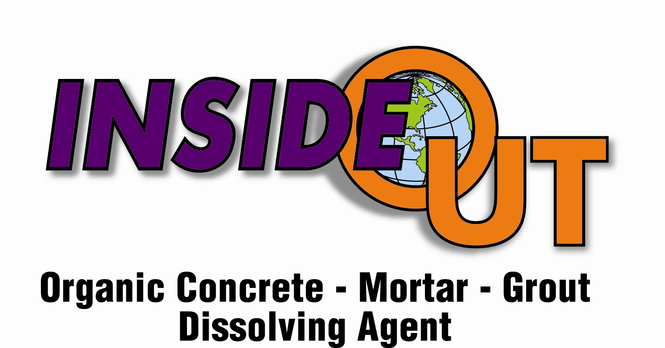

Chemme.co recommends always wearing chemical splash safety goggles when handling any chemical. See MSDS

Factor the X 2X or 1X Concentrate Level

DIRECTIONS FOR USE:

APPLY ON DRY SURFACE; PRE-WETING CEMENT BUILDUP WITH WATER CAUSES PRODUT TO BE INEFFECTIVE.

1. SPRAY or FOAM on Cementious surface until coated well with. Set dwell timer for 5 minutes, and then re-apply keeping area wet and moist with. Timer should be reset for an added 10 - 15 minutes. If foaming on product a wetter foaming desired for greater effectiveness and penetration.

2. Allow penetration time, typically 10 – 15 minutes to pass maybe longer depending upon heat and or wind. Extreme temperatures can cause product to dry out, if this occurs rewet area being cleaned with . After 10 -15 minutes, re-apply to thicker Cementious areas if needed. Keep surface wet and moist with . Brushing is not necessary at this time and can cause the brush to act as sand paper on your paint. You will know when the Cementious area is ready to be removed by its texture and color change from grey to off white. It should have an orange peel affect were as the buildup is crusting off the surface like Swiss cheese.

3. Rinse with CLEAN CITY WATER before dries.

Cleaning Temperatures = Best if applied between 60F – 90F, Temperatures above 90F may causeto dry to quickly, and a wetter foam will help compensate for temperature loss. Chemme.co recommends using a Cen-Tech / Laser Surface Thermometer if unsure. Chemme.co recommends contacting your paint manufacturer for paint compatibility, physical properties, and chemical resistance. Beware of hot cleaning surfaces, non-chemical resistant paints. Typically paints used on Mixer Trucks are highly chemical resistant. See Chemme.co’s paint recommendations flyer, specs, and questions, or if you need a paint type recommendation for refinish.

Will not harm Paint, Metal, Glass, Wiring, or Plastic Surfaces.
Can be used on Aluminum, Stainless Steel, and Chrome.
For best results do no leave on Chrome for extended periods of time.
A small test spot is recommended on any bare metal surface for compatibility.

Truck Cabs – Spray down cab, let dwell for 1 minute, brush if needed, then rinse with city water for best results.

