were familiar tunes beautifully sung and unfamiliar Australian pieces which were just enchanting. Those attending the earlier “workshop” were invited to join the singers ”on stage” as it were – an added treat for us all.
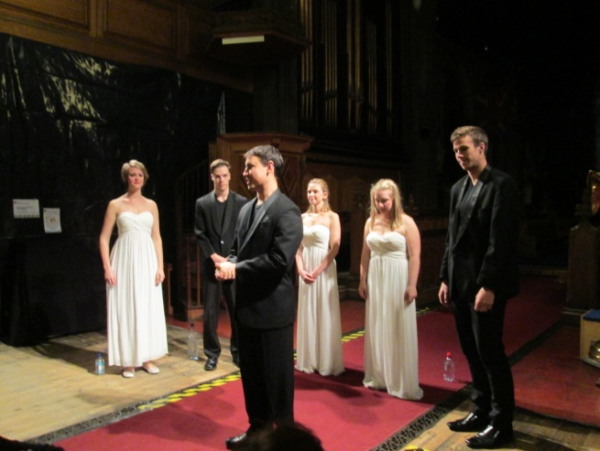
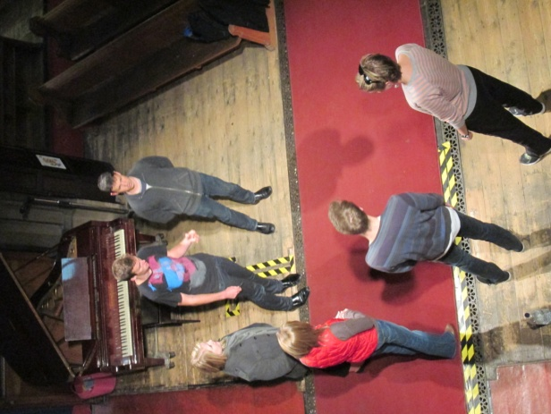

There was also the more serious side to our ministry at St Mary’s as we welcomed family and friends to the Memorial Service of Malcolm Linton Hall LLB (1920-2012).
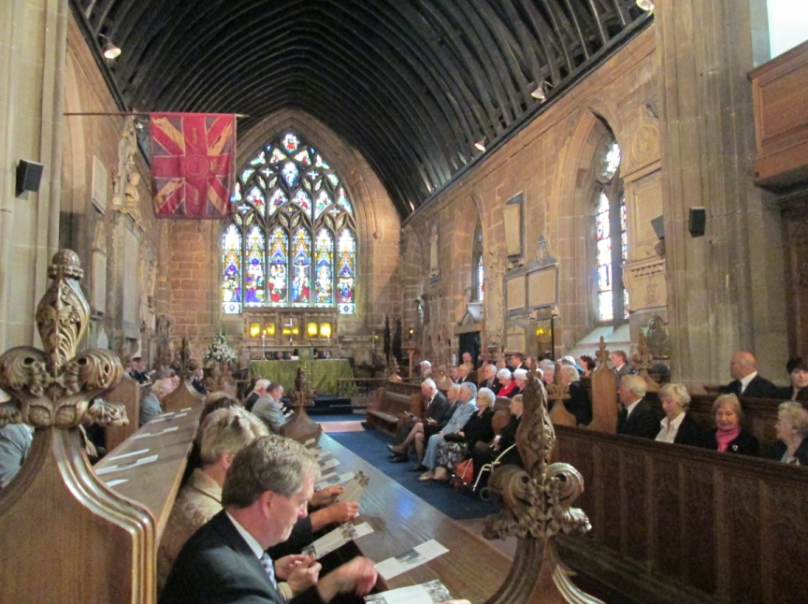

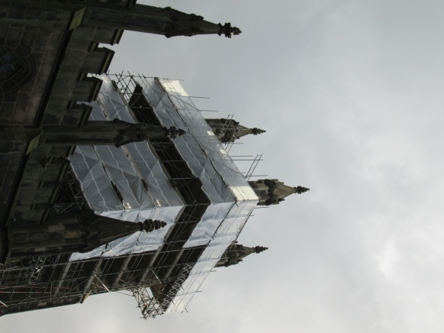
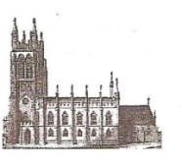
St Mary’s in the Marketplace.

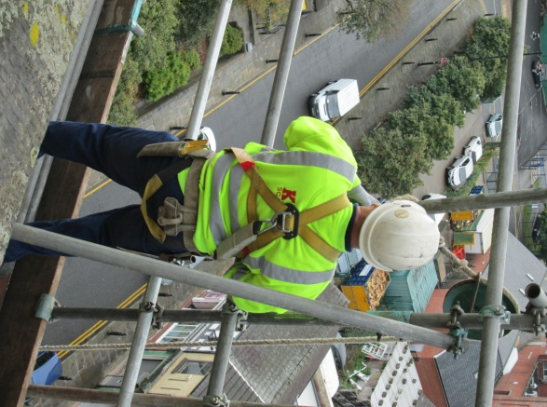
No 9 (16th September 2012)
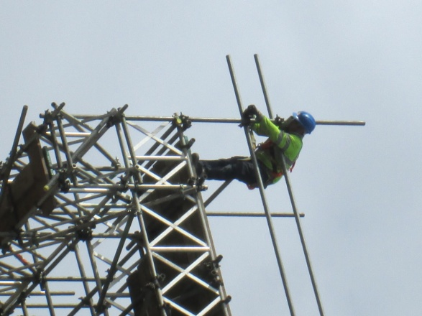
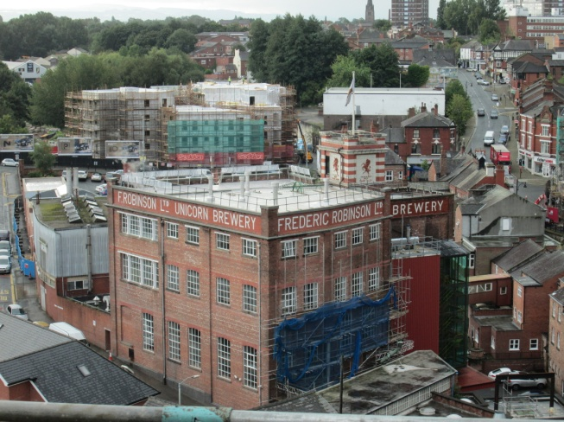
Things are really moving this week as we see the tower disappear behind the sheeting – but more is to come when the canopy over the roof is completed. In a few months time our east face will re-emerge beautfully restored with our new tower roof in place, the flag pole reinstated and once again we can fly our flag and ring our bells. It’s some view up there but you have to be impressed with our scaffolding - the size of the structure, the weight it has to carry – the skill of those who have designed it and those who have assembled it - pole by pole, plank by plank. and when you get up there you can just look down beneth us at those rather insignificant structures to be seen on the side of Robinsons and the new-builds further back. We have scaffolding to be proud of!

At a more reasonable height we find Pendlebury Glass removing the window from the old office. This wall will be knocked through to join the former choir vestry (the new area for the Stockport Heritage Trust.
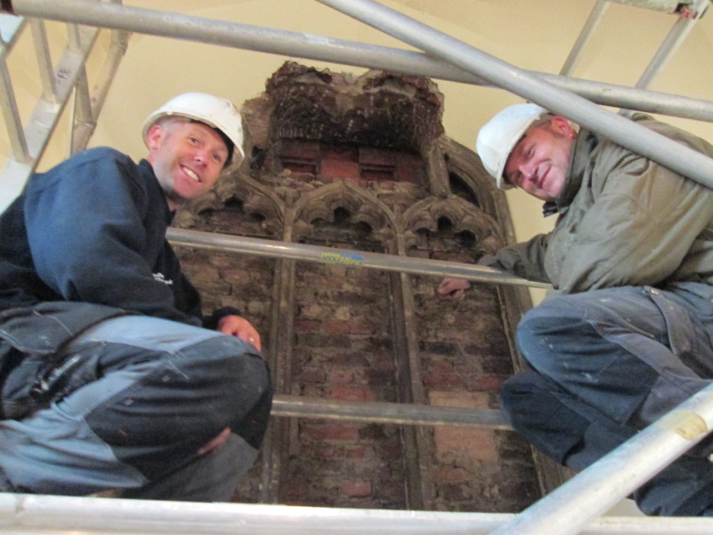

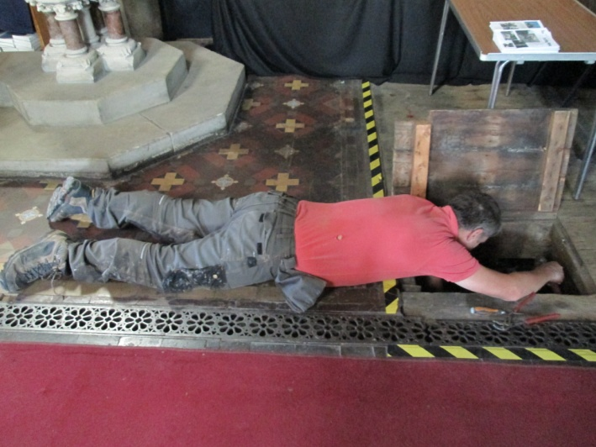
There is still quite a lot of activity under the floor – but the boilers were switched on and St Mary’s “toasty warm” for the first time since…… well …… oh joy! Still no pots of gold down there, hidden treasurer just dust!
The audience of our first concert of the season benefited from the warmth on what turned out to be a chilly evening. If you were not with us you missed a treat (if you were you know what a delight they were). The Australian Voices – were simply brilliant. It was a joy to welcome these talented young people into St Mary’s --- and here we are in the car park.
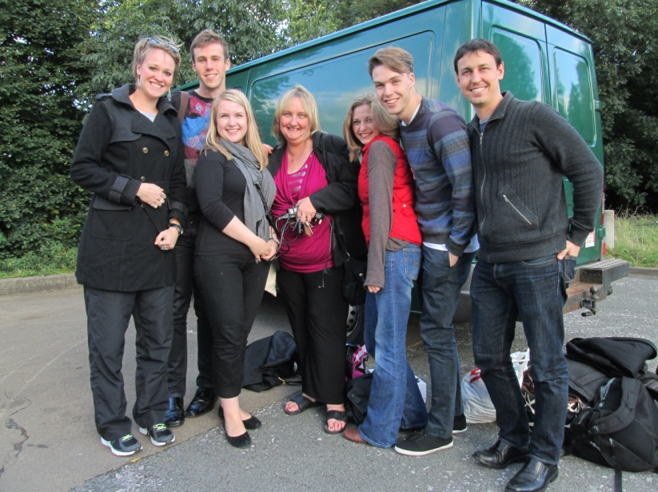
The group are undertaking an epic world tour starting with 80 cities in the UK – we were second on the list. We know where they are if you want to catch up with them. There

