North Delivers Crushing Defeat to the Confederacy

August 2, 2004
Associated Press

HARBOR SPRINGS, MI –- In a time long before each of us, perhaps Governor Sam Houston of Texas had a vision of what was to come on the shores of Little Traverse Bay in Harbor Springs during the summer of 2004.

“Let me tell you what is coming. The North is determined … They are not a fiery, impulsive people as you are, for they live in colder climates. But when they begin to move in a given direction, they move with the steady momentum and perseverance of a mighty avalanche.”

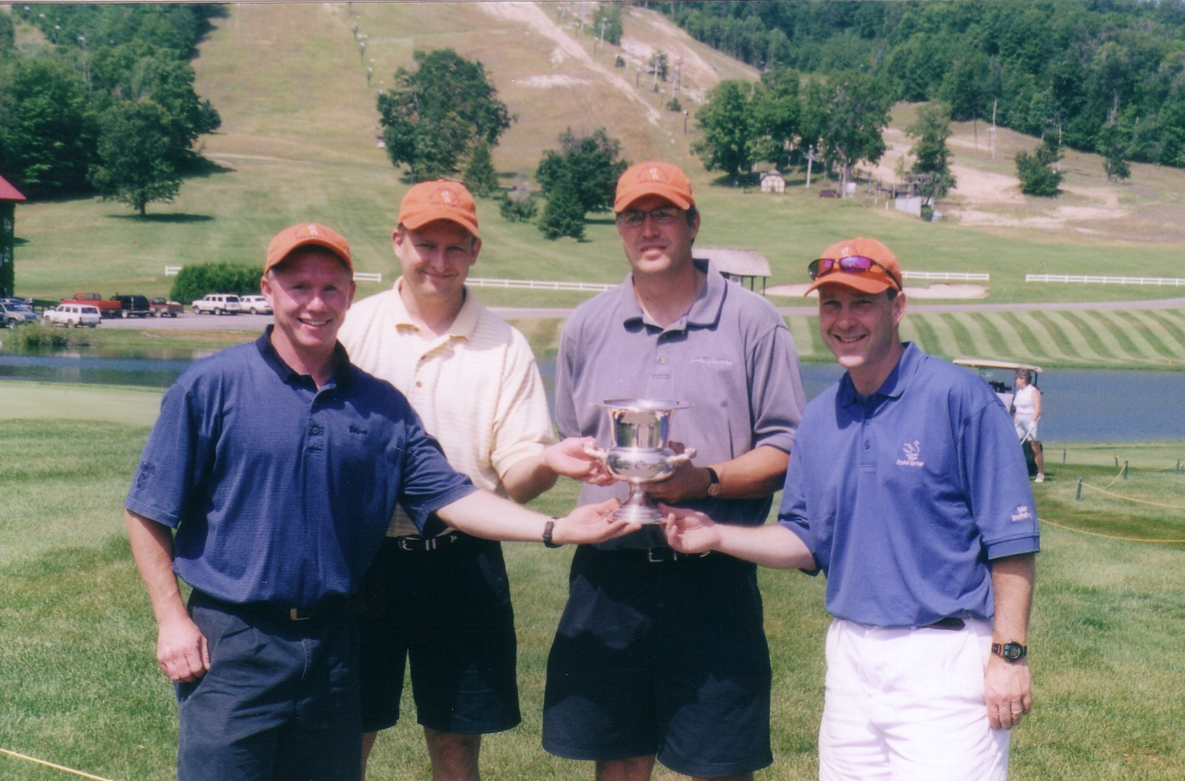
The North Squad celebrates with the prized Queso Cup just above the 18th at the Heather.

Okay, so maybe it was stripped and taken far out of context, but heck, who can argue with his logic? In what certainly proved to be the most competitive Queso Cup in its rich, 3-year history, the North delivered a crushing defeat to the South with a commanding sweep of the final round singles matches.

This year’s match began with two opening rounds at Bay Harbor Golf Club. For veteran Cuppers, that meant the opportunity to exorcise the demons of previous years on that hallowed ground. In particular, two-time losers Jeff Penzien and John Masley were given the opportunity to strike back against the courses that were the source of countless nightmares over the last year. Even though the curse was lifted, the best these two clowns could fare through two days were matching 1-1-0 records.

In addition, the Cup rookies from each squad, Tom Workman and Mark Schuckman, came out firing with no fear and positioned themselves with perfect 2-0-0 records through two days of matches.

The rock-solid play of sole defending Cup champion John Fitzgerald yielded surprisingly nothing but an 0-2-0 record through two days. Joining Fitz at 0-2-0 from the South side was Jon Lambert, who was obviously distracted wondering how he was going to sell his home before three hurricanes reached Florida later this summer.

Rob Cornell and Chris Gryskiewicz, under similar duress from equally daunting yet vastly different “triple troubles” in their futures, could only muster 1-1-0 records through two days of action on the soggy grounds of Bay Harbor.

Day Three brought to the surface nervousness that some of these individuals have yet to ever feel on a golf course. The individual match play has a way of making the palms and pits sweat a little more, the knees want to shake a little more, and the short ones appear much longer than they actually are.

That being said, the North took the South out to the whooping shed and delivered a clean 4-0-0 sweep of Day Three, and subsequent 6-2-0 overall Queso Cup victory. Of note in the individual matches would be:

- The revenge exacted by Fitz on Work-O after two days of team beatings
- The come-from-behind victories delivered by RC and Plug over Lamb and Gav respectively after rough starts
- The awakening by Schuckman to school Masley after trying to literally give away the front nine

The revised team format brought new life to the event this year and will certainly be the mainstay of the event for the years ahead.

Honorable mention from this year:

- Hats off to Barb Schuckman, who gets honorable mention for showing up on a moment’s notice and buying a bunch of golf gear only to get rained on for a complete afternoon of couples golf
- For that matter, hats off to all the spouses and families for continuing to put up with our event for 3 years running
- We finally got the accommodations right!
- Sooner or later, everyone will learn that beef for dinner after Day 2 spells trouble
- I don’t know about everyone else, but I’m already looking forward to next summer
- Due to the victory, the North will play host once again to the Queso Cup in 2005 -- details to come

Final Thoughts on 2004:

Each year, I think that this event can’t get much better.

Each year, my expectations are blown away with the friends and fellowship we share in this short period of time together.

Each year, I thank my lucky stars for friends like all of you.

Thanks again to everyone for such an enjoyable trip.
Masley

