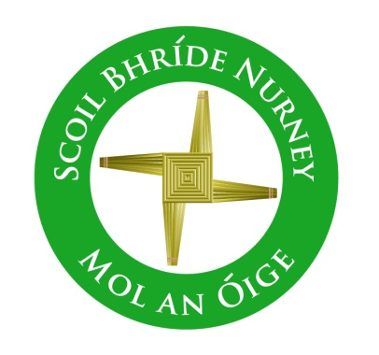
Scoil Bhríde,
Nurney,
Principal – Vinny Thorpe
Dep. Principal – Catherine Owens

County Kildare.
Te/Fax: (045)526767
Email: sbnurney@gmail.com
www.nurneyns.com
Roll no: 16345A
August 20th
Dear Parent / Guardian

An update on reopening our school. Please read in full. Thank you

Classroom Bubbles and Pods
Please click the following link to access a school video about new arrangements for entering our school building and a view of examples of classroom Bubbles and Pods in our school.
https://youtu.be/Za4jkSUloJs

Return of School Books from children’s homes
We ask all families to now begin preparing to return any school books belonging to the school you have in your home. Many of these books were sent home with your children before the and during the school lock down. Please clean them with anti-bacterial cleaner and place them in a plastic bag and return them to your child’s class teacher when the school re-opens. Thank you.

Footballs at break times
In order to limit the spread of infectious disease in our school we will not be allowing children to bring in their own footballs etc. for use at play time. The school will give each class footballs to use at break time. These will be cleaned thoroughly each and every day before use.

A Reminder to anyone attending school who has travelled abroad
Government policy, which is based on official public health advice, continues to advise against non-essential travel overseas for everyone. It is a requirement for anyone coming into Ireland, from locations other than those with a rating of ‘normal precautions’ (“green”), to restrict their movements for 14 days, and this includes school staff, parents and children or other students coming from abroad to attend school in Ireland. Restricting your movements means staying indoors in one location and avoiding contact with other people and social situations as much as possible.

The school will be in touch over the next two weeks with more updates to reopening our school.
God Bless to you and all your family.
Vinny Thorpe
Principal

