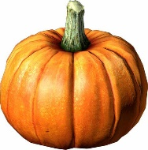  October 2021 Holiday Club  Programme |  |  | www.wildaboutplayridgewood.co.uk
October | Mon 25th | Tues 26th | Weds 27th | Thurs 28th | Fri 29th
Opens 8am | Monster Madness | 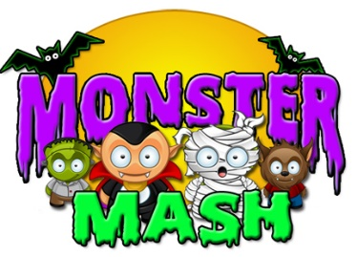  Dance Competition | Marshmallow Toss | Pumpkin Stress Balls | Illuminous Art
Cinema Trip
£ tbc per child, please arrive by 9am latest

9:30am  10:30am |  |  | Ridge Woods Nature Walk
 |  | 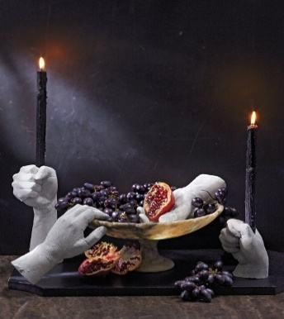  Spooky Candle Holders |  |  | Candy Floss Making  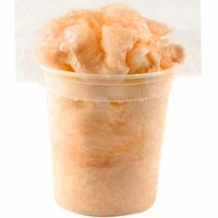
12:00pm | 12pm Lunch time |  | Healthy packed lunch with ice pack for 12pm dinner each day please!
 | 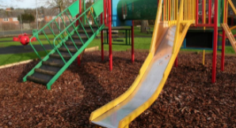  Park Play |  |  | Anti-racism Workshop
1:00pm |  |  |  |  | Web Party Game
2:30pm |  | Individual Apple Bobbing
4:00pm  Closes 6pm |  |  | Paper Plate Designs |  | Spider Making  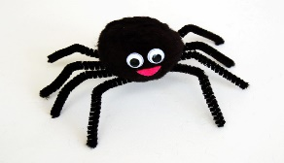
Call Club Owner Sian: Onsite Mobile:
07531 344 549 The booking deadline is Friday 15th October - Don’t miss it! 07784 48 10 32

Email your booking form to us at wapridgewood@yahoo.co.uk

Date  Please tick your selected sessions | Morning Session  (8am-1pm)  £15.15 |  | Afternoon Session  (1pm-6pm)  £15.15 |  |  |  |  | All Day Care  (8am-6pm)  £22.10
Mon 25th
Tues 26th
Weds 27th
Thurs 28th | Cinema +£ tbc |  |  |  |  |  |  | Cinema +£ tbc
Fri 29th
Please note that trips are compulsory and there will not be an option of staying at Club.
We welcome suggestions for competitively priced trips and visitors to continue to keep fees low.

By booking certain dates, you are giving your consent for Wild About Play staff to take your child/children off Club premises, to travel by Club mini-bus or coach company, to the stated trip destination or take part in a particular activity.
Name/s of Children: |  |  |  |  |  | Age/s during the October Holidays:
Name of parent/carer: |  |  |  |  |  | Telephone number:
Home Address:
(House number & Post-code)
Email address: |  |  |  |  |  | School:
Please circle payment type: |  |  |  | BACS | Childcare Vouchers | Cash no longer accepted |  |  | Cheques no longer accepted
Signature: |  |  |  |  |  | Date:
October 2021 Holiday Club Booking Form

The booking deadline is Friday 15th October - Don’t miss it!

