Amelia-Nottoway Technical Center News 4/30/2021

**ANTC STUDENT SPOTLIGHT!**

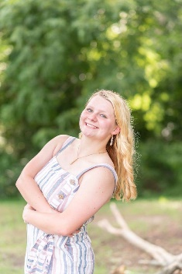 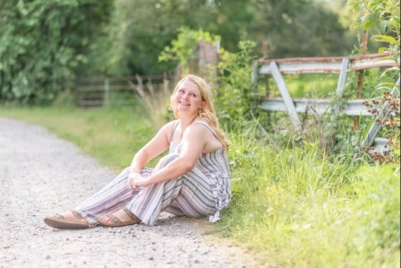 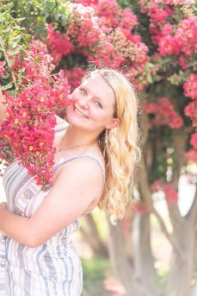

**Alyssa Tolbert - NHS Senior Medical Assistant I**

**What brought you to ANTC?**Casey talking about how fun the medical assisting class is.

**What is your dream job?**Owning a facility that houses different animals to care for.

**What is your favorite class that you have taken so far? Why?**Medical Assisting, because it always keeps my attention and is interesting.

**What is the best advice you have been given by your instructor at ANTC?**It is okay to make mistakes, it's part of being a human.

**What is your favorite memory at ANTC?**Choosing a disease and having my classmates diagnose me.

**What was the first feeling you had when you attended ANTC?**  I was nervous.  I only knew one person, but that feeling faded quickly.

**What words of wisdom do you have for other students?**Take a class at ANTC.  Regardless what program it is, Auto Body, Cosmetology, or Medical Assisting all of the teachers really care for all of the students, not just the ones in their program.

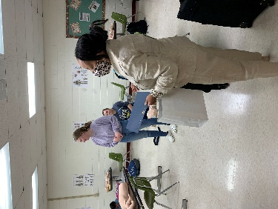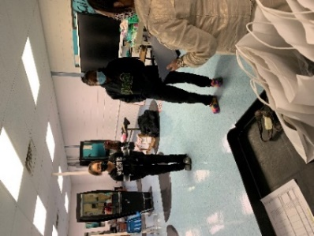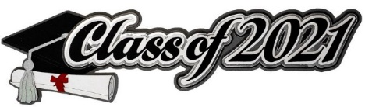

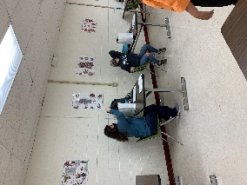

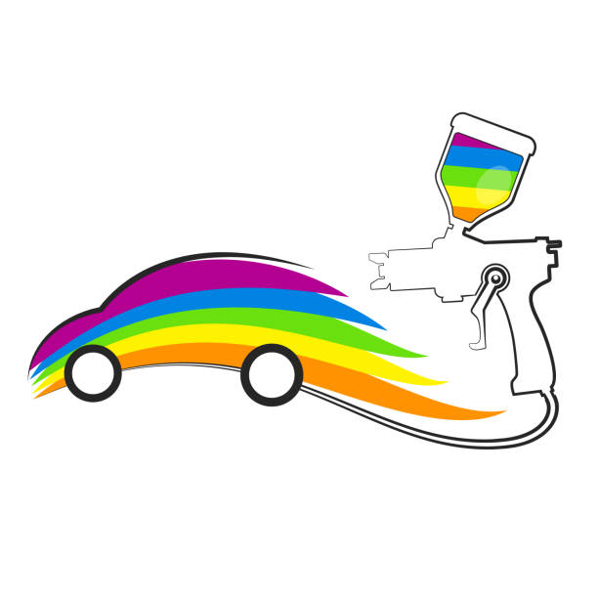

**Program:** Auto Body l & II; Amelia and Nottoway

**Skills:** Welding and Vehicle Prep

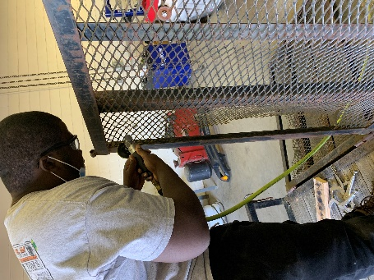 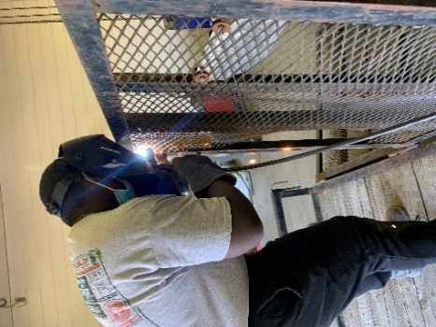 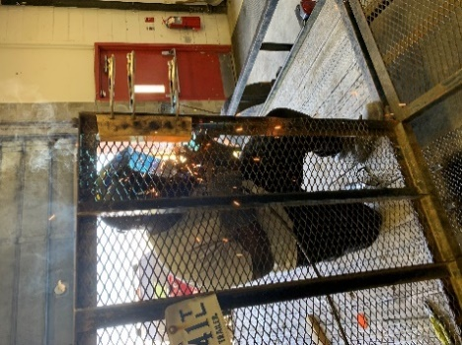

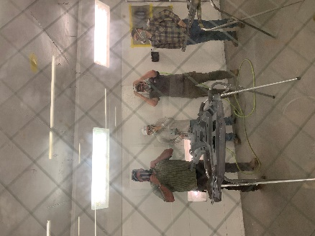

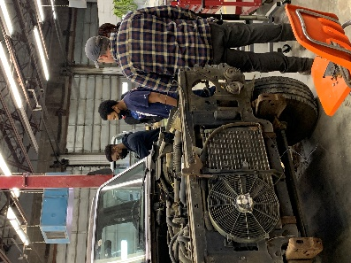 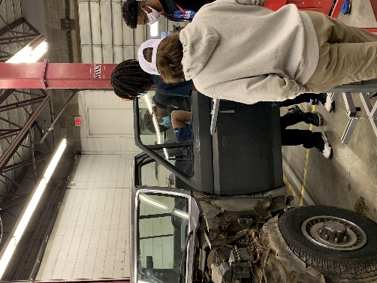



**Program:** Cosmetology l & II

**Skills:** Relaxing, Styling, and Inventory

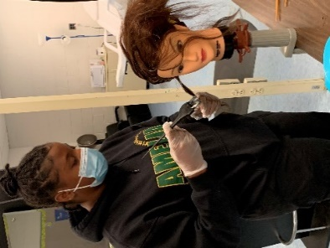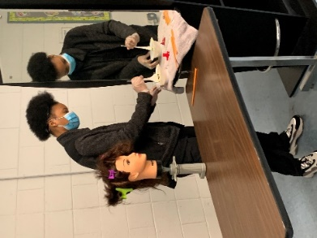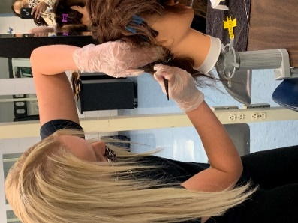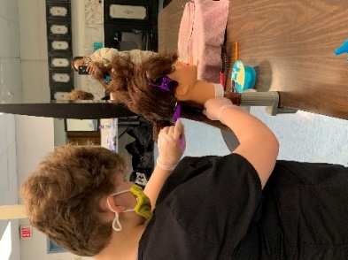

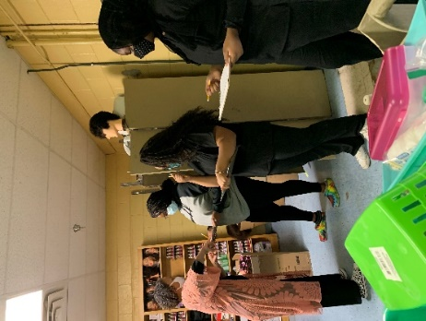 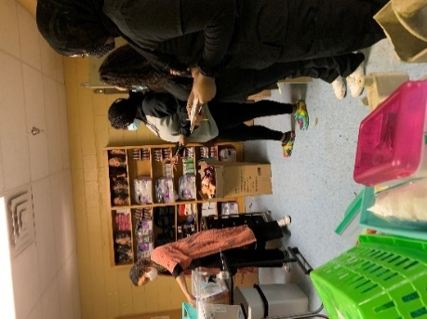

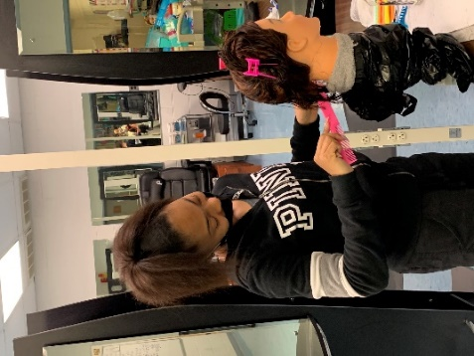

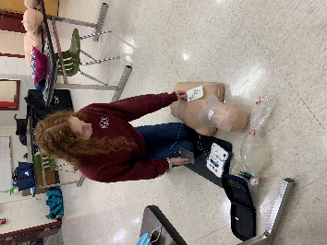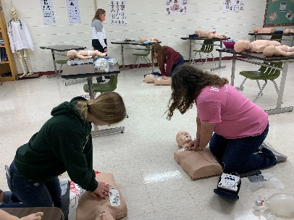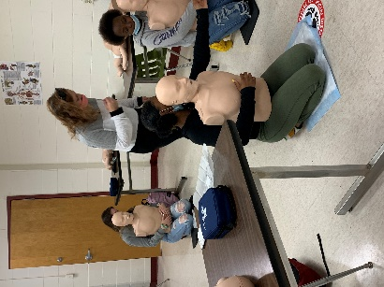 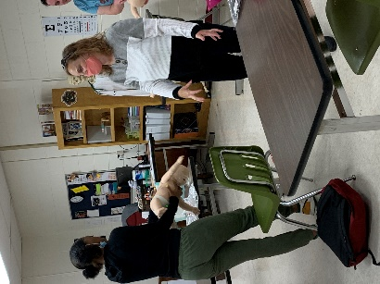 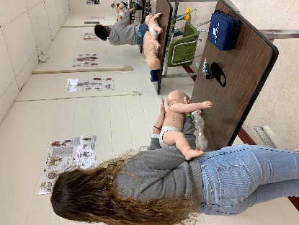 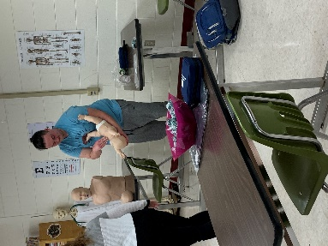

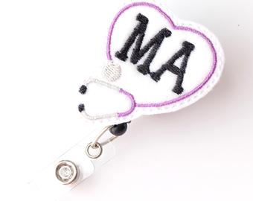

**Parent Presentation**

**Kaitlyn Jordan**

**Program:** Medical Assistant I & II

**Skills:** CPR – Adult and Pediatric

