Table of Contents
Table of Contents 1
1 SPECIFICATION FORM DOCUMENTS 5
1.1 FORMS ORGANIZED BY DATA OWNER AND INTEGRATED IN A SINGLE DOCUMENT 6
1.1.1 Operating Parameters Data Ownership 6
1.1.2 Device Specification Data Ownership 6
1.1.3 General or Special Requirements Data 6
1.2 FORM TERMINOLOGY BASIS AND CONTENT DIFFER BY PART 6
1.2.1 Operating Parameters Terminology and Content 6
1.2.2 Device Specification Terminology and Content 6
1.2.3 Component Type Terminology May Vary Over Lifecycle 7
1.2.4 Basis of Component Type Terminology 7
1.2.5 Field Prompt Terminology Clarified “By Example” Pick List 7
1.2.6 Application Service Terminology Assist Manufacturers 7
1.3 MODERNIZED LOOK-AND-FEEL OF WORD 2010/2013/2016/2019/365 XML FORMS 8
1.3.1 Immediate Distinction of Forms with Enhanced Functionality 8
1.3.2 Word’s Content Control Web Style Placeholder Text 8
1.3.3 Standard and Modified Placeholder Text 8
1.3.4 Hidden (blank) Placeholder Text 9
1.3.5 Clarified Field Prompt Choices of Preferred Values 9
1.3.6 Drop-Down List with Auto-Seek for Choosing Standardized/Preferred Values 9
1.3.7 User Defined Logo 10
1.3.8 Simulated Header and Footer Repeating Values for Multipage Forms 10
1.3.9 Date Picker for Entering Dates 10
1.3.10 Display of Robust Data Entry Field Title 10
1.3.11 Support for Multiple Lines of Data 11
1.3.12 Enhanced Data Formatting 11
1.3.13 Enabled Spelling Checker 11
1.3.14 Protected Form Design 11
1.3.15 Coordinated Multipage Form Titles and Page Files 12
1.3.16 Subtitle Identification of Main (Device) Component Type 12
1.3.17 Free Formatted General or Special Requirements Content 12
1.4 MODERNIZED CONTENT AND TERMINOLOGY OF FORMS 14
1.4.1 Updated or New Operating Parameters Properties 14
1.4.2 Line Operating Parameters 14
1.4.3 Support for Improved Calculation Programs 14
1.4.4 Updated Pick List for Manufacturers 2017-2020 Data 14
1.4.5 New Communication Inputs and Outputs Section 15
1.4.6 Expanded Calibration and Test Section Page 15
1.4.7 Choosing or Editing of Calibration and Test Section Measurement Descriptions 15
1.4.8 Software Configuration Documentation 16
2 MACROS PROVIDE ENHANCED WORK PROCESS FUNCTIONALITY 16
2.1 MACRO SECURITY 16
2.1.1 Notification and Enabling Macros Using Form Loader Dashboard 17
2.1.2 Notification and Enabling When Directly Viewing a Document File 17
2.2 HELP FUNCTIONALITY 18
2.2.1 Context Sensitive Help Definitions 18
2.2.2 Form Application User Help 19
2.3 NUMERIC DATA VALIDATION 19
2.4 OPTIONAL ADD-TO-LIST FUNCTIONALITY 20
2.4.1 Identify List Change Options 20
2.4.2 Document Recommendations for Changes 21
2.5 OPTIONAL COPY & PASTE ALL SOURCE DATA 22
2.6 REQUIRE DOCUMENT NUMBER BEFORE SAVING 23
2.7 ASSISTED SAVE FILE CONTENT AS *.DOCM WORK PROCESS 24
2.8 SAVE SELECTED DATA TO INSTRUMENT INDEX DATA TABLE 25
2.9 SUPPRESS PRINTING OF OPTIONAL GENERAL OR SPECIAL REQUIREMENTS PAGES 25
3 FACILITATE ENHANCED WORK PROCESSES USING COPY CAPABILITY 26
3.1 COPY OPERATING PARAMETERS DATA FOR CONSISTENCY 26
3.1.1 Operating Parameter Data for Lines Containing One or More Instruments 26
3.1.2 Operating Parameters Data for Vessels Containing One or More Instruments 26
3.1.3 Copy Line Operating Parameters Data to Device Specification Forms 26
3.1.4 Copy Operating Parameters Data from a Form Developed Earlier 26
3.1.5 Copy Operating Parameters Between Device Specification Forms 26
3.2 COPY TYPICAL DEVICE DATA FOR EFFICIENCY 26
3.2.1 Create Library of Typical Device Specification of High Usage Devices 26
3.2.2 Create Library of Typical Device Specification of Auxiliary Devices 26
3.3 CHANGE THE DEVICE SPECIFICATION FORM FOR A SPECIFIC TAG 26
3.4 COPY DATA BETWEEN SIMILAR TAGS OR APPLICATIONS 26
3.5 COPY DATA FROM SELECTED MANUFACTURER’S COMPLETED FORM 26
3.6 COPY SELECTIVE FIELDS TO INSTRUMENT INDEX DATA TABLE 27
4 WORK SHARING OR COLLABORATION 27
4.1 EDITING DOCUMENTS WITHOUT FORM LOADER DASHBOARD 27
4.2 MANAGING EXTERNALLY EDITED DOCUMENT REVISIONS 28
4.3 REVIEW MANUFACTURER(S) SPECIFICATION EXCHANGE DOCUMENTS 29
4.4 EVALUATE ALTERNATE PROPOSALS 29
5 CUSTOMIZABLE TEMPLATES FOR OPTIMIZED WORK APPLICATIONS 29
5.1 EDIT OUT-OF-THE-BOX TEMPLATES 29
5.2 MANAGE CUSTOMIZATION OF TEMPLATES PICK LIST CHANGES 29
5.3 EDIT DROP-DOWN CONTROL PICK LIST 30
6 USE OF TYPICAL FORMS 32
7 DATA INTEGRATION WITH WORD/SHAREPOINT DOCUMENT PROPERTIES AND METADATA 33
7.1 DATA INTEGRATION WITH WORD/SHAREPOINT DOCUMENT PROPERTIES 33
7.2 CUSTOM DOCUMENT PROPERTIES 34
7.3 DOCUMENT METADATA MAPPED TO INTERNATIONAL STANDARDS XML COREPROPERTIES 34
7.3.1 CoreProperties Mapping 34
7.3.2 Microsoft Office Cover Page Properties Mapping 34
7.3.3 Office Document Extended-properties Mapping 35
8 INTEGRATED FORM LOADER DASHBOARD 35
8.1 OPERATING PARAMETERS FORM 35
8.2 DEVICE SPECIFICATION FORMS by FORM NUMBER 35
8.3 DEVICE SPECIFICATION FORMS BY COMPONENT 36
8.4 MULTIPLE EDIT SESSIONS AND REVISION MANAGEMENT 37
8.5 HELP AND TUTORIAL LINKS 38
8.6 INTEGRATED INSTRUMENT INDEX DATA BROWSER 38
8.6.1 Selected Specification Form Data Subset 38
8.6.2 Browse Specification Form Data and Status 39
8.6.3 Extended Manual Data Entry Instrument Index Fields 40
8.6.4 Comparing Safety Design Conditions 41
8.6.5 Instrument Index Custom Reports for Deliverables 41
9 DATA MAPPING AND EXCHANGE 41
9.1 XML MAPPING CAPABILITIES 41
9.2 DATA EXTRACTION AND EXPORT 41
10 FREQUENTLY ASKED QUESTIONS 41
Answer: This information can be ignored, as it only means that the protection scheme of the main view can not be applied to other views. Only the main view needs such protection! 42
11 TERMS of USE 42
12 FEEDBACK 43
13 DOWNLOAD AND APPLICATION SETUP 44
13.1 WEBSITE DOWNLOAD OF INSTALLATION FILES 44
13.2 WORKING WITH THE DOWNLOADED INSTALLATION FILES 45
13.3 INITIAL INSTALLATION 46
13.4 UPGRADE INSTALLATION 48
Annex A Specification Templates List 50
TABLE 1 - Operating Parameter Device Categories and Form Titles 50
TABLE 2 - Device Specification Categories and Form Titles 50
ANNEX B INSTRUMENT INDEX DATA LIST 55
TABLE 3 - Specification Form Integrated Data 55
TABLE 4 - Manual Data Entry Properties of Instrument Index Data Table 57
TABLE 5 - Manual Entry Instrument Index Property Dropdown List 58
TABLE 6 - Custom Views of Instrument Index Data Table 60

1 SPECIFICATION FORM DOCUMENTS

Instrument Specs and Index aims to provide crowd sourced tools for instrument device design documentation and consistent product driven specifications, to optimize the “suitable for use” determinations and facilitate documenting a complete device, accessories, and related software configuration data for the purchase of these devices.
It is the intention of Instrument Specs and Index to handle any kind of instrument offered by multiple competing manufacturers which publish their technical data on the Internet. Therefore, frequent revisions and addition of new specification templates is a goal and expectation.
The historically available specification forms are primarily applicable with processes for continuous flow of fluids or level measurement. This set of forms greatly broadens applications to represent those instrument devices used with:
- Parameter analysis
- Pharmaceutical and hygienic application
- Sampling systems and water/wastewater analysis
- Material handling
- Bulk solids processing
- Machinery monitoring and protection
- Environmental monitoring
- Agricultural monitoring
- Fire monitoring and alarming
- Weight based batch control
- Weather monitoring
- Multivariable and Multifunction devices

A perspective of the magnitude of available Device Specification forms over the last 40 years is identified by comparison to two major publishing as shown below.

Form Basis | ISA 20  1981 |  | ISA-TR20-00.01 | InstrumentSpecsandIndex  2021
 |  |  | 2001
Analyzer forms | 0 |  | 8 | 50
Valve forms | 5 |  | 9 | 22
Flow forms | 5 |  | 19 | 50
Level forms | 4 |  | 14 | 37
Pressure forms | 4 |  | 11 | 24
Temperature forms | 4 |  | 9 | 15
Multivariable forms | 1 |  | 2 | 16
Weight | 0 |  | 2 | 8
Speed | 0 |  | 0 | 10
Machinery Analysis Safety | 0 |  | 0 | 4
Others | 3 |  | 4 | 19
Total Device forms | 26 |  | 78 | 255
Single page/short forms |  | 15 | 16 | 136
Standard multipage forms |  | 11 | 62 | 117
Operating Parameters forms |  | 0 | 10 | 18

- See Annex A Specification Template List

These specification documentation work processes and user interface techniques have been in use for decades in large integrated software applications but are unknown to previously have been available for individual form files. Therefore, many of the descriptions of this document are primarily new in the depth of their application and availability using basic Microsoft® software applications.

FORMS ORGANIZED BY DATA OWNER AND INTEGRATED IN A SINGLE DOCUMENT

The use of Operating Parameters and Device Specification forms encompass the major life cycle activities of instrument specification documentation activities. Such work process activities are generally accomplished by multiple individuals within disparate departments and external partners, such as manufacturers or vendors.
The intended use of the specification form, such as a document for preliminary inquiry and quotation, a traditional specification, or a conforming specification, can affect how much of the form content is required to be used to accomplish the respective objectives.

1.1.1 Operating Parameters Data Ownership
The Operating Parameters Part documents the design conditions for which the selected instrument device must be “suitable for use”. Its data is entered and owned exclusively by the Responsible Organization’s various departments.

1.1.2 Device Specification Data Ownership
The Device Specification Part documents the proposed and eventually agreed upon, instrument device offered by the manufacturer, intended to meet all requirements of the purchaser.
- Note that device specification work process is generally a collaborative effort between the specifier and the device manufacturer. The specifier should enter device data primarily for those properties where experience has established a strong preference and allow the manufacturer to offer standard product properties based upon application experience and product performance data.
The specifier should direct the manufacture to fully document the device’s properties as grouped on the specification form. Negotiations often need to resolve final properties, but the final device documentation should accurately reflect the manufacturer’s data for the purchased device.

1.1.3 General or Special Requirements Data
All forms include the optional General or Special Requirements Part which documents any significant aspects that are not captured within the other sections and can be used by both the specifier and the manufacturer to clarify such issues that need to be agreed upon for completing the work activity. This form part will not print if no data has been entered.

1.2 FORM TERMINOLOGY BASIS AND CONTENT DIFFER BY PART

1.2.1 Operating Parameters Terminology and Content
The Operating Parameters Part attempts to maintain “technically correct”, most recent revision, terminology of national, international, and recognized sizing calculation programs. Their pick list values originate from such organization sources; whenever available.

1.2.2 Device Specification Terminology and Content
The Device Specification Part attempts to be inclusive of all reviewed device manufacturers literature and therefore frequently needs to generalize field prompts in each subsection. The pick list data is generally inclusive of all reviewed literature as well as common preferred values that can assist in promoting consistent terminology; where applicable.

1.2.3 Component Type Terminology May Vary Over Lifecycle
The “Component Type” data is the highest-level classification terminology of a device, but its value may depend on its context throughout the lifecycle of specification documentation. This property may represent a degree of precision that is appropriate to the specific stage of a work process.
- During the initial engineering phase of P&ID development or Process Engineering, the device types associated with the Instrument Symbols and Identifications as documented in ANSI/ISA-5.1-2009 graphic symbols, may be sufficient for the intended use. Those component type names from Table 5.2, are included for use in the Operating Parameters Specification forms pick list.
- After subsequent evaluation of project specific instrument design guidelines, it may be desirable to improve a flow device classification to “positive displacement meter”
- When the manufacturer has determined the final recommended device, this field’s data may be improved in precision to “helical gear flowmeter”

1.2.4 Basis of Component Type Terminology
- Generalized device degrees of precision as identified above
- Differing prevailing terminology practices for generalized device classifications such as meter, monitor, transducer, sensor, probe, gauge, module, alarm, etc.
- Synonyms such as “by-pass level indicator” versus “magnetic level gauge”
- Prefixed with “sanitary” to allow searching based upon this usage
- Common application based such as “counting scale” or “prescription scale”
- Function identification like “level transmitter” versus construction style such as “differential pressure transmitter”
- Multifunctional inclusiveness such as “diff press ind w/switch” or “w/seals”
- Require abbreviated terms due to limited field length, such as “xmtr” vs “transmitter”
- Legacy terminology from before specific device standards were published

1.2.5 Field Prompt Terminology Clarified “By Example” Pick List
The nearly universal use of drop-down pick list can clarify the field prompts context, especially when abbreviations are used, or the forms are used by international users or manufacturers.
- Reviewing the precision, breath, and syntax of listed values can assist users, especially when new item values are being considered as appropriate.
- Recognizing familiar values can build confidence in the quality of the data being entered.
- Consistent use of “NA” for not applicable properties, minimizes assumptions about possible incomplete data entry and allows the Instrument Index Data calculated completion to more correctly calculate % completed data.

1.2.6 Application Service Terminology Assist Manufacturers
Synergy between the specifier and the manufacturer can be enhanced with the usage of application terminology values, familiar to manufacturers expertise.

1.3 MODERNIZED LOOK-AND-FEEL OF WORD 2010/2013/2016/2019/365 XML FORMS

1.3.1 Immediate Distinction of Forms with Enhanced Functionality

The form’s subsection title highlighting uses a pleasant tan; to immediately make it evident that the user is working with a significantly different work product. This coloring is significant to developers, administrators and others that are frequently working between old files and the new files, and when trouble shooting or assisting users who question how their form is acting.
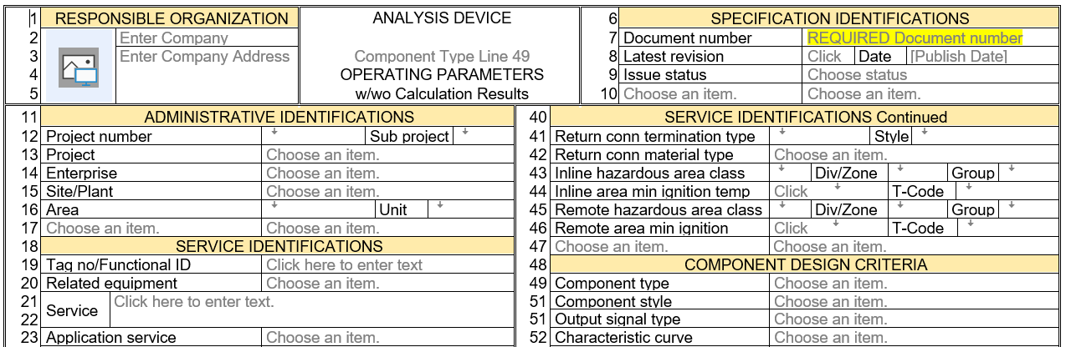

1.3.2 Word’s Content Control Web Style Placeholder Text
Word’s XML integrated Content Controls utilize Web style placeholder text (PHT) that is automatically displayed for all Text Box and the Combo Box controls that have not had data entered. These data placeholder messages can be especially useful to provide user assistance with understanding expectations and data status, such as:
  - Identifies unprotected areas of the form where data should be entered.
  - Identifies where the user can Choose an item from a list of suggested/preferred values
  - Identifies where the user should Click to enter text without a list
  - Provides data entry field content identifications/description where controls do not have an associated label, such as Company and Company Address fields
  - Identifies user definable Field Prompt and Value locations for data entry
User definable field prompts for a units value is not required if the field value is not numeric. Therefore, such units field pick list includes a blank value that results in hiding the PHT text and icon.
  - Identifies presence of required unit of measure data entry fields directly associated with their numeric data entry field.
The absence of visible placeholder text is implemented for Process Condition data numeric fields that have a visible units content control and frequently are not ALL required for any specific device application.
  - Identifies expected data entry fields that have yet to be evaluated and appropriate data entered or identified as “Not Applicable” (NA)
  - Data entry fields that may require data entry in future document revision and approval lifecycles

1.3.3 Standard and Modified Placeholder Text

- Identification of Available Integrated Pick List Values
Default placeholder text = Choose an item
Modified placeholder text ꜜ symbol; used where inadequate data entry field width occurs for allowing the default placeholder text

- Directly Enter Text without Available Integrated Pick List Values
Default placeholder text = Click here to enter text
Truncated placeholder text = Click (used where inadequate field width occurs for default placeholder text)

1.3.4 Hidden (blank) Placeholder Text
Non-visible placeholder text (5 space characters) is utilized on the Operating Parameters pages for Process Condition data numeric fields that have a visible units content control and frequently are not ALL required for any specific device application.

1.3.5 Clarified Field Prompt Choices of Preferred Values
Where generic field prompts of similar fields could be ambiguous, the use of custom placeholder text has been applied to clarify the distinction between such field prompts, such as shown below:
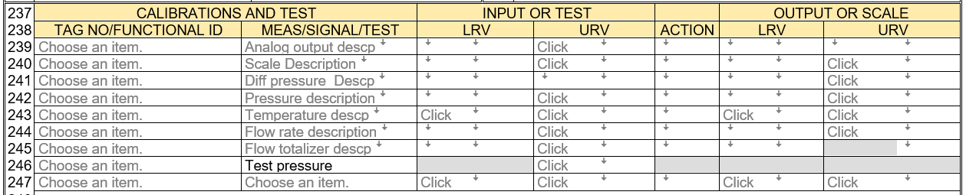

1.3.6 Drop-Down List with Auto-Seek for Choosing Standardized/Preferred Values

Fields with Choose an Item Placeholders text or ꜜ symbol will display a drop-down list icon which, when clicked, will open a list of standardized or preferred values for that field. Auto-seek functionality will move the item selection highlight to the first record matching any key that is typed, to speed up the process of navigating to any specific listed item.
Review of those list values will frequently clarify the intended information where the field prompt is not self-explanatory.
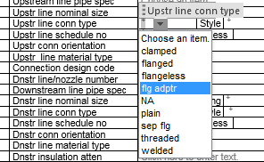

- Note: Any value not in the list can be entered and will be saved; after the Not-in-List message box has requested the optimized action from the user.

1.3.7 User Defined Logo

The user can select the appropriate Logo for insertion into the document’s Responsible Organization section, with the user-friendly interface.
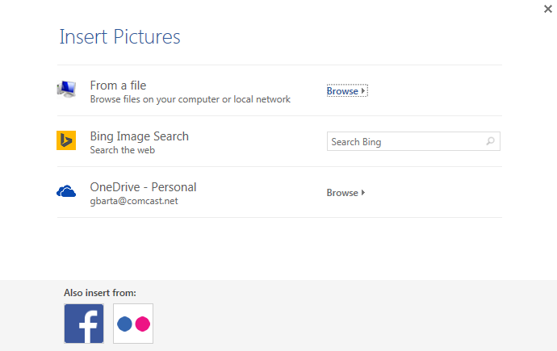
- Note: The Responsible Organization is the device owner’s representative responsible for documenting compliance with all legal requirements and “Good Engineering Practices”. This almost never is the organization whose created the blank form. The Responsible Organization’s name and location are located immediately to the right of their logo, to provide additional identification information.

1.3.8 Simulated Header and Footer Repeating Values for Multipage Forms

The data entry field values located in the header and footer simulated form sections; will automatically repeat their values to all pages of the document.

1.3.9 Date Picker for Entering Dates
Web Style Date Picker is used wherever a date entry is required, as shown below:

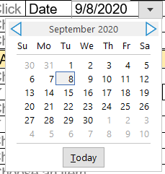
- Note: The date text will be entered and displayed using the active date format that is enabled on the computer being used. (International versus County format)

1.3.10 Display of Robust Data Entry Field Title

The full and robust Content Control Title for those locations with minimal width can be especially useful in confirming the intended content, such as seen below:

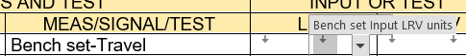

1.3.11 Support for Multiple Lines of Data

A few configured data entry fields can optionally support multiple lines of text, including:
- Company Address
- Form Title (Subject) not editable by user
- Service (description)
- Remarks (comments)

1.3.12 Enhanced Data Formatting
Word’s full capabilities to enhance the display of data entry values are available, including:
- Bold
- Italic
- Underline
- Strikeout
- Highlight color
- Font color
- Font type or size
- Data alignment
- Any combination of the above

This can be especially useful to convey when data has been changed or needs special attention; as shown below.

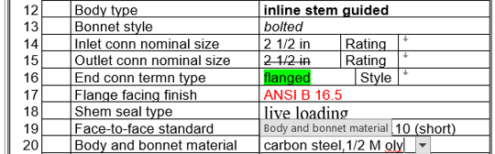

1.3.13 Enabled Spelling Checker
Word’s standard spell-checking functionality is enabled and will display suspected errors with red underline, as shown on above line 20 data.

1.3.14 Protected Form Design
Use of XML’s enhanced protection from users making changes to the form’s content other than the designated areas for data entry is enforced, while still allowing Word’s enhanced data formatting capabilities.
- Note: Most forms implemented in Excel or text editors, do not provide security against users revising their field prompts. Their only mechanism for form design security is to save and exchange the files as noneditable PDF files. Such totally secured files require the recipient to use alternate documents to return his specification data and the specifier to correlate data and enter it into the original unsecured document.

1.3.15 Coordinated Multipage Form Titles and Page Files
The correct Operating Parameters page, and one or more Device Specification pages, and the optional General or Special Requirements page are integrated into a single form file. This eliminates previous errors associated with managing multiple files of individual pages representing a single device specification.
- Note: The Title (subject) of the Operating Parameters page is properly adjusted when such a page is used as a standalone form or as the first page of a multipage device specification form.

1.3.16 Subtitle Identification of Main (Device) Component Type
Form titles frequently need to use generalized subject terminology when multiple types of similar instruments are within the scope of that form. Therefore, Form Titles (Subject) are enhanced to include a Subtitle identifying the main Component Type (the highest-level classification terminology of a device), such as “CHROMATOGRAPH ANALYZER”. This component type data is selected by the user when the form is first initialized.
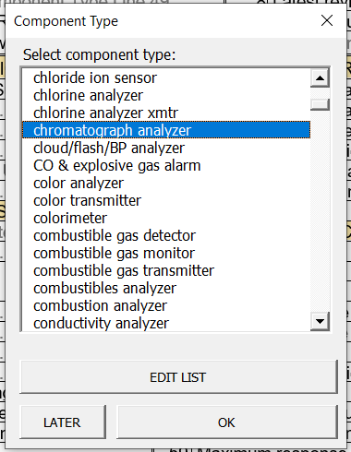
The Component Type data can be changed at any later time by using the Content Control.

After entering a Component Type value, that value will be added as the subtitle.
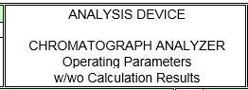

1.3.17 Free Formatted General or Special Requirements Content
All forms include the optional General or Special Requirements Part which documents any significant aspects that are not captured within the other sections and can be used by both the specifier and the manufacturer to clarify such issues that need to be agreed upon for completing the work activity. This form part will not print if no data has been entered. This section allows:
- Direct data entry or copy and paste of extensive formatted content incorporating all of Word’s formatting functionality, including embedded pictures
- Internet URL links to supporting material or Websites
https://www.emerson.com/documents/automation/Product-Data-Sheet-Rosemount-114C-Thermowells-en-80170.pdf
- Copied and pasted files for viewing or extracting files to other locations
- Insert any of Words illustration objects

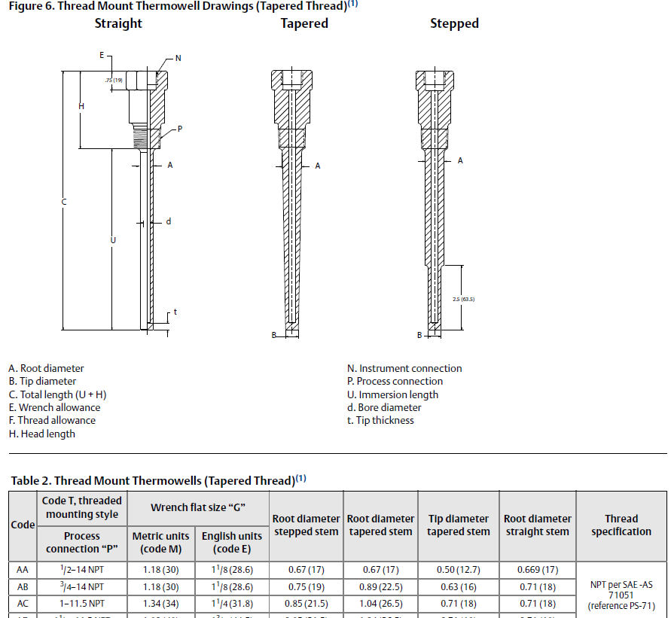

- Copy properties from Part1 or Part 2 which will include their picklist and past multiple times to emulate multi choice pick list selections
Compliance standard | 3A sanitary standard
Compliance standard | ASME BPE
Compliance standard | NACE® MR 0175-2002
Compliance standard | USP CLVI
Compliance standard | 21CFR 177.2600
Compliance standard | FDA

- Functionality to automatically build the required Table of Contents from entered data using Heading 1, Heading 2 and Heading 3, can be activated by clicking the Update Table Icon.
- Insert and manage resolution of Words comment functionality.

- Let your imagination open to the endless possibilities of Word’s inherent functionality

1.4 MODERNIZED CONTENT AND TERMINOLOGY OF FORMS

1.4.1 Updated or New Operating Parameters Properties

- “Application service” property has been added to list common applications that assist manufacturers in including design experience common in such applications.
- Criticality code has been updated to “Criticality classification” to harmonize with other standards and significantly broaden the list of such classifications.
- Max EMI susceptibility has been updated to “EMC class” and Reference, to replace obsolete standard reference and harmonize with IEC classifications.
- NFPA health hazard has been updated to “GHS health hazard” to replace obsolete standard reference and harmonize with UN international guidelines.
- Base pressure and Base temperature have been added as appropriate, to document the basis of normalized flow rate data.
- Units of measure of values of “1” or “NA” have been added for use with SI unit symbols, for those variables that the US usage considers as dimensionless.

1.4.2 Line Operating Parameters
This release also includes a form for documenting and approving line operating conditions at the earliest stage of a project. Such data can subsequently be easily copied to Device Operating Parameter and Device Specification forms.

1.4.3 Support for Improved Calculation Programs
- All the known calculation programs for sizing Control Valves and Differential Pressure Transmitters with diaphragm seals were investigated and those forms were upgraded to provide all data required to perform the improved calculations.
- Form C2501 Thermowell or Protecting Tube Assembly has added additional fields to document the ASME PTC 19.3 TW-20 2016 calculations.

1.4.4 Updated Pick List for Manufacturers 2017-2020 Data
The pick list data for devices has been updated with manufacturers data sourced from Internet searches and typically included:
- Commonly more global or non-US manufacturers than US manufacturers
- 20-90 downloaded searchable PDF files per form
- Frequently technical data content approaching that recommended by IEC 61987
- Tables specifically identifying the manufacturer’s required properties and codes to build their intelligent model numbers
- Installation instructions which is used to understand recommended accessories
- Device software configuration instructions used to identify standard digital signal options and their allowable calibration units
- Local operator interface (HMI) optional features and programmability
- Agency certification options and details
- Remote interface and diagnostic software options and configuration

The exposure to the extensive breadth of non-US manufacturers literature referenced above, has resulted in the inclusion of pick list values referencing back to international design piping standards as applicable to the end connections of instruments.
- Metric
- EU
- UK
- German (DIN)
- Japanese
- South Korean
- US
With respect to the properties of:
- End connection nominal sizes
- End connection nominal pressure rating
- End connection style
- End connection facing finish
- Face-to-face standards
- Material of construction

1.4.5 New Communication Inputs and Outputs Section
Many instruments now include functionality to accept external instrument signals to be used to compensate their primary measurement or to act as local data collection centers for concentrations of local instruments. Multiple digital output signals are also common to facilitate communications with remote control systems for software configuration, workstations, or inventory management systems. Wireless communication capability is also becoming widely available.
A new form section has been added where appropriate, to document the requirements for the multiple signal inputs and outputs for those instruments that have such extensive signal capability. This information should be adequate to define the coded model number for such instruments.

1.4.6 Expanded Calibration and Test Section Page
When more than 8-10 lines are required to document the Calibration and Test section signals, an addition page will be used which can accommodate about 50 lines of Calibration and Test documentation. This page should accommodate most applications, although some instruments are capable of interfacing with hundreds of signals. If more lines are required to document the Calibrations, then the option General or Special Requirements page should be used to address the data, for the remaining signals.

1.4.7 Choosing or Editing of Calibration and Test Section Measurement Descriptions

1.4.7a Calculated Variables
Many multivariable instruments are now capable of calculating variable properties that are related to the instrument’s measured variable or compensating the measured variable based upon a second variable or a stored correlation table. Where such options have been identified by instrument manufacturers, the appropriate Calibration and Test Section’s Measurement descriptions have been upgraded to a pick list of known alternatives. As with all pick list, new Measurement descriptions can be added to unambiguously identify other required variable signals.
Examples of such variable measurement descriptions include:
- Humidity, Dewpoint, Enthalpy, Frostpoint, Mixing ratio, Wet bulb temperature, Haze, Referred humidity, Relative humidity, Absolute humidity
- Specific gravity, Density, Concentration, % Solids, Net solids, API Degree, Base density, Brix, Referred density, Alcohol proof
- Viscosity, Referred viscosity, Kinematic viscosity, Intrinsic viscosity, Apparent viscosity, Base viscosity
- Specific ions, Surfactant, Residual chlorine, Water hardness
- Turbidity, Opacity, Optical density, Absorption, Particulate, Color

1.4.7b Distinction of Multiple Output Signals
Many single and multivariable instruments are capable of outputting multiple output signals of analog, digital and discrete types. Discrete outputs may be initiated by a single event or frequently are a common output for many events such as waring messages or alarms. Where such dedicated options have been identified by instrument manufacturers, the appropriate Calibration and Test Section’s Measurement output descriptions have been upgraded to a pick list of known alternatives.

1.4.7c Identifying Multiple Scales
Most instrument displays are limited to 1 or 2 variables, due to limited display space, while the instrument may output many more variables on its digital output signal. Especially when calculated variables are available, it may be necessary to provide the appropriate Calibration and Test Section’s Measurement scale descriptions to have a pick list of known alternatives.

1.4.8 Software Configuration Documentation
Comprehensive software configuration documentation is impractical within these forms, primarily due to its manufacturer specific expectations. However, most of such required information is related to the input and output signal properties which can be extensively documented on these forms. If the software configuration is performed by the instrument manufacturer or purchaser, the information on these forms may be adequate documentation when combined with their standard practices that are documented elsewhere.
The signal specific data documented on these forms can be supplemented with standard software configuration practice requirements that can be documented in the optional General or Special Requirements page and may be adequate for the manufacturer’s configuration effort.

2 MACROS PROVIDE ENHANCED WORK PROCESS FUNCTIONALITY

Significant additional functionality has been included to assist the user in maintaining and improving the consistency and technical validity of managed data.

2.1 MACRO SECURITY
The Microsoft macro security setting is being enforced to “Disable all macros with notification” to ensure that the template and form user is notified about their existence and MUST take action to enable them before they take effect.
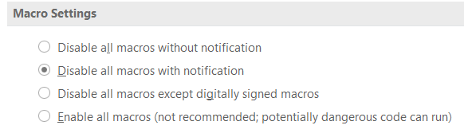
- Note: The Macro Settings option to “Enable all macros” will eliminate notification for any Word file opened, until the Word application setting is changed. This could be a potential problem if multiple users use Word for files other than these documents.
The application will disable all macros until the user has decided whether to enable them. The work process will display equivalent windows depending upon the how the file is being loaded.

2.1.1 Notification and Enabling Macros Using Form Loader Dashboard

After the user selects a template or form to open, the application will immediately display a message window to identify that the user will be required to enable macros.
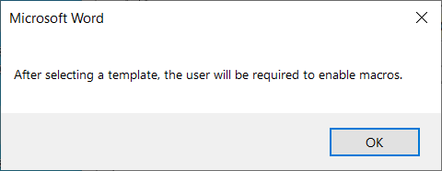
- Click the OK button to proceed to the Microsoft Word Security Notice window.

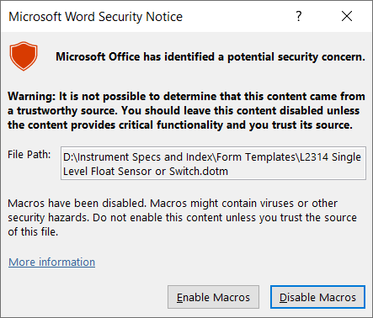
- Click the button to proceed to Enabled Content message.

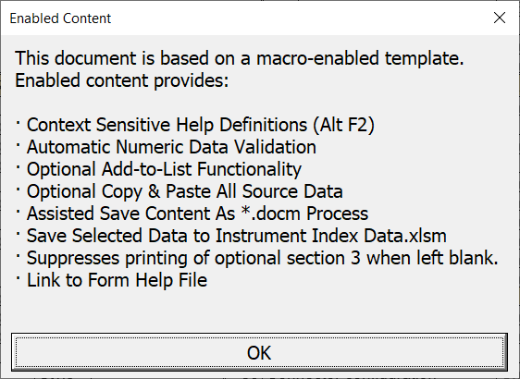
- Click the OK button to proceed to editing the form.

2.1.2 Notification and Enabling When Directly Viewing a Document File
After double clicking on a document file name to view the form, the application will immediately display the Microsoft Visual Basic for Application message window to identify that the user will be required to enable macros.

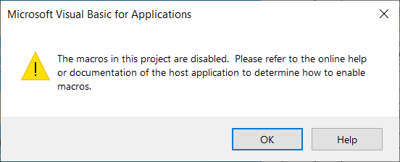
- Click the OK button to proceed to the Microsoft SECURITY WARNING menu option

- There is no need to refer to online help or documentation of the application.

The application will then provide a temporary ribbon to allow the user to click the Enable Content button to enable the macros or ignore that ribbon and edit the template without the active macros.
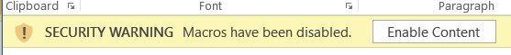
- Click the button to proceed to Enabled Content confirmation.

- Click the OK button to proceed to editing the form.

2.2 HELP FUNCTIONALITY

2.2.1 Context Sensitive Help Definitions
Help Definitions are available for many data entry fields when the user enters those field locations, on the form. The application’s status bar at the bottom of window will display the message to “Press Alt+F2 to display help text”.

If the user presses the Alt+F2 keys, a message window will display the definition such as shown below:
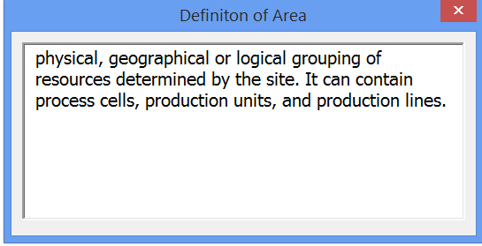

The displayed Help Definitions have generally been copied from various National and International Standards that are applicable to the Instrumentation profession.

2.2.2 Form Application User Help
This Form Help Document has been integrated into the specification forms such that users can easily search for assistance in understanding the special features of the form application.

Start by clicking Word’s standard menu Help option, which opens the sub menu including the Link to Form Help Document:

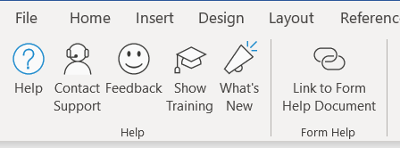

Clicking this custom tab will open the Form Application User Help file.

2.3 NUMERIC DATA VALIDATION
Numeric data validation is enforced for such properties that can have their values Electronically Data Interchange (EDI) with external files that require valid data types.
When the user enters text data into such validated numeric data entry fields and tries to exit that field; the application will produce a warning sound and the status bar at the bottom of window will display the following message:
The user will then need to enter valid numeric data before moving to another location.

- Note: Numeric data entry fields on Operating Parameter forms frequently do not have any Placeholder Text visible on the form but will be followed on their right side by an associated unit of measure field.

2.4 OPTIONAL ADD-TO-LIST FUNCTIONALITY

The option to Add-to-List only applies to the specific document being edited. Therefore, recommendations which should be considered for inclusion on the master template can be documented and transmitted to an administrator for editing of the template.

2.4.1 Identify List Change Options
Whenever a value is entered into a drop-down control that is not a listed item, the Add-to-List functionality interface will open and provides alternatives to assist in the management of pick list enhancements and subsequent template updates.

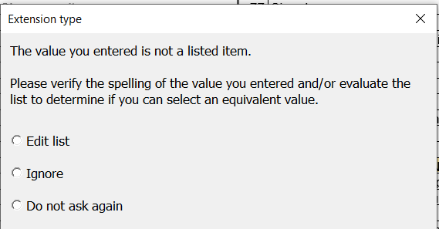

- Select Ignore to bypass any addition to the specific list and its report, which is appropriate for uncommon unique values.
- Select Do not ask again to cancel all future not-in-list message windows until the document has been saved and reopened.
- The Edit list option opens the Content Control Properties window, where the entered (New item) is added to the end of the list.
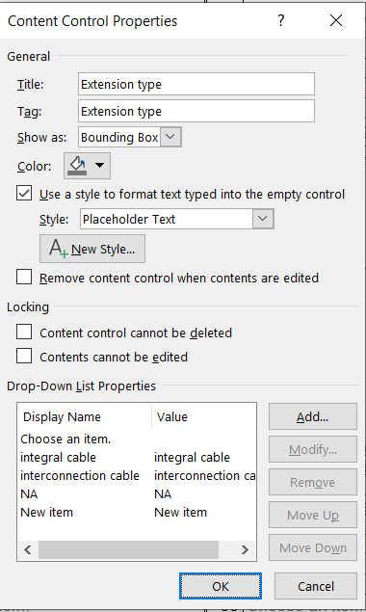

The New item entry can be moved up to sort properly with the existing list items

2.4.2 Document Recommendations for Changes

Clicking OK after editing the Content Control Property will provide access to send a report of all changes to the form.

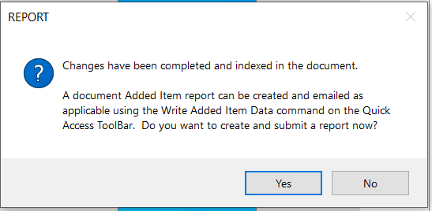

Clicking the Yes button will load the report with its existing data as shown below, and a message window providing an option to delete obsolete item changes.

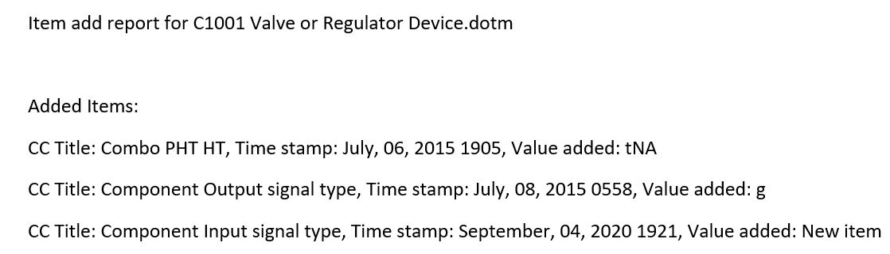

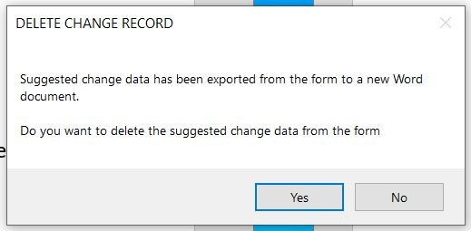

Clicking the No button will open the EMAIL REPORT message window.

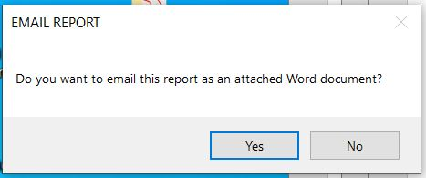

Clicking the Yes button will open the users Email application and attach the report.
Enter the appropriate template administrator email name to resolve change suggestions and click the Send button.

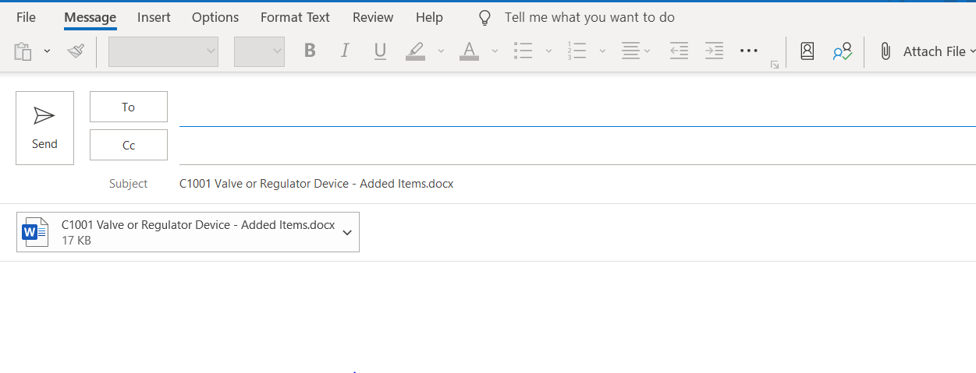

- Note: The user can Write Added Item Data to a word document at any time; by clicking the Quick Access Toolbar menu iconat the top left of the Word window. Sharing that document with the form’s template administrator could allow such items to be added to the master template for all future new documents.

2.5 OPTIONAL COPY & PASTE ALL SOURCE DATA
All data of matching field names in any open active document, can be copied and pasted in a single action, from any source document. (See this document’s discussion of “Facilitate Enhanced Work Processes Dependent Upon Copy Capability” for several common work processes)

Clicking the customized Quick Access Toolbar menu icon at the top left of the Word window, will open Word’s File Open navigation window for selecting the source file to copy data from.

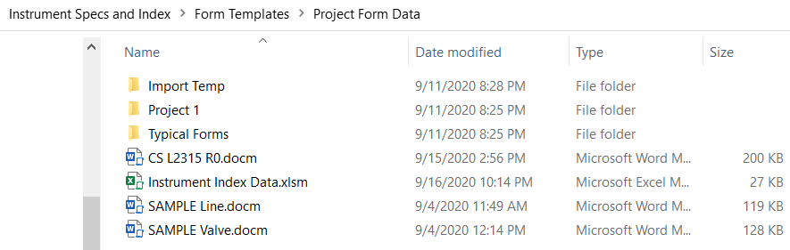
Highlighting the desired source document and clicking on the OK button, will open that document for reference and the Copy Data information window. That window identifies the number of source fields with data that potentially will be copied to the open document, along with the total number of data fields on that source document.

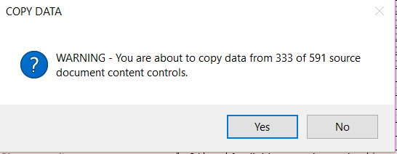

Clicking on the Yes button will open the status bar window identifying the progress of the copy and paste operation.

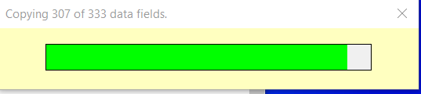

When the copy and paste operation is complete, the open form’s document will be redisplayed with the copied data.

2.6 REQUIRE DOCUMENT NUMBER BEFORE SAVING

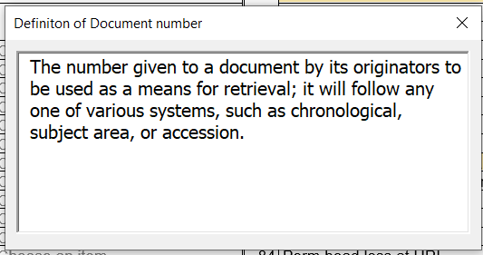

The Document number is key information used for document retrieval in:

- The Form Loader Dashboard
- The integrated Instrument Index Data spreadsheet and browse interface
- Microsoft SharePoint and most other Document Management Systems
- Most software applications that manage electronic specification forms
This field is required and cannot be empty when the form’s data is saved. When new forms are created from a template, the Document number is initially highlighted to emphasize the requirement to enter this data.

2.7 ASSISTED SAVE FILE CONTENT AS *.DOCM WORK PROCESS
When data editing is sufficient for any specific editing session, save the work by clicking Word’s Quick Access Toolbar menu icon at the top left of the program window. A message window will be displayed to inform the user that the automation macros will be saved when the file is automatically saved as a Word document, with the file extension of “.docm”.
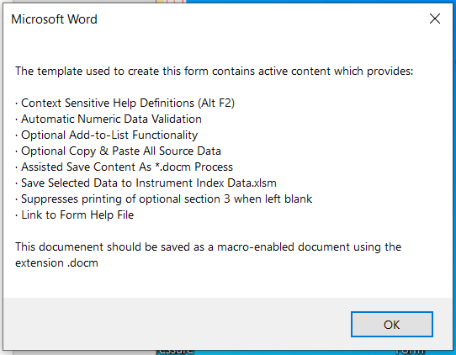
Clicking the OK button will display the File Save As window with the Project Form Data folder listing and the Document number proposed as the file name. This is the desired file name and location unless subfolders have been created for specific projects.
- Note: Subfolders can easily be created by copy and pasting the sample Project 1 folder and naming the new folder.

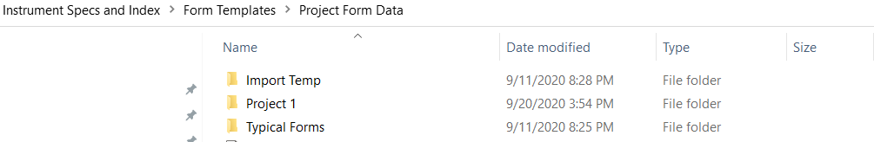

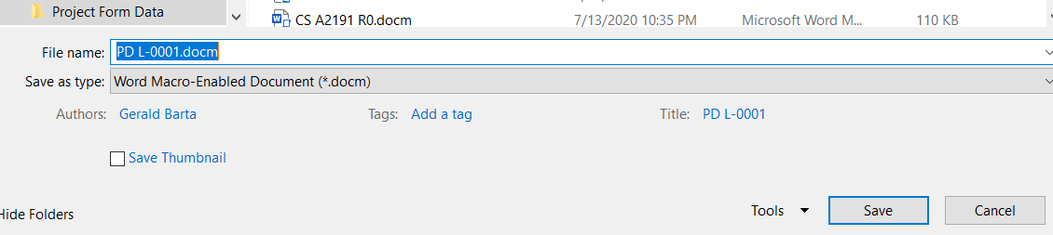

Clicking the 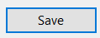 icon will save the Word document file and additionally, after a few seconds, display the message window confirming successfully saving of both the form and the Instrument Index data.
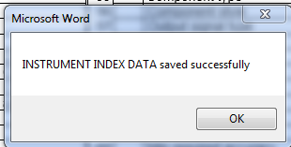

Click the OK button to close this message window and then close the document file by clicking Word’s Quick Access Toolbar menu icon at the top left of the program window.

2.8 SAVE SELECTED DATA TO INSTRUMENT INDEX DATA TABLE
About 80 fields from each specification form are automatically copied to the Excel Instrument Index Data table, whenever a specification document is saved.

Click the OK button to close this message window and then close the document file by clicking Word’s Quick Access Toolbar menu icon at the top left of the program window.

2.9 SUPPRESS PRINTING OF OPTIONAL GENERAL OR SPECIAL REQUIREMENTS PAGES
The printing of the optional General or Special Requirements pages will be suppressed if no data has been entered in the content control labeled “Click or tap here to enter text”. After printing the document will redisplay the page for future editing.

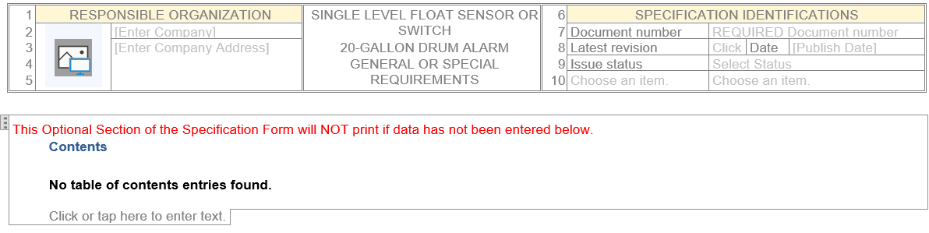

3 FACILITATE ENHANCED WORK PROCESSES USING COPY CAPABILITY

The ability to mass copy data between forms will allow efficient work processes and consistent data.

3.1 COPY OPERATING PARAMETERS DATA FOR CONSISTENCY

3.1.1 Operating Parameter Data for Lines Containing One or More Instruments
Document Operating Parameters data for lines containing one or more instruments, on form F1101, at the earliest phase of a project. (Likely performed by process engineering personnel) Manage the checking and approval of this data by its owners.

3.1.2 Operating Parameters Data for Vessels Containing One or More Instruments
Document Operating Parameters data for vessels containing one or more instruments, on form L1001, P1002 or P1004, at the earliest phase of a project. (Likely performed by process engineering or mechanical engineering personnel.) Manage the checking and approval of this data by its owners.

3.1.3 Copy Line Operating Parameters Data to Device Specification Forms
Copy line operating Parameters data from F1101 forms to the appropriate Device Specification forms, for all instruments that are inline or directly connected to that line.

3.1.4 Copy Operating Parameters Data from a Form Developed Earlier
Copy operating Parameters data from a standalone measured variable based form, developed at an earlier project stage, to the appropriate Device Specification form at a later project stage.

3.1.5 Copy Operating Parameters Between Device Specification Forms
When line operating parameter forms or standalone measured variable based form are not being utilized, then copy operating parameters between Device Specification forms for devices in the same line, such as an orifice plate, its associated control valve, flow transmitter or pressure gauge.

3.2 COPY TYPICAL DEVICE DATA FOR EFFICIENCY

3.2.1 Create Library of Typical Device Specification of High Usage Devices
Create a library of master Device Specification templates of high usage devices that can later be copied into multiple tag specific documents.

3.2.2 Create Library of Typical Device Specification of Auxiliary Devices
Create a library of master Device Specification templates of high usage auxiliary devices such as solenoid valves or limit switches that can later be copied into multiple tag specific documents.

3.3 CHANGE THE DEVICE SPECIFICATION FORM FOR A SPECIFIC TAG
Change the Device Specification form for a tag on an existing form, such as a Linear Motion Type Control Valve to a Rotary Motion Type Control Valve, by copying the data into the new form and then perform editing in the new form.

3.4 COPY DATA BETWEEN SIMILAR TAGS OR APPLICATIONS
Copy data between similar tags or applications including those from other active or historical projects.

3.5 COPY DATA FROM SELECTED MANUFACTURER’S COMPLETED FORM
Copy data from the selected manufacture’s returned form file into the project master file, to update the specification form’s data with the manufacturer provided data.

3.6 COPY SELECTIVE FIELDS TO INSTRUMENT INDEX DATA TABLE
About 80 fields from each specification form are automatically copied to an Excel Instrument Index Data table, whenever a form is saved. A DATA FILE NOT FOUND warning will be presented If the Excel file is not found in the folder where the specification form is being saved.
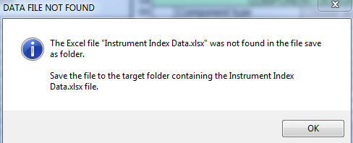

Whenever the Excel file has been found, the data saving will be completed, and the user notified.

The Instrument Index Data table has one record for each specification document number and that record will be updated with the latest data at each saving of the document. This tabular data presentation can be instrumental in review for inconsistencies between multiple forms, partial status of the form’s data entry or as an index to identify data related to a tag or functional identification.

WORK SHARING OR COLLABORATION
Extensive opportunities for work sharing or collaboration exist, where initialized or partially completed forms will be sent to an internal or external partner who do not have the installed file structure or Form Loading Dashboard.
Such data exchanges generally include multiple document files within the single data exchange. Inclusion of a blank Instrument Index Data.xlsm Excel file as part of the exchange, will prevent warning messages when saving the documents and allow that party to have an index of their work products.

- Note: A blank Excel file is installed in the “Instrument Specs and Index\Form Templates\Instrument Index Data.xlsm” folder, for such use.

4.1 EDITING DOCUMENTS WITHOUT FORM LOADER DASHBOARD
When such document files are received and saved from any email or compressed file to a folder, they can be viewed and edited by double clicking a document file name, like most other data files.

After acknowledging the Microsoft Visual Basic for Application notification pop-up message.

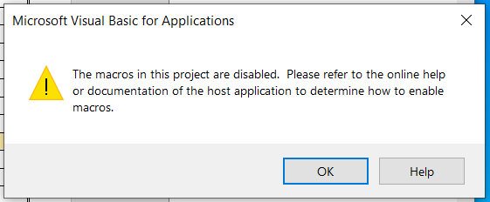

- Note that there is no need to refer to external documentation because the standard interface below, is sufficient.

The application will then provide a temporary ribbon to allow the user to click the Enable Content button to enable the macros or ignore that ribbon and edit the template without the active macros.
The form can then be edited and saved the same as those managed by the Form Loader Dashboard. If the Instrument Index Data.xlsm file is not found in the folder with the document files, an information message will be displayed.

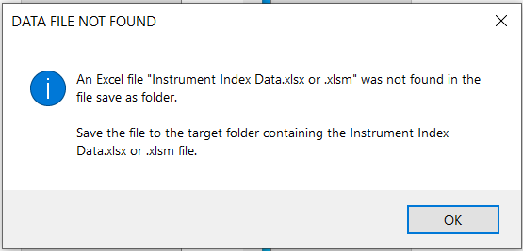

This message can be ignored since the Document file has already successfully been saved.

4.2 MANAGING EXTERNALLY EDITED DOCUMENT REVISIONS

Procedures for managing document revisions or versions is too variable and complex to be addressed here. However, a procedure to supplement and/or increment a suffix to the external edited file name, will prevent a overwrite of the origin data before the returned content can be reviewed and accepted.
When such document files are returned from external parties and saved from any mail or compressed file to the “Import temp” folder, they should have their files renamed to include a revision suffix.
As an example, renaming document number “PD FV-0001.docm” to “PD FV-0001 R1.docm” will allow that file to be integrated into the Project Form Data folder without overwriting the original file.

- Note: See Quick Start Tour document for step-by-step procedure

4.3 REVIEW MANUFACTURER(S) SPECIFICATION EXCHANGE DOCUMENTS

- Copy the (Manufacturer edited) document to the “Import temp” folder
- Review the (Manufacturer edited) form using the Form Loader Dashboard and the Project Form Data listing of files, located in the “Import temp” folder.

EVALUATE ALTERNATE PROPOSALS

Loading files into the “Import temp” folder also allows managing alternate proposals of a single manufacturer or multiple proposals of alternate manufacturers. The only requirement is that the file names are unique. After a manufacturer’s proposal has been accepted, the alternate files can be deleted from the “Import Temp” folder.

5 CUSTOMIZABLE TEMPLATES FOR OPTIMIZED WORK APPLICATIONS

5.1 EDIT OUT-OF-THE-BOX TEMPLATES
Many of the Word document features can be optimized through a process of editing the out-of-the-box template for high volume forms; to become work/project specific. Examples of common opportunities to modify the template include:
- Enter Responsible Organization data
  - Select Logo
  - Enter Company name and Address
- Enter Administrative Identification Pick List values specific to the project

- Note: These property values are extensively used in the Instrument Index Data spreadsheet as filter conditions, and their consistent spelling can be critical to reliable query results.

- Add Issue status values consistent with document control requirements or project milestone events
- Add pick list values in user definable field prompts available in all sections; based upon project or client requirements or preferences
- Add to any drop-down list values that are common to the project or have been identified as opportunities for improvement from Not-in-List reports
- Enter Document Custom Document Properties that will be automatically saved for each document produced
- Add Preferred manufacturers to Manufacturer list
- Add General or Special Requirements data if applicable

5.2 MANAGE CUSTOMIZATION OF TEMPLATES PICK LIST CHANGES

Section 2.4 OPTIONAL ADD-TO-LIST FUNCTIONALITY Identifies the functionality for users to document recommendations for changes to the pick list and Email them to an administrator.
Since significant effort has been committed to achieving a moderate degree of consistency in pick list context and terminology, relative to standards and manufacturers literature, it is recommended that user suggestions for changes be approved by a template administrator before the templates are modified.

- Note: Any such custom changes may need to be reproduced if revised templates from the InstrumentSpecsandIndex.com Website are installed.

For an administrator to be able to edit a form template, the following procedure will need to be followed.

- Unhide Developer Tab

Note: Word’s Custom Ribbon Developer tab is required to edit templates. By default, it is hidden to discourage modifications of the forms by users not authorized to modify templates. The actions to unhide this tab vary by Word versions but can be determined by using the Word Help and search on “Developer tab”.

- File Open Command Required

- Note: To edit and save a modified template, that file MUST first be opened with the File Open action or Word’s Internal Open other document option. Highlight the template file name and use the right mouse action menu to select Open.

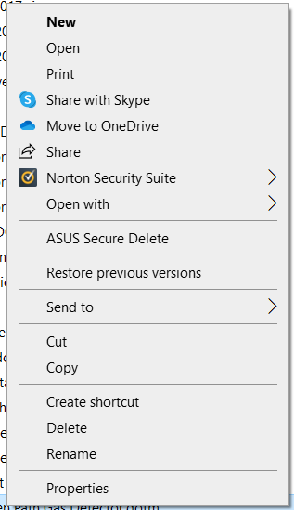

- Note: Failure to use File open action will result in saving a template file without the macro features. There is no recovery path from this error; so, it is recommended to perform all changes on a backup copy of the original template file.

5.3 EDIT DROP-DOWN CONTROL PICK LIST

As the template file opens, click the OK button to dismiss the Enabled Content information window

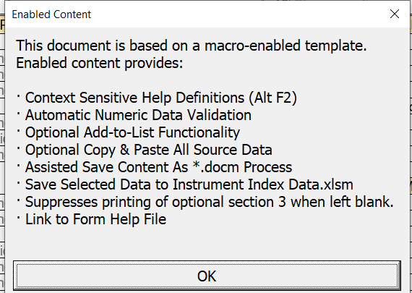

To edit any specific drop-down control, follow this procedure:

- Click on the Custom Ribbon tab of “Developer” to open the menu options for that tab

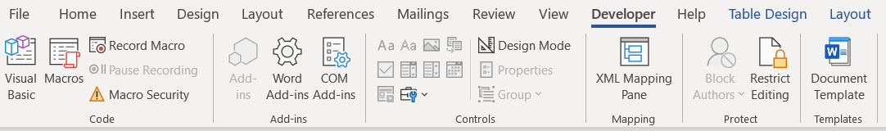

- Click on the content control of interest and the control will display its highlighted name

- Click on the Properties option of the Developer Controls tab

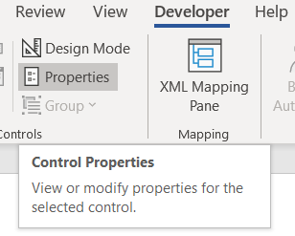

- The Content Control Properties window will open and allow full editing of the Drop-Down List Properties

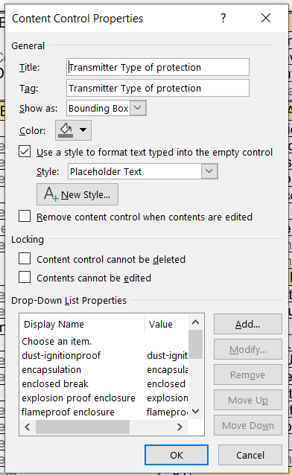

- Note: Do NOT change the General properties.

- Click the OK button after edits are complete and repeat these steps for other form properties.

When data editing is sufficient for any specific editing session, save the work by clicking Word’s Quick Access Toolbar menu icon at the top left of the program window. Test the revised template by double clicking the file and confirming that the macros are detected, and the editing changes are present.

6 USE OF TYPICAL FORMS
Specifiers as well as manufacturers or vendors that are anticipating repetitive demands for completing these forms of specific device types, may choose to create Typical Forms as a source for efficiently copying their data to future Device Specification documents, as in the example below.
A manufacturer that has recently completed a Device Specification Form A2131 Open Path Gas Detector, can copy that document to a folder such as the provided “Typical Forms” folder and perform the following editing:
- Rename the specification document number to represent the form number and component type, such as “A2131 Open Path Gas Detector”
- Edit the line 7 Document number field to align with the file name
- Delete any data in those sections owned by the specifier, such as Operating Parameters and Calibration and Test section range values
- Delete data that may be over specific for other applications

A “Sample Open Path Gas Detector.docm” has been provided in the Typical Forms folder, to demonstrate this process.

- Note: See Quick Start Tour document for step-by-step work process

7 DATA INTEGRATION WITH WORD/SHAREPOINT DOCUMENT PROPERTIES AND METADATA

7.1 DATA INTEGRATION WITH WORD/SHAREPOINT DOCUMENT PROPERTIES
The form’s Document Properties are linked with Word/SharePoint standard document properties, which can be accessed by clicking the File menu option and the Home page tab for Info
or directly by using the View menu option and the tab, if running Word 365.
Word’s Home Info tab will open with summarized properties, such as:
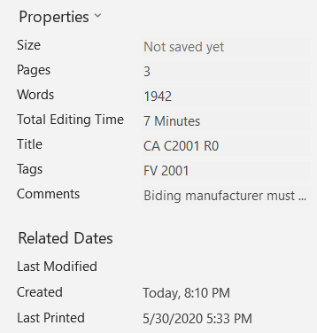
Clicking on the drop-down icon will display the Advanced Properties message.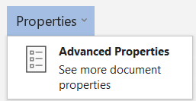
Click within this window to open the Summary tab of the Document Properties window.
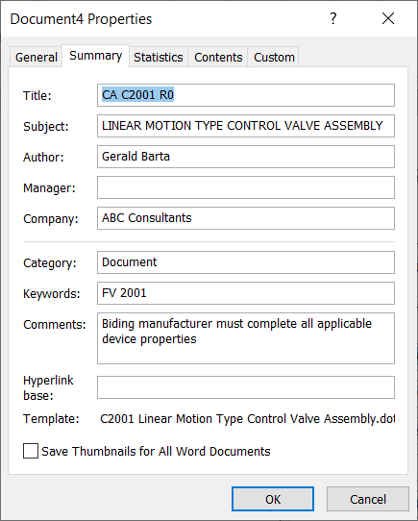
The document properties data entered in the form is displayed, as well as the Template file name that was used to create the document.

7.2 CUSTOM DOCUMENT PROPERTIES

Selecting the Custom tab will display the edit window for Custom properties. Five Custom Document Properties have been implemented and can optionally be used to identify additional information about the environment in which the document has been prepared. Such information can be useful when viewed by personnel not directly familiar with the author or that position within the organization.
- Note: The Custom properties are not visible on the specification form and can only be entered in the Document Properties window accessed from the File Info menu.
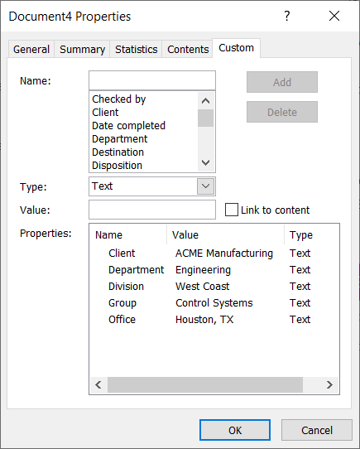

To enter or edit Custom Property Data:
- Click the name of the property
- Enter or edit data into the Value text box
- The Add button will change to Modify
- Click the Modify button to save the value
- The saved value will display in the window

7.3 DOCUMENT METADATA MAPPED TO INTERNATIONAL STANDARDS XML COREPROPERTIES

7.3.1 CoreProperties Mapping
Word’s document metadata properties as shown in the Document Properties panel; are automatically mapped to multiple internationally recognized Openxmlformats core-properties; in the file’s integral XML Part.

7.3.2 Microsoft Office Cover Page Properties Mapping
The Publish date and Company Address are automatically mapped to the Microsoft/office/coverPageProps in the file’s integral XML Part.

7.3.3 Office Document Extended-properties Mapping
The Company name is automatically mapped to the officeDocument/extended-properties; in the file’s integral XML Part.

Note: All the above metadata can be retrieved by Electronic Data Management Systems (EDMS) such as Microsoft’s SharePoint application; for managing document lifecycle events.

INTEGRATED FORM LOADER DASHBOARD

A Form Loader Dashboard is included as the common interface for access to all templates, forms, Instrument Index files and their data storage folders. Use the Form Loader Dashboard by double clicking the 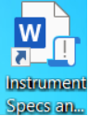 Desktop shortcut to activate the dashboard interface.
The Quick Start Tour document, section 2 & 3 provides step-by-step examples of the work process uses of this dashboard.

8.1 OPERATING PARAMETERS FORM
When the integrated Form Loader Dashboard opens:
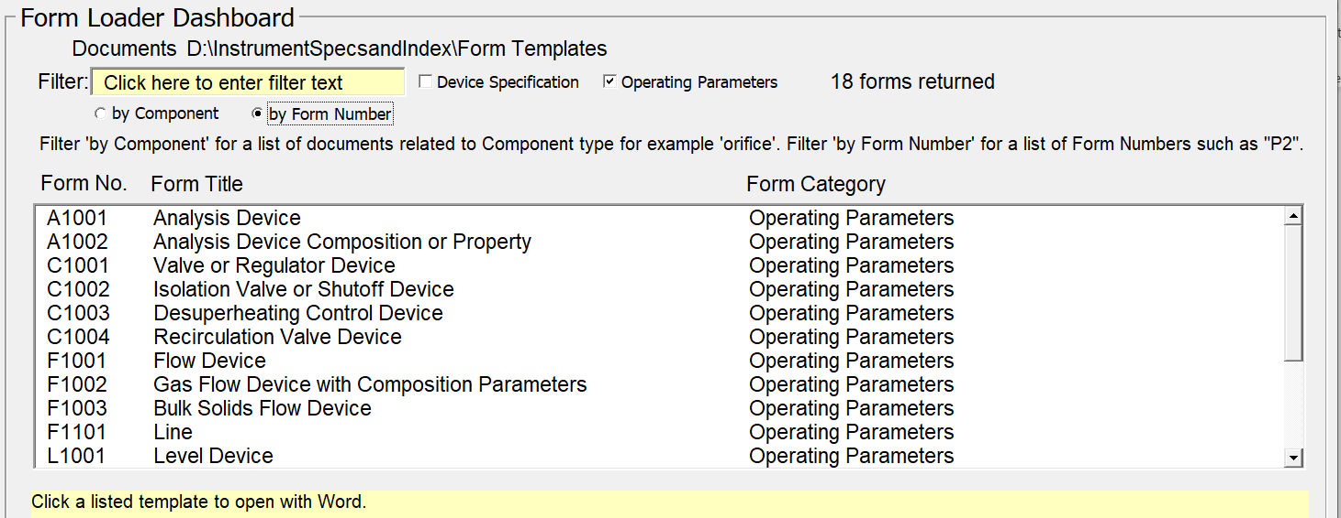
Set the check boxes to select the Form Loader Dashboard filters:
- Check “Operating Parameters” box
- Check “by Form Number” box
- Uncheck “Device Specification” box

The query results window will automatically display the (18) Operating Parameters forms.
Click on a selection window entry, which will become highlighted in blue, and open the Microsoft Word message windows and load the form.

DEVICE SPECIFICATION FORMS by FORM NUMBER

When the integrated Form Loader Dashboard opens:
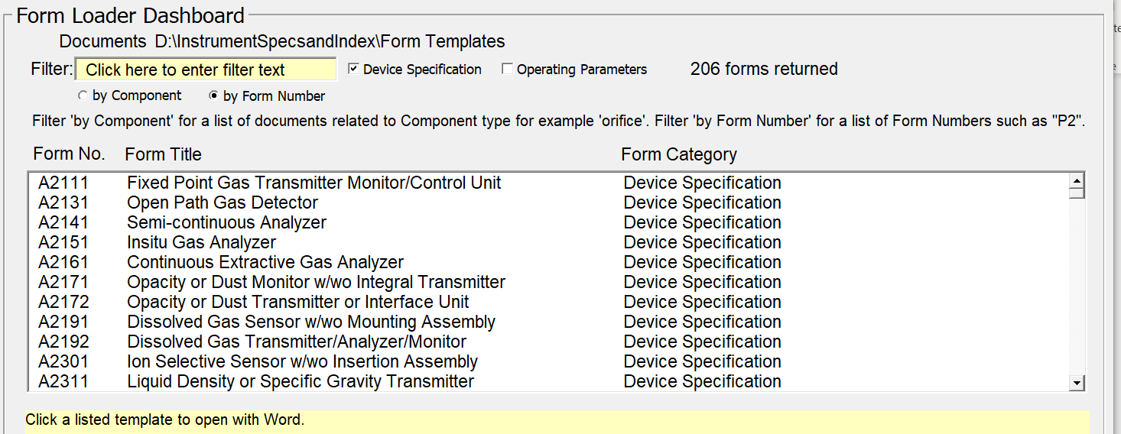
Set the check boxes to select the Form Loader Dashboard filters:
- Check “by Form Number” box

The query results window will automatically display the (206) Device specification forms.
Click on a selection window entry, which will become highlighted in blue, and open the Microsoft Word message windows and load the form.

8.3 DEVICE SPECIFICATION FORMS BY COMPONENT
When the integrated Form Loader Dashboard opens:
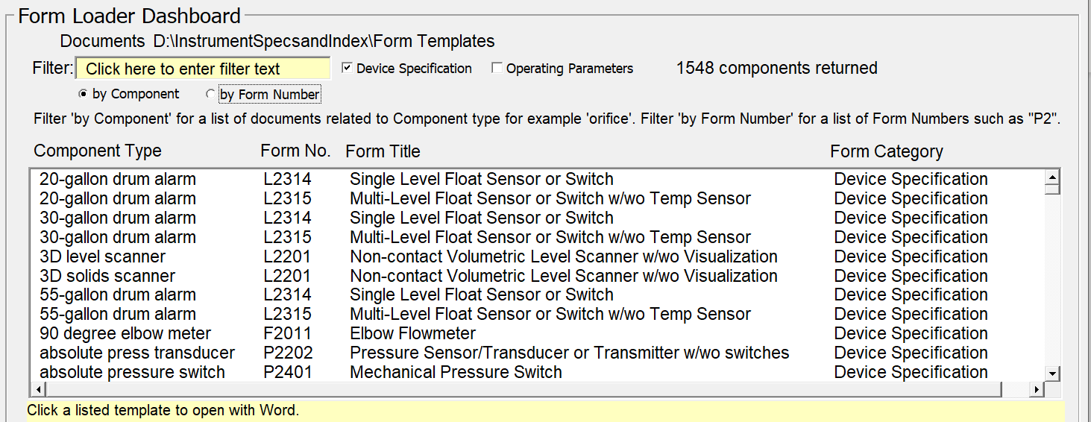
The default query results window will automatically display the (1548) device components and their specification forms. Scrolling to review such quantities would not be effective. Instead, entering data into the Filter text field will quickly narrow the options for a meaningful review.

Entering data into the “Filter” field of this Dashboard window, will automatically update the list of Component Type, Form No, Form Title, Form Category, and number of forms that contain the entered Component Type text string. Modifying the entered filter data can be used to expand or narrow the resulting list of forms.

As an example, entering “control valve” into the filter field, returns 45 components and forms.

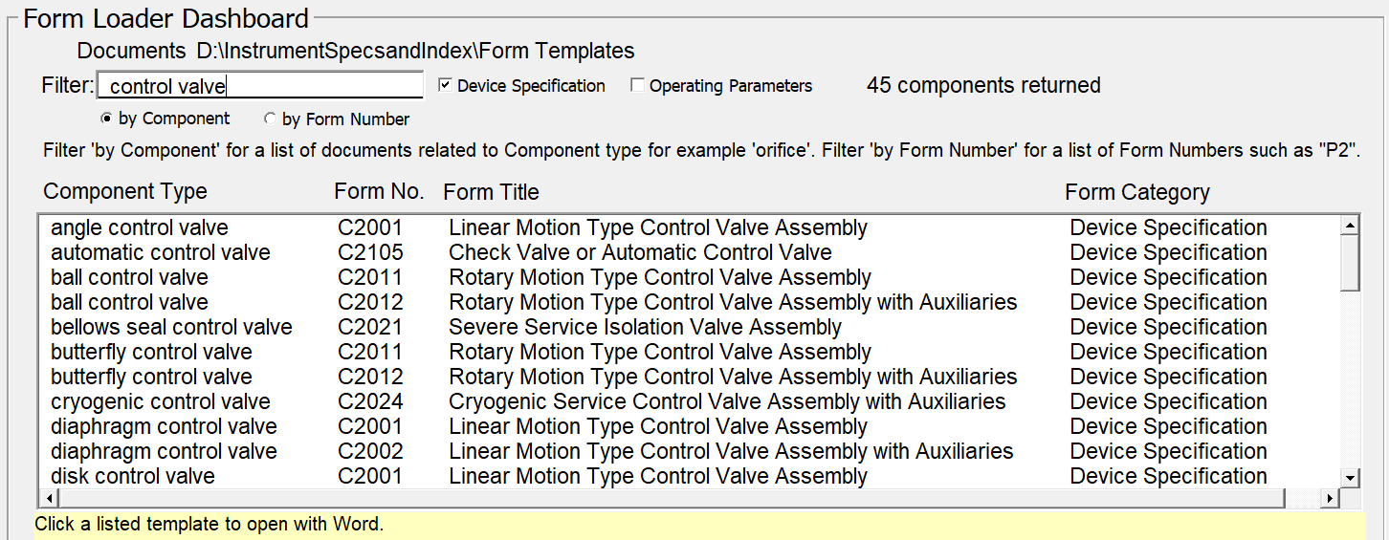

Click on a selection window entry, which will become highlighted in blue, and open the Microsoft Word message windows and load the form.

8.4 MULTIPLE EDIT SESSIONS AND REVISION MANAGEMENT

Most forms will need to be reviewed or edited after its initialization, to complete their data or add revision chronicle data, often by users that are different from the one who created the document.
To edit any document form, use the Form Loader Dashboard by double clicking the Desktop shortcut to activate the interface. When the integrated interface opens, scroll through the list of Project Form Data documents, and click the window row document number of interests. The selected document number will be highlighted while the form is loading.

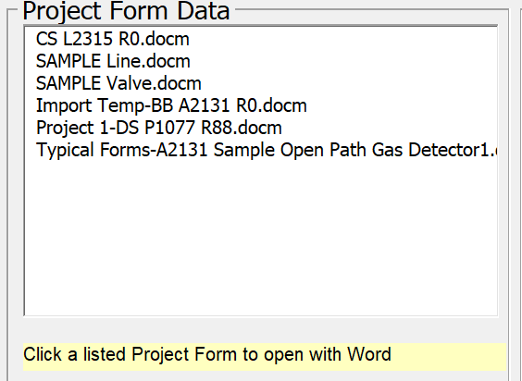

Scroll through the list of Project Form Data documents and click the window row document number of interests. The selected document number will be highlighted while the form is loading.

8.5 HELP AND TUTORIAL LINKS

The Quick Start Tour, form application Help and two detailed tutorials are accessible from the Form Loader Dashboard interface.

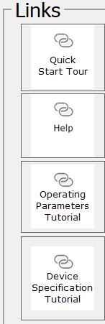

Clicking the desired link icon will open the document for review.

8.6 INTEGRATED INSTRUMENT INDEX DATA BROWSER

- Note: Data changes made in the Instrument Index Data table are NOT propagated to the Specification Form documents. Therefore, any changes identified by review of the index table must be corrected on the individual document, which when saved will update the Instrument Index Data file.

8.6.1 Selected Specification Form Data Subset

While specification forms are created as individual files, they generally are reviewed, approved, and packaged together for multiple different information exchanges. Our integrated Instrument Index Data browser is automatically populated when document files are saved, with over 80 fields of data, which only adds 1-2 seconds to the saving time.

- Note: See Annex B Instrument Index Data List

To browse the Instrument Index Data for any file folder, use the Form Loader Dashboard by double clicking the Desktop shortcut to activate the interface. When the integrated interface opens, scroll through the list of Instrument Index Data files, and click the window row for the Excel® spreadsheet of interests. The selected file will be highlighted while it is loading.

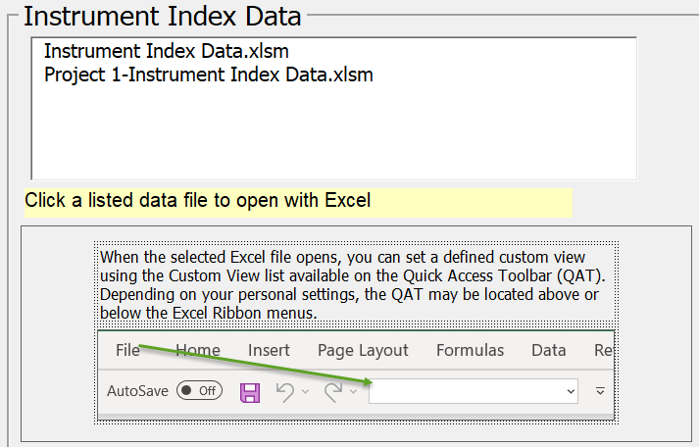

- Note: The Form Loader Dashboard interface includes a reminder that several Custom Views are available if the user opens the spreadsheet dropdown list of configured views, or uses the View tab and Custom view tab, as shown below.

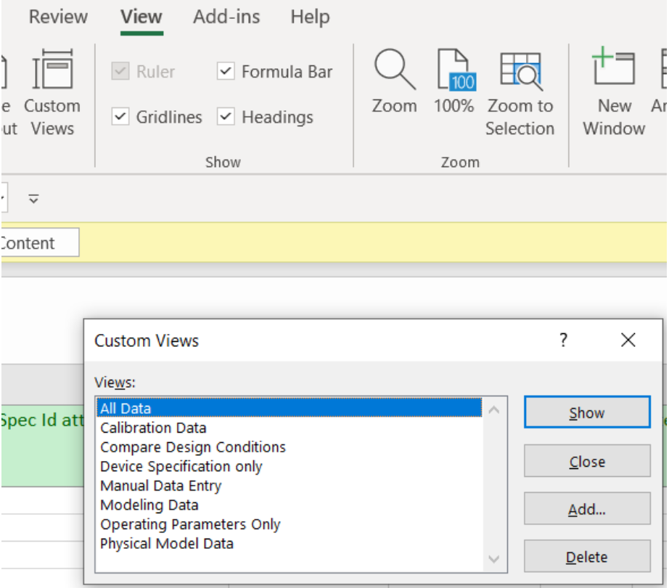

8.6.2 Browse Specification Form Data and Status

The spreadsheet opens with the last saved Custom View as its default. The data is automatically ordered by the Tag no/Functional ID (keywords) and indicates a calculated % complete for each field.

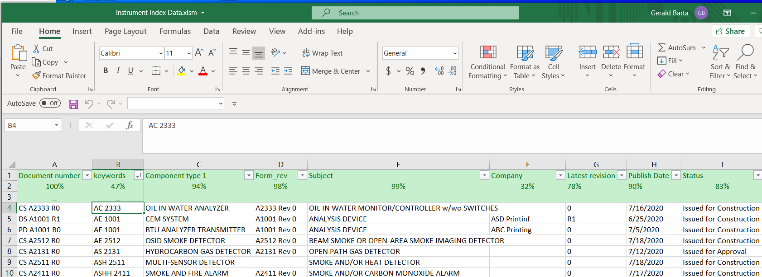

Each field has a dropdown sort & filter list for convenience in reviewing the list of unique values and limiting the view for review.
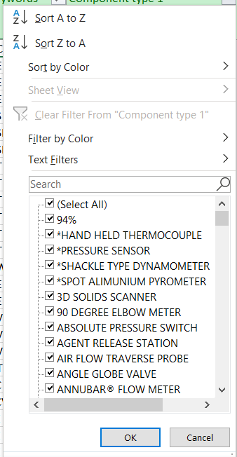

8.6.3 Extended Manual Data Entry Instrument Index Fields

Over 25 additional typical Instrument Index Fields, related to the specification form’s tagged device, are provided, and can be expanded if desired. They can be easily accessed by selecting the “Manual Data Entry” custom view. This data will NOT be overwritten when specification documents are revised and saved.

Several of these fields include dropdown list to assist in maintaining consistency, as identified on the third row of the header and defined below:

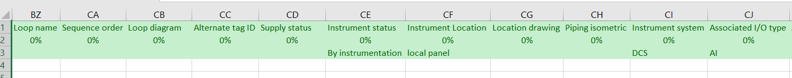

- See Annex B Instrument Index Data List

8.6.4 Comparing Safety Design Conditions
OSHA design requirements specifically document requiring that Device Specification design conditions exceed the Operating Parameters design conditions. The Instrument Index table (browser) allows viewing Operating Parameter data typically from page one with Device Specification design data typically from page two, in adjacent columns. This can assist in ensuring that the design criteria are appropriate for the intended process use.
To facilitate comparing such form data that generally occur pages apart, the Comparing Design Conditions custom view is available. The field names with the ‘PC” prefix are those of the device’s Performance Characteristics section.

8.6.5 Instrument Index Custom Reports for Deliverables
Although no custom reports are presently included, such reports can be designed to produce special listings of data, such as:
- Calibration data report
- Safety instrument report
- Document status report
- Reports filtered by Physical Model properties such as Unit number
- etc.

9 DATA MAPPING AND EXCHANGE

9.1 XML MAPPING CAPABILITIES

Calculation routines and custom data exports are outside the scope of these forms. Data exchange to such programs requires significant knowledge of such applications. Therefore, Word’s XML Mapping Pane which can be used to create Content Control mappings to referenced existing standard XML schemas, is not being used at this time.

9.2 DATA EXTRACTION AND EXPORT
All of a form’s property data can easily be exported using a free third-party add-in “Extract Data from Word Document File”, to many different common file formats.
https://gregmaxey.com/word_tip_pages/extract_data_from_forms.html

10 FREQUENTLY ASKED QUESTIONS
Question: Why can I sometimes NOT edit or delete data from a field?
Answer: Word generally opens a data entry control with a width less than the full width of the data entry cell and therefore there maybe form space available to the right of the data entry control. Under some circumstances, a user may be able to improperly enter data into that unused space of the form. Such data will appear to be integral with the data within the control but is only present on the unused portion of the form. To remove such data, the user must place the cursor to the right of the last character and then use the backspace key to delete the data from that area of the form.
Question: How can more than one option be specified from the pick list of any property?
Answer: In the situation where it is necessary to document more than one value from a pick list, such as multiple Compliance standards, the user can enter text such as “see SR note 1.1”. Then create such a note in the General or Special Requirements Part with reference back to the source property line number and prompt text.
Compliance standards
99 | Compliance standard | 3A sanitary standard
99 | Compliance standard | ASME BPE
99 | Compliance standard | NACE® MR 0175-2002
99 | Compliance standard | USP CLVI
99 | Compliance standard | 21CFR 177.2600
99 | Compliance standard | FDA

Question: What is the concern with the Excel information message when opening Custom views about “some view settings could not be applied”?

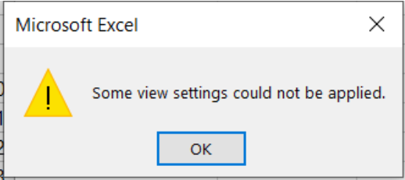

Answer: This information can be ignored, as it only means that the protection scheme of the main view cannot be applied to other views. Only the main view needs such protection!

11 TERMS of USE
The latest application and installation files can be downloaded at instrumentspecsandindex.com website, which aims to publish and solicit FREE crowd sourced information about instrument device design documentation.
All templates, software, documentation, and other information on this website are only intended for personal use or use within your company, school, or organization and not for resale.
In general, permission is granted for educational purposes or use of the specification templates within your company or organization and for the purpose of documenting or purchasing instrument devices.
The template created specification form files, in the form of Word documents, are the preferred transmittal sent to a vendor for the purpose of soliciting bids and purchasing instrument devices.
You have the right to modify, change, add or remove the content of the specification templates to personalize to your satisfaction. In such cases, you must change the template number and/or revision to indicate that they have been modified. Adding a revision suffix is adequate for changes of only pick list data that are not visible on the face of the form.
If you have any doubts or questions about the use of the files, please contact us.

Disclaimer
InstrumentSpecsandIndex or its author(s) will not be responsible for mistakes, incompleteness or errors on this website or the specification templates available, or downloadable from this website. The organization, business, or person using the templates or the information on this website bears all risks and responsibility for the quality and performance of the available or downloadable software and for the use of the information on this website.

Limitation of liability
InstrumentSpecsandIndex or its author(s) will, in no event, be liable to you, for any damages or injuries, including, but not limited to, any lost profits, lost savings, or lost money in general, or any other direct, indirect, special, incidental or consequential damages or injuries arising from the use or inability to use this website or the specification templates available or downloadable from this website, even if InstrumentSpecsandIndex or its author(s) has (have) been advised of the possibility of these damages or injuries.
Infringes Your Rights
InstrumentSpecsandIndex only has educational purposes to promote the knowledge associated with specifying instrument devices. If you believe that something is published on InstrumentSpecsandIndex that infringes your rights, please report it via the contact us. page.

Using InstrumentSpecsandIndex
By using this website as well as the downloadable software, provided on this website, you agree to the terms of use as described above. If you do not agree to these Terms of Use, you may not use this website or download any software. We reserve the right to modify or supplement these Terms of Use at any time and without any prior notification.

12 FEEDBACK
My passion for applying knowledge-based software to improve the effectiveness and quality of instrumentation design has led to build this website. Many of the templates included here represent a third-generation implementation of over 15,000 man-hours effort. The next step in improving their capabilities is obtaining extensive feedback from actual usage.
All observations from wordsmithing to enhancing technical contend are welcomed.
Such communications can be initiated through the instrumentspecsandindex.com website contact us tab, or directly Email instrumentspecsandindex@comcast.net

13 DOWNLOAD AND APPLICATION SETUP

13.1 WEBSITE DOWNLOAD OF INSTALLATION FILES

Instrument Specs and Index Setup.zip file can be downloaded from the Website https://instrumentspecsandindex.com and saved to the computer’s Downloads folder.
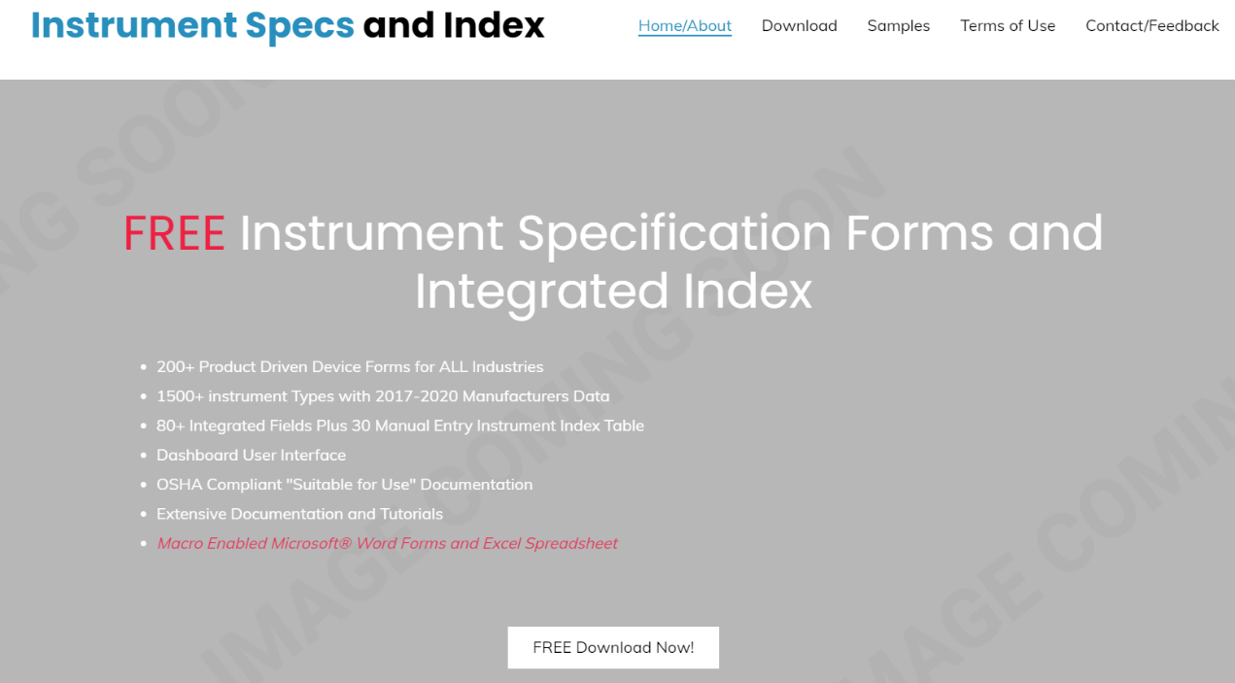

Clicking the “FREE Download Now! Button” will open the Google Drive download window.

Clicking the download icon will open the Google Drive can’t scan file that is too large window.
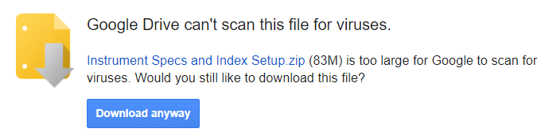

Clicking the “Download anyway” button will download the Instrument Specs and Index Setup.zip file.
- Note: Depending upon what web browser is being used, the download progress may be displayed; above the download window, below the window or inferred by a flashing browser icon.
The Google Drive download window can be closed.
- Note: If the download is not complete a browser warning message will appear.
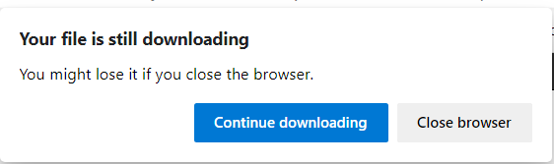
Clicking the “Continue downloading” button will allow completion of the download.

13.2 WORKING WITH THE DOWNLOADED INSTALLATION FILES

Navigating to the computer’s Downloads folder will allow access to the Instrument Specs and Index Setup.zip file.
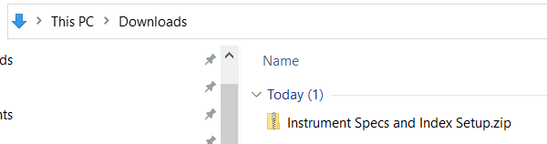

Double clicking, or right mouse click and choose the open menu option of the Instrument Specs and Index Setup.zip file, will open the compressed file and display its content.

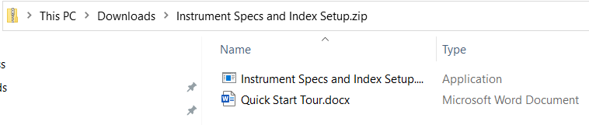
The Quick Start Tour.docx file is a step-by-step guideline that is highly recommended for users that do not have previous experience with this application. It is recommended that new users copy and paste this file to the Desktop for use until they become familiar with how access the file from within the Dashboard interface.
Double clicking on the Specs and Instrument Index Setup.exe file, will open the Compressed (zipped) folders action window.

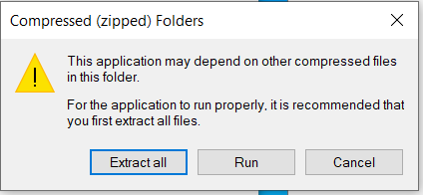

This information warning does not apply to our application, therefore clicking on the “Run button” will open the “Windows Protected your PC” window.

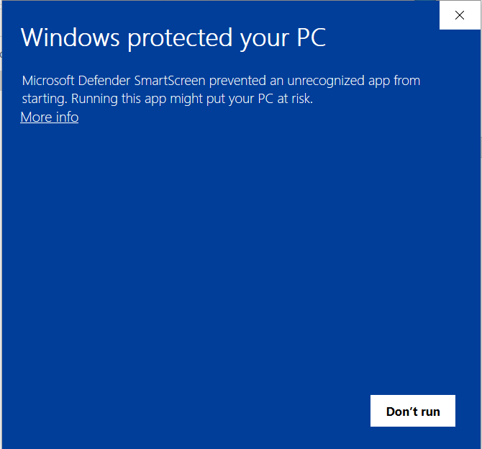

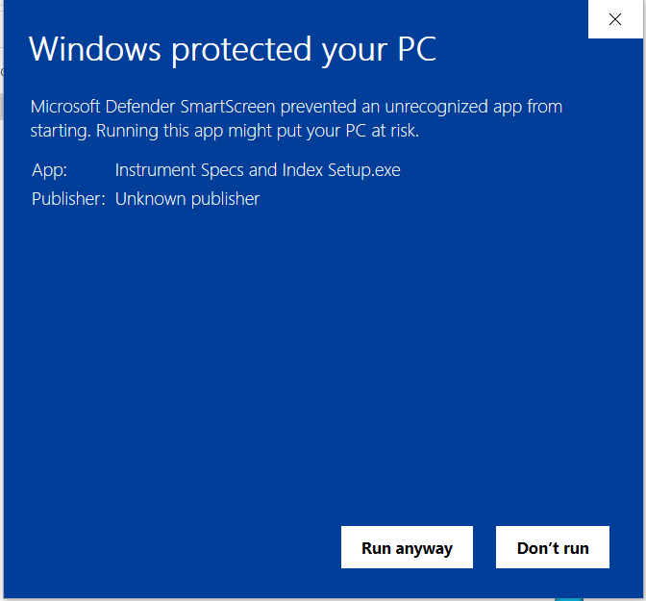

This well intended warning is does not apply to our application, therefore Clicking the “More info” icon will add our desired option to “Run anyway”.
- Note: If your computer has an additional third-party virus protection, then you will get an additional window offering the option to “Run this program anyway”.
- A warning message about unknown source material may appear depending on computer operating system.
- Click to proceed with installation.

13.3 INITIAL INSTALLATION

After all the virus protection software has been acknowledged, the Instrument Specs and Index Setup “Readme information” window will open.

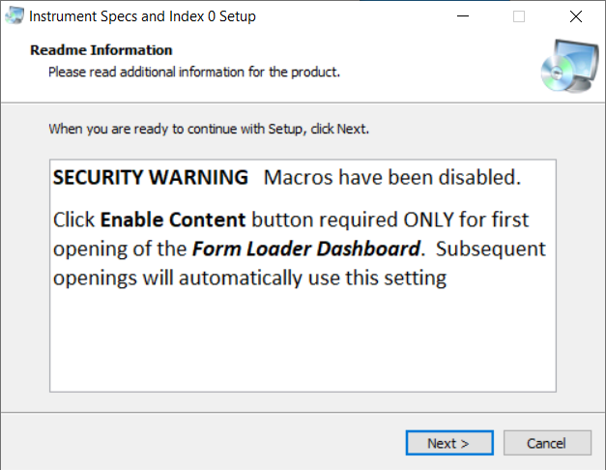

This information window is identifying that the application files include Microsoft® macros that will be disabled during installation, but will need to be enabled by the user, the first time that the application is run.

Clicking the Next button will open the “Select Application Folder” window.

These Microsoft® Word specification forms are designed for electronic file editing and integration with Microsoft® Excel and external software applications, using integrated XML technology. For their effective use, all files need to be located at a drive and folder location accessible to all intended internal project users.
- If a network location is appropriate, then use the Browse button to navigate to that drive/folder.
- The default installation is in the root directly of the active drive. This should be appropriate because there are no “Program Files” present in this application. (Microsoft Word and Excel are the associated program files)

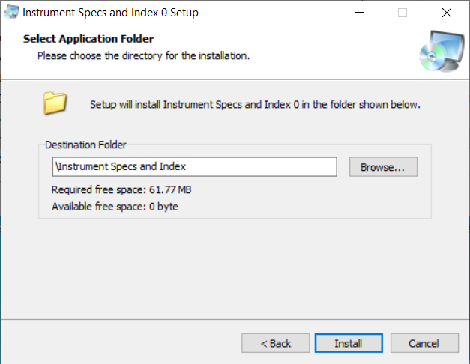

- Click the Install button to proceed with copying the files to the drive

- The Installation complete window will display.

- 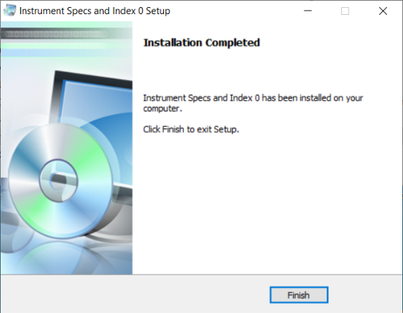

- Click the Finish button to return to your Desktop and verify the application shortcut.

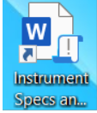

- The Windows Start list will also display the Instrument Specs and Index program and its uninstall program.

13.4 UPGRADE INSTALLATION

- Switch to the drive where you want to install this application and run the Instrument “Specs and Index Setup.exe” program.
- Windows’ warning message about unknown source material may appear depending on computer operating system. Click to proceed with installation.
- The “Instrument Specs and Index 0 Setup” window will display with the message window identifying that you must first uninstall your current installed version.

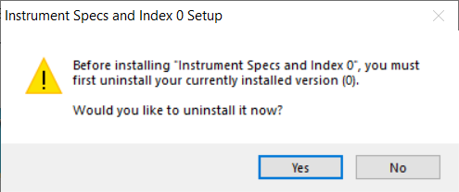
- Click the Yes button to acknowledge this information and open the confirmation window.

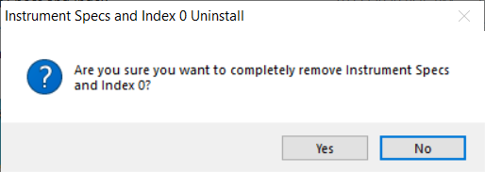
- Click the Yes button to complete the uninstall and open the notification window.

- Note: It is advisable to backup files in the Project Form Data folder incase the uninstall activity accidently deletes your project files!

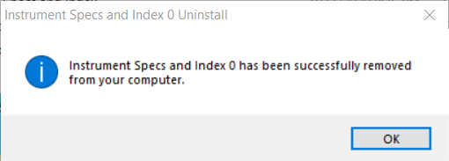

- Click the OK button and the follow the above identified procedures for installation.

Annex A Specification Templates List

TABLE 1 - Operating Parameter Device Categories and Form Titles

Form Number | Form Title | Rev
A1001 | Analysis Device | 0
A1002 | Analysis Device with Composition or Property | 0
C1001 | Valve or Regulator Device | 0
C1002 | Isolation Valve or Shutoff Device | 0
C1003 | Desuperheating Control Valve Device | 0
C1004 | Recirculation Valve device | 0
F1001 | Flow Device | 0
F1002 | Gas Flow Device with Composition Parameters | 0
F1003 | Bulk Solids Flow Device | 0
F1101 | Line | 0
L1001 | Level Device | 0
P1001 | Differential Pressure Device | 0
P1002 | Pressure Relief or Safety Relief Device | 0
P1003 | Pressure Device | 0
P1004 | Tank or Line Venting Device | 0
T1001 | Temperature Device | 0
T1002 | Non-contact Temperature Measurement Device | 0
W1001 | Weight or Force Device | 0

TABLE 2 - Device Specification Categories and Form Titles

Form Number | Form Title | Rev
Analysis Devices
A2111 | Fixed Point Gas Transmitter Monitor/Control Unit | 0
A2131 | Open Path Gas Detector | 0
A2141 | Semi-continuous Analyzer | 0
A2143 | Online Catalytic Combustion Based TOC Analyzer | 0
A2151 | Insitu Gas Analyzer | 0
A2161 | Continuous Extractive Gas Analyzer | 0
A2171 | Opacity or Dust Monitor w/wo Integral Transmitter | 0
A2172 | Opacity or Dust Transmitter or Interface Unit | 0
A2181 | Online Colorimetric Based Wet-chemical Analyzer | 0
A2183 | Online ISE Based Wet-chemical Analyzer | 0
A2185 | Online Respirometry Based BOD or Toxicity Analyzer | 0
A2187 | Online Thermal Digestion Based COD or Analyzer | 0
A2189 | Online Chemical Oxidation Based TOC, TIC and TC Analyzer | 0
A2191 | Dissolved Gas Sensor w/wo Mounting Assembly | 0
A2192 | Dissolved Gas Transmitter/Analyzer/Monitor | 0
A2301 | Ion Selective Sensor w/wo Insertion Assembly | 0
A2201 | Online Liquid Particle Counter Sensor w/wo Analyzer | 0
A2203 | Remote or Portable Airborne Particle counter w/wo Pump | 0
A2205 | Online or Handheld Particle Counter or Monitor | 0
A2207 | Remote or Handheld Condensation Particle Counter | 0
A2301 | Ion Selective Sensor w/wo Insertion Assembly | 0
A2311 | Liquid Density or Specific Gravity Transmitter | 0
A2321 | Nuclear Type Density Transmitter w/wo Switches | 0
A2331 | Continuous Extractive Oil in Water Monitor w/wo Switches | 0
A2332 | Insitu Oil in Water Sensor w/wo Insertion Assembly | 0
A2333 | Oil in Water Monitor/Controller w/wo Switches | 0
A2341 | pH/ORP Sensor w/wo Insertion Assembly | 0
A2342 | pH/ORP/Conductivity/Resistivity Transmitter/Analyzer/Monitor | 0
A2345 | Continuous TOC Sensor w/wo Transmitter or Analyzer | 0
A2349 | Continuous UV-VIS Sensor w/wo Controller | 0
A2351 | Turbidity or Photometric Sensor w/wo Transmitter | 0
A2352 | Turbidity or Photometric Transmitter or Controller | 0
A2361 | Viscosity and Density Sensor w/wo Integral Transmitter | 0
A2363 | Gas Density Meter w/wo Calculated Variables | 0
A2371 | Moisture Analyzer or Dew Point Xmtr w/wo Sample Sys | 0
A2372 | Single Channel Moisture Analyzer or Dew Point Xmtr | 0
A2373 | Humidity/Dewpoint Transmitter w/wo Switches | 0
A2381 | Conductivity Sensor w/wo Insertion Assembly | 0
A2391 | Entrained/Holdup Gas Monitor | 0
A2411 | Smoke and/or Carbon Monoxide Alarm | 0
A2511 | Smoke Detector | 0
A2512 | Beam Smoke or Open-Air Smoke Imaging Detector | 0
A2611 | Soil Moisture or Water Potential Sensor with Probe | 0
A2612 | Soil Moisture and Temperature and Salinity Profiling Probe | 0
A2901 | Sample Gas Conditioning System w/wo Phase Separation | 0
A2902 | Sample Probe or Extractor | 0
A2903 | Steam and Water Grab Sample and Conditioning System | 0
A2904 | Grab Sample or Bottle Sampling System | 0
A2905 | Steam and Water Grab Sampling System | 0
A2906 | Automated Steam and Water Sample Conditioning System | 0
A2910 | Analyzer Controller | 0
Burner or Combustion Devices
B2001 | Flame Scanner w/wo Flame Relay or Amplifier | 0
B2002 | Optical Flame Detector w/wo Video Camera | 0
Valve or Regulator Devices
C2001 | Linear Motion Type Control Valve Assembly | 0
C2002 | Linear Motion Type Control Valve Assembly with Auxiliaries | 0
C2011 | Rotary Motion Type Control Valve Assembly | 0
C2012 | Rotary Motion Type Control Valve Assembly with Auxiliaries | 0
C2021 | Severe Service Isolation Valve Assembly | 0
C2022 | Severe Service Control Valve Assembly w/Auxiliaries | 0
C2023 | Cryogenic Service Isolation Valve Assembly with Auxiliaries | 0
C2024 | Cryogenic Service Control Valve Assembly w/Auxiliaries | 0
C2031 | Desuperheater Device/Control Valve Assembly | 0
C2041 | Linear Motion Type Motor Operated Valve Assembly | 0
C2042 | Rotary Motion Type Motor Operated Valve Assembly | 0
C2043 | Electric Actuator and Auxiliaries | 0
C2051 | Linear Motion Type Isolation Valve Assembly | 0
C2052 | Rotary Motion Type Isolation Valve Assembly | 0
C2061 | Linear Motion Type Emergency Valve Assembly | 0
C2062 | Rotary Motion Type Emergency Valve Assembly | 0
C2101 | Automatic Recirculation Valve w/wo Back Pressure Regulator | 0
C2105 | Check Valve or Automatic Control Valve | 0
C2111 | Pressure Regulator w/wo Pilot Valve | 0
C2131 | Self-Acting Temperature Regulator Valve | 0
C2141 | Air-Release or Air/Vacuum and Combination Air Valves | 0
C2211 | Solenoid Valve or Manifold Assembly | 0
Flow Devices
F2001 | Air Flow Traverse Probe w/wo Flow Straightener | 0
F2011 | Elbow Flow Meter | 0
F2021 | Flow Nozzle w/wo Meter Tube | 0
F2031 | Orifice Plate (with Sizing Data) | 0
F2032 | Orifice or Restriction Orifice Plate | 0
F2041 | Orifice Plate Assembly w/wo Meter Tube | 0
F2061 | Paddle Flow Switch or Transmitter | 0
F2062 | Waterflow Detector w/wo Retard | 0
F2071 | Pitot Tube w/wo Insertion Assembly | 0
F2081 | Segmental Wedge Flow Element | 0
F2091 | Target Flowmeter/Switch w/wo Insertion Assembly | 0
F2101 | V-Shaped Cone Flowmeter | 0
F2111 | Venturi or Flow Tube w/wo Meter Tube | 0
F2121 | Laminar Flow element w/wo Transmitter | 0
F2211 | Flume Flowmeter | 0
F2231 | Rotameter/Variable Area Flowmeter-Direct Reading Type | 0
F2251 | Variable Area Flowmeter or Transmitter w/wo Switches | 0
F2261 | Weir Flowmeter Assembly | 0
F2271 | Piston or Shuttle Flow Switch | 0
F2301 | Coriolis Solids Mass Flowmeter w/wo Switches | 0
F2311 | Free-Falling or Conveyed Bulk Solids Flowmeter | 0
F2312 | Belt Scale System | 0
F2313 | Impact or Solid-Particle Mass Flowmeter | 0
F2314 | Microwave Solids Flow or Velocity Transmitter | 0
F2315 | Microwave Solids Flow or Blocked Chute Switch | 0
F2321 | Magnetic Flowmeter w/wo Integral Totalizer Indicator | 0
F2322 | Insertion Type Magnetic Flowmeter w/wo Transmitter | 0
F2331 | Radiation-Based Bulk Solids Flowmeter | 0
F2341 | Ultrasonic Flowmeter w/wo Switches | 0
F2342 | Ultrasonic Flare Gas Sensor w/wo Insertion Assembly | 0
F2343 | Clamp-on Ultrasonic Flowmeter | 0
F2351 | Thermal Mass Flowmeter w/wo Switches | 0
F2361 | Thermal Mass Flow Switch | 0
F2371 | Turbine Flowmeter Direct-Reading Type | 0
F2372 | Turbine Flowmeter w/wo Switches | 0
F2375 | Paddlewheel Flowmeter w/wo Switches | 0
F2381 | Vortex or Swirl Flowmeter w/wo Totalizer Indicator | 0
F2382 | Insertion Type Vortex Flowmeter w/wo Transmitter | 0
F2391 | Sonar Flowmeter w/wo Entrained Gas Monitor | 0
F2411 | Positive Displacement Flowmeter Direct-Reading Type | 0
F2431 | Gear-Type PD Flowmeter w/wo Transmitter | 0
F2432 | Helical Gear PD Flowmeter w/wo Transmitter | 0
F2441 | Rotary-Type Gas PD Meter w/wo Transmitter | 0
F2451 | Sliding/Rotary Vane Type PD Flowmeter | 0
F2461 | Piston-Type PD Flowmeter w/wo Transmitter | 0
F2471 | Nutating Disc PD Meter w/wo Transmitter | 0
F2511 | Multi-Gas Flowmeter w/wo Controller | 0
F2521 | Coriolis Mass Flowmeter w/wo Totalizer Indicator | 0
F2611 | Sight Flow Indicator w/wo Illuminator | 0
F2711 | Meter Tube w/wo Flow Straightener | 0
Hand Control Devices
20H2031 | Manual Pull Station | 0
Level Devices
L2101 | Capacitance or RF Admittance Level Transmitter | 0
L2111 | Diff Pressure Level Transmitter-Flange Mounted | 0
L2112 | Diff Pressure Level Transmitter with Remote Sensor | 0
L2113 | Diff Pressure Level Transmitter with Seals | 0
L2114 | Submersible Level Transmitter w/wo Data Logger | 0
L2121 | Displacer-Type Level or Density Transmitter or Controller | 0
L2122 | Displacer-Type Level Indicator w/wo Switches | 0
L2131 | Tank Level Gauge or Transmitter w/wo Switches | 0
L2141 | Nuclear Radiation-Based Level Transmitter w/wo Switches | 0
L2151 | Resistance-Tape Level Transmitter w/wo Switches | 0
L2161 | Non-contact Radar Level Transmitter For Liquid | 0
L2162 | Guided Wave Radar Level or Interface Transmitter | 0
L2163 | Non-contact Radar Level Transmitter For Solids | 0
L2171 | Non-contact Ultrasonic Level Transmitter w/wo Switches | 0
L2181 | Magnetostrictive Level or Interface Transmitter or Switch | 0
L2191 | Laser Level Transmitter w/wo Switches | 0
L2201 | Non-contact Volumetric Level Scanner w/wo Visualization | 0
L2211 | Professional Precipitation Sensor or Rain Gauge | 0
L2212 | Snow Depth Sensor or Gauge | 0
L2301 | Capacitance or RF Admittance Level Switch | 0
L2302 | Conductivity Level Probe or Switch | 0
L2303 | Capacitive or Proximity Level Switch | 0
L2305 | Thermal Dispersion Level Switch | 0
L2311 | Float or Displacer Level Switch w/wo External Cage | 0
L2312 | Tank Level Gauge or Indicator w/wo Switches | 0
L2313 | Tilt Level Switch | 0
L2314 | Single Level Float Sensor or Switch | 0
L2315 | Multi-level Float Sensor or Switch w/wo Temp Sensor | 0
L2321 | Nuclear Radiation-Based Level Switch | 0
L2351 | Ultrasonic Contact-Type Level Switch | 0
L2361 | Vibrating Element Level Switch | 0
L2371 | Rotary Level Switch | 0
L2381 | Optical Level Switch w/wo Remote Controller | 0
L2391 | Diaphragm Level Switch | 0
L2501 | Liquid Level Gauge Glass w/wo Illuminator | 0
L2511 | Magnetic Liquid Level Gauge or Indicator w/wo Switches | 0
L2521 | Electromechanical Servo/Plumb Bob Level Transmitter | 0
Pressure or Differential Pressure Devices
P2001 | Pressure Gauge | 0
P2002 | Digital Press or Diff Press Gauge w/wo Output Signal | 0
P2011 | Pressure Gauge with Diaphragm Seal | 0
P2101 | Differential Pressure Gauge | 0
P2201 | Pressure Transmitter w/wo Integral Isolating Diaphragm | 0
P2202 | Pressure Sensor/Transducer or Transmitter w/wo Switches | 0
P2211 | Pressure Transmitter with Remote Diaphragm Seal | 0
P2301 | Differential Pressure Transmitter | 0
P2311 | Differential Pressure Transmitter with Seals | 0
P2312 | Diff Pressure Transmitter with Remote Sensor | 0
P2401 | Mechanical Pressure Switch | 0
P2402 | Electronic Pressure Switch w/wo Transmitter | 0
P2501 | Mechanical Differential Pressure Switch | 0
P2502 | Electronic Differential Pressure Switch w/wo Transmitter | 0
Pressure Safety Devices
P2901 | Rupture Disk Assembly w/wo Burst Sensor | 0
P2902 | Explosion or Pressure Relief Vent | 0
P2911 | Pressure Relief Tank Vent w/wo Integral Flame Arrester | 0
P2912 | Emergency Pressure or Vacuum Vent | 0
P2913 | Pilot Operated Pressure Vacuum Relief Valve | 0
P2921 | Pressure Relief Valve | 0
P2923 | Safety Relief Valve | 0
P2924 | Pilot Operated Pressure Relief or Safety Relief Valve | 0
P2925 | Hydraulic Pilot Operated Relief Valve w/wo Unloader | 0
P2931 | Flame or Detonation Arrester w/wo Temperature Sensor | 0
Receiver Devices
R2221 | Field Signal Indicator w/wo Switches | 0
Speed Devices
S2001 | Wind Speed and Direction Sensor | 0
Temperature Devices
T2001 | Bimetallic Thermometer w/wo Thermowell | 0
T2101 | Filled-System Thermometer w/wo Thermowell | 0
T2111 | Filled-System Temperature Switch w/wo Thermowell | 0
T2121 | Filled-System Temperature Transmitter w/wo Thermowell | 0
T2201 | RTD Assembly w/wo Thermowell | 0
T2211 | Thermistor Assembly | 0
T2221 | RTD/Thermocouple Temperature Transmitter-Field Mount | 0
T2222 | RTD/Thermocouple Temperature Transmitter-Head Mount | 0
T2223 | Temperature Transmitter or Switch-Rail Mount | 0
T2224 | Temperature Transmitter Assembly with Integral Sensor | 0
T2301 | Thermocouple Assembly w/wo Thermowell | 0
T2302 | Multipoint RTD/Thermocouple Assembly w/wo Thermowell | 0
T2401 | Radiation or Infrared Thermometer or Pyrometer | 0
T2402 | Handheld IR Thermometer w/wo Secondary Measurement | 0
T2501 | Thermowell or Protecting Tube Assembly | 0
Multivariable Devices
U2001 | Professional or Military Grade Weather Station | 0
U2002 | Multivariable Data Logger or Remote Monitoring Station | 0
U2005 | Flood Warning System or Sensor | 0
U2011 | Annunciator w/wo Event Recording | 0
U2012 | Annunciator Lamp Cabinet or Indicator | 0
U2013 | Fire Alarm Control Panel w/wo Integral Annunciator | 0
U2014 | Fire Panel Remote Annunciator or Indicator | 0
U2015 | Pressure Relief Device Monitor or Annunciator | 0
U2051 | Multivariable Flow Transmitter w/wo Calculation | 0
U2347 | Insitu Water Multi-parameter Probe w/wo Transmitter | 0
U2348 | Insitu Water Multi-parameter Multiprobe with Transmitter | 0
U2402 | Thermal or Hot-wire Anemometer with Probe | 0
U2910 | Flow Computer or Totalizer or Transmitter | 0
U2911 | Tank Data Integration or Monitor or Calculator w/wo Switches
U2912 | Multi-Tank or Multi-Channel On-Off Level Controller
U2913 | Tank or Leak/Point Level Alarm or Control
Vibration or Mechanical Analysis Devices
V2101 | Vibration Sensor/Transducer or Transmitter | 0
V2201 | Vibration Transmitter/Alarm or Conditioner Module | 0
V2301 | Vibration Switch | 0
V2311 | Machinery Monitoring or Protection System | 0
Weight Devices
W2011 | Precision Scale or Balance | 0
W2015 | Bench or Floor or Platform Scale | 0
W2017 | Truck or Vehicle Scale | 0
W2018 | Railroad Track or Combo Truck Scale | 0
W2111 | Hanging Weight Indicator or Crane Scale | 0
W2211 | Load Cell or Weighing Module | 0
W2221 | Weight Indicator or Remote Display | 0
W2910 | Weighing or Batch Indicator or Controller | 0
Relay or Compute or Converter Devices
Y2211 | Signal Conditioner or Converter or Transmitter | 0
Y2511 | Fieldbus Junction Component | 0
Y2611 | Audible Signal Device | 0
Y2612 | Visual Signal Device | 0
Position Devices
Z2011 | Electromechanical Limit Switch | 0
Z2012 | Proximity Sensor or Switch | 0
Z2021 | Photoelectric or Distance Sensor or Switch | 0

ANNEX B INSTRUMENT INDEX DATA LIST

TABLE 3 - Specification Form Integrated Data

About 82 default fields are automatically copied to an Excel Instrument Index Data table, whenever a specification document is saved.
Content Control Property Title | Data Description
Document number | Specification Document number (must be unique)
Keywords (Tag no/Functional ID) | Document master Tag no/Functional identification
Component type 1 | Primary Component type name
Form_rev | Specification form number and revision
Subject | Specification form title (document Subject description)
Company | Responsible Organization company identification
Latest revision | Document latest revision
Publish Date | Document publish date
Status | Document issue status
Spec Id attri1value | Specification Identifications section definable field name
Spec id attribute 1 value | Specification Identifications section definable field value
Project number | Project number
Sub project no | Sub project number
Project | Project title
Enterprise | Enterprise identification
Site | Site name
Area | Area identification acronym
Unit | Unit identification acronym
Admin Def attribute 1 name | Administrative Identifications section definable field bane
Admin Def attribute 1 value | Administrative Identifications section definable field value
Comments | Word/SharePoint document comment
Related equipment | Related equipment identification
Service | Service description
P_ID_Reference dwg number | P&ID or Reference drawing number
Upstr line_nozzle number | Upstream line or nozzle number
Upstr line pipe spec | Upstream line pipe spec
Upstr line nom rating | Upstream line nominal rating
Upstr line conn type | Upstream line connection type
Upstr line termn style | Upstream line termination style
Upstr line material type | Upstream line material type
Primary construction material | Material of pressure containing shell component
Inline hazardous area cl | Inline or Local Hazardous Area Class
Inline hazardous Div_Zone | Inline or Local Hazardous Area Division or Zone
Inline hazardous gr | Inline or Local Hazardous Area Group
Inline T Code | Inline or Local Hazardous Area Temperature Code
Criticality classification | Criticality classification
Signal loss failure mode | Signal loss failure mode
Supply loss failure mode | Supply loss failure mode
Design Inlet press max | Design Inlet pressure maximum value
Design inlet press units | Design Inlet pressure maximum value units
PC Max press at design temp | Performance Characteristics Max pressure at design temp
PC Max press at design temp units | Performance Characteristics Max pressure at design temp units
Design Inlet temp max | Design Inlet temperature maximum value
Design inlet temp units | Design Inlet temperature maximum value units
PC Max design temp | Performance Characteristics Max design temp
PC Max design temp units | Performance Characteristics Max design temp units
Inlet temp min cond | Inlet temperature minimum flow condition
Inlet temp max cond | Inlet temperature max flow condition
Inlet temperature units | Inlet temperature units
PC Min working temp | Performance Characteristics Min working temperature
PC Min working temp units | Performance Characteristics Min working temperature units
PC Max working temp | Performance Characteristics Max working temperature
PC Max working temp units | Performance Characteristics Max working temperature units
Minimum ambient temp | Minimum ambient working temperature
Minimum ambient temp units | Minimum ambient working temperature units
PC Min ambient working temp | Performance Characteristics Min ambient working temperature
PC Min ambient working temp units | Performance Characteristics Min ambient working temperature units
Maximum ambient temp | Maximum ambient working temperature
Maximum ambient temp units | Maximum ambient working temperature units
PC Max ambient working temp | Performance Characteristics Max ambient working temperature
PC Max ambient working temp units | Performance Characteristics Max ambient working temperature units
Material name | Process Material name
GHS health hazard | GHS Health Hazard
Signal power source | Identification of the signal power range required for the device
Digital communication std | Identification of the primary digital communication standard
Compliance standard | Compliance standard
Component Manufacturer 1 | Primary Component Manufacturer name
Component Model number 1 | Primary Component Model number
Estimated weight | Estimated weight
Estimated weight units | Estimated weight units
Prim Tag no Input_Output | Tag number or functional identification of the primary input or output signal
Prim_CAL_Input_Output Desc | Primary Calibration Input-Output Description
Prim_CAL_Input_LRV | Primary Calibration Input LRV
Prim_CAL_Input_LRV units | Primary Calibration Input LRV units
Prim_CAL_Action | Primary Calibration Action
Prim_CAL_Output LRV | Primary Calibration Output LRV
Prim_CAL_Output LRV units | Primary Calibration Output LRV units
Prim_CAL_Output URV | Primary Calibration Output URV
Prim_CAL_Output URV units | Primary Calibration Output URV units
Test pressure Input URV | Test pressure value
Test pressure Input URV units | Test pressure units
File Name | Document full path or file name

- Note: Any additional Content Control property titles can be added to the Excel file columns and subsequent document savings will copy such additional data to the modified Instrument Index Data table.

TABLE 4 - Manual Data Entry Properties of Instrument Index Data Table

About 28 additional manual data entry properties can be managed in the Instrument Index Data table:

Extended Index Property Title | Data Description
Loop name | Identifying parent name common to all members of the loop
Sequence order | Loop sequence order of individual member of a loop
Loop diagram | Loop diagram drawing
Alternate tag ID | Alternate identification of a device such as assigned by package equipment manufacturer, electrical interface equipment number or of a renamed device
Supply status | Identify organization responsible to supply of device such as instrumentation. piping, electrical, packaged equipment, etc.
Instrument status | Identification of the device status such as existing, new, spare, abandoned in place, to-be-removed, etc.
Instrument location | Relative location such as field, local panel, remote panel, I/O building, etc.
Location drawing | Drawing number showing the device relative location
Piping isometric | Drawing number showing the device location within a piping isometric
Instrument system | Abbreviation for the digital system which the device signal is connected to, such as DCS, PLC, ANALYZER, ESD, etc.
Associated I/O type | Associated digital system I/O component such as AI. AO, DI. DO, HART®, etc.
Associated I/O location | Location of associated I/O component such as building number, cabinet/rack number, panel number, etc.
Interlock Logic number | Name/number common to all members of the interlock
Process data owner | Organization responsible for providing process data such as Process, Mechanical, Vessel, Electrical or packaged equipment
Specification package | Specification package ID
Turnover System | Identification of the data packaging for transfer to the owner
Process data required | Required date for process data specifications
Requisition required | Required date for issuing specification requisition
Required on site | Required date for receiving device on site
Air/Purge connection | Air/Purge connection detail drawing
Electrical/Signal connection | Electrical/Signal connection detail drawing
Environmental protection | Environmental protection detail drawing
Junction Box | Junction Box detail drawing
Process connection | Process connection detail drawing
Support/Mounting | Support/Mounting detail drawing
Requires power supply | Identifies devices that require power independent of their signal wiring.
P&ID status | Identification of P&ID activity such as future work, work on hold, pending deletion or pending scope change
P&ID Checked By | Initials of individual who checked the P&ID and Index data for completeness and consistency

- Note: Any additional manual entry property titles can be added to the Excel file columns.

TABLE 5 - Manual Entry Instrument Index Property Dropdown List

Supply status
By electrical | Furnished by electrical discipline
By instrument | Furnished by instrument discipline
By mechanical | Furnished by instrument discipline
By vessel | Furnished by vessel discipline
By others | Furnished by vessel discipline
NA | Not applicable
Instrument status
By instrumentation | New instrument by instrumentation
By others | Furnished by others
NA | Not applicable
Relocate | Existing device to be relocated
Reuse in place | Existing device to be reused in place
Vendor package | New instrument in packed equipment
Instrument location
Actuator | Mounted on actuator
External mount | Mounted external to a vessel (bridle)
Main panel | Located on the front of a panel
Sec panel | Mounted front of secondary panel
Close coupled | Close coupled element or gauge
Non-process | Field located without process connections
Equipment | Directly inserted in or on equipment
In line | Directly inserted inline
In vessel | Located in vessel/connection
Shelter | Located in a local instrument shelter
Local panel | Visible on front of panel
MCC | Motor control center
NA | Not applicable
On line | Mounted on line (non-intrusive)
Rear panel | Mounted rear of main panel
Rear sec panel | Mounted rear of secondary panel
Remote | Remote transmitter from primary element
SIS | Safety Instrumented System
Shared control | Integral to instrument system shared control
Video display | Integral to instrument system shared display
Instrument system
ACS | Analyzer Control System
AS | Alarm System (panel)
BMS | Burner Management System
BPCS | Basic Process Control System
CCS | Computer Control System
CEMS | Continuous Emissions Monitoring System
DCS | Distributed Control System
ECS | Electronic Control System
FGS | Fire & Gas System
LOCAL | Self-contained instrument or loop
MCS | Machinery Control System
NA | Not applicable
PLC | Programmable Logic System
Associated I/O type
AI | Analog input
AO | Analog output
DI | Discrete input
DO | Discrete output
FF | FOUNDATION fieldbus
Profibus-DP | Profibus-DP fieldbus
Profibus-PA | Profibus-PA fieldbus
FI | Frequency input
FO | Frequency output
HART AI | HART AI
HART AO | Hart AO
NA | Not applicable
RTD | RTD element
SERIAL | Serial communication
TC | Thermocouple element
Process data owner
Instrumentation | Instrumentation department
Line list | Line classification list
Mechanical | Mechanical engineering department
NA | Not applicable
Package vendor | Packaged equipment vendor
Process data sheet | Process design department
Vessel | Vessel design department
P&ID status
Approved | Drawing revision approved
Future work | Drawing revision future work
Hold work | Drawing revision work on hold
NA | Not applicable
Pending change | Drawing revision pending change
Pending deletion | Drawing revision pending deletion
Pending scope change | Drawing revision pending scope change

TABLE 6 - Custom Views of Instrument Index Data Table

Seven basic custom views of the Instrument Index Data are provided and can be added to and configured:
All Data Entry
Calibration Data
Compare Design Conditions
Device Specification only
Manual Data Entry
Operating Parameters Only
Physical Model Data

- Note: Any additional Custom View can be added to the Excel file columns.

