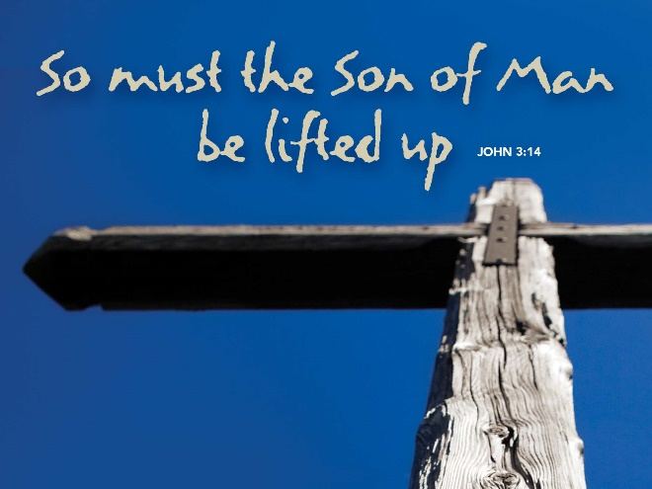

What Is Eternal Life?
March 11, 2018
John 3:14-21

Grace and peace to you from God Our Father and from the One who was lifted up so you could have eternal life, Jesus Christ, our Savior and Lord, amen.
What is “Eternal Life”? Apparently, there’s a lot of interest in it. When I Googled that very question I got over 16.5 million hits. I didn’t read all 16.5 million websites, but the ones I scanned, most indicated that eternal life has something to do with living forever or a never-ending span of life. Some of the sites I looked at said you either spend forever in heaven or in hell, but everyone goes someplace when they die and it’s a looooong time. Most of the sites indicate that eternal life happens after you die.
Back in 2008 the Pew Research Institute did a survey of nearly 3000 Americans and they asked some questions about our beliefs when it comes to Eternal Life. Here’s what I found interesting and a little disturbing about the Pew survey. The first thing that caught my eye was that a full 65% of Americans in this survey said that many other, non-Christian religions can lead to eternal life. Another 29% said their religion alone can do it, while 6% either didn’t know or refused to answer. The next thing I noticed was that when asked what determines eternal life, 30% said one’s beliefs and 29% said one’s actions. Another 10% said it was a combination of our beliefs and actions, 10% said something else, 14% didn’t know and only 7% said they didn’t believe in eternal life.
Almost 70% of Americans said some combination of what we believe or what we do determines our eternal future. The upshot of all this for us means that we’d better watch out and get our beliefs right and even our actions right before it’s too late or we’ll be going to that place where the furnace never shuts off and the flesh on our bones gets charred, but never consumed… So, today we’re going to try to understand what Jesus means when he says, “…whoever believes in him may have eternal life.”
“For God so loved the world. That he gave his only son, so that everyone who believes in him may not parish, but may have eternal life.” John 3:16 is a verse everyone knows. Luther said it is the Gospel in a nutshell. The trouble with that is, do you know the only thing that fits inside a nutshell? That’s right… a nut… Let’s try to see if we can understand what Jesus means in this fairly long explanation to the Jewish ruler Nicodemus. The Greek term for eternal life is “Zoa Aonion”. From the first word “Zoa” we get the English word Zoology or the study of animal life. The word “Anion” literally means into the ages… Together these two form a Greek idiom to describe a change in human existence brought about by faith in Jesus Christ. In the English translations this eternal life is brought about through belief in Jesus Christ. The Greek term translated as believe is the word “Pistis” and this one word is randomly translated as belief, faith, trust, and even hope throughout the Bible. These English words mean very different things to us, but they all come from the exact same Greek word. If we take John 3:16 or even this whole passage out of the context of the while Biblical story and only read this one translation you would easily think that one must intellectually agree that Jesus Christ is the Son of God and then you’ve done your job and eternal life for you is now assured. This is called decision theology and has been rejected by Lutherans since, since, well since Luther was a Lutheran… I find it very difficult to understand gaining Eternal Life simply believing in Jesus because the Devil believes in Jesus. The devil even believes Jesus is the Son of God. The trouble with that is, the devil still rules in Hell and has not attained Eternal Life as we think about it being in Heaven with Jesus. There has to be something other than simple belief. Lutherans claim or cling to the terminology of faith, trust or hope rather that belief and we define that as something given to us a gift, not something we do on our own. The Bible describes it like this, faith comes by hearing the Word of God.
Enough about how one comes to this Eternal Life, how about if we just leave that up to God and trust that Jesus has done all the heavy lifting to get all of us there… I think we should spend a minute or so thinking about what it is to have eternal life. Again, going back to all those 16.5 million websites, it seems most people think eternal life means endless years. It is true that when we talk about God, we say God is eternal and by that we mean God has no beginning and no end. If all there is to eternal life is more years added on to the end after I die, then count me out. I’m not really interested in just having more and more of this same old life! There’s got to be something else, something more to it than just adding an endless supply of years to this old, worn out, and tired body. Biblically speaking, eternity doesn’t mean mere endless duration of human existence. Eternal life is a way of describing our lives as being in the never-ending presence of God. What we mean when we say eternal life is to have a life no longer defined by blood or by the will of our flesh, by human will, or our old, sinful nature, but by God. To have eternal life is to be a Child of God.
This view of eternal life quite literally changes everything! Most people think of eternal life as that place you go when you die or at the end of time when Jesus returns to make all things right and to reconcile all things back to God. That places the emphasis on the end or what happens after you die. WRONG! WRONG! WRONG! Eternal Life is what Jesus gives to us right here and right now. It has much more to do with the quality of your life than it has to the quantity of years you have after you die. Eternal life isn’t something God holds out there in the future like a carrot on a stick for those who act or believe in a certain way. It’s not your reward for a job well done here on earth… Eternal life is your new life you receive through faith, trust, and hope on the fact that Jesus was lifted up like a bronze snake to heal your sin-sick soul.
This passage from John’s Gospel draws a clear distinction between the light and the dark. God has sent Jesus out of his love for all the world, not just believers, but everyone. Those who love darkness and evil will remain in the dark and judgment has already happened. They are missing out on eternal life right now! Every minute of every day that passes by they are missing out on the love and the joy of living in the very presence of God. God’s judgment of the world isn’t some future cosmic event, but is underway right now, in the present and was initiated by Jesus coming into the world as the one who descended from heaven. God sends his son into the world in love to save the world and yet his very presence confronts the world and demands a decision. Is that decision a work of righteousness or are we prompted by the Holy Spirit into faith, making it all God’s work and we do nothing? That’s one of the great debates of our age and I can’t tell you where to stand. In the end I’m not sure all that matters a whole lot anyway. The proof is in how we live as a new creature, living according to God’s will.
In the end, the offer of new life, eternal life, only comes from one source. It comes from the crucifixion, resurrection, and ascension of Jesus Christ. The offer of eternal life, Jesus’ offer of his life, through being lifted up on a cross makes “eternal life” possible for those who believe, have faith, trust and hope in Him.
May you have this saving belief, faith, trust, or hope in Jesus Christ. May you look upon His Cross and be healed. Then, walking in this newness of life, may the quality of your present days be changed as you realize you now live and have your being in the presence of the God who created you and is totally crazy in love with you now and forever. Amen.

