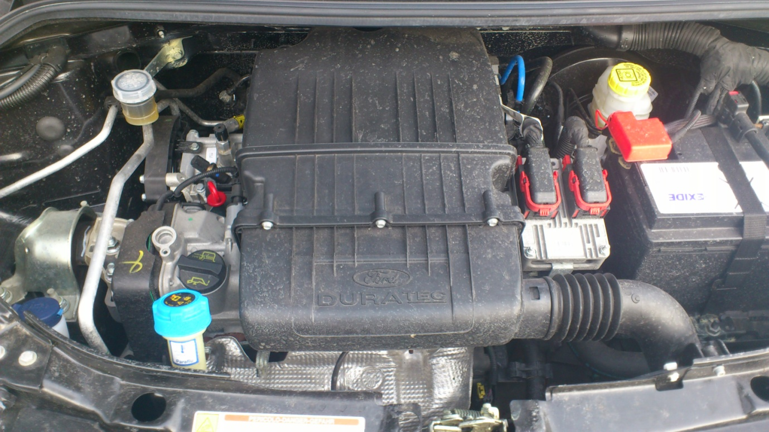

Screenwash

Power Steering

Dip Stick

Oil filler

Antifreeze/Coolant

Brake Fluid