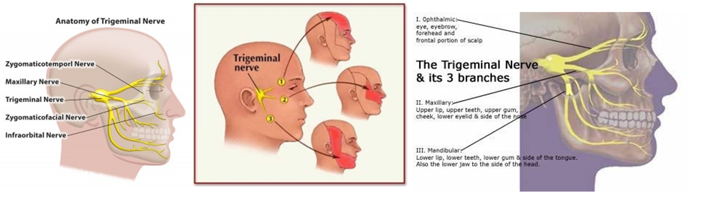
Neuralgia

- Neuralgia is a stabbing, burning, and often quite severe pain that occurs along a damaged nerve.
- The damaged nerve may be anywhere in the body, but is most common in the face and neck.
- The cause of a damaged nerve may be a disease like diabetes or multiple sclerosis, an infection like shingles, or the result of old age. Treatment for the pain of neuralgia depends on the cause.
Types of Neuralgia
- Postherpetic Neuralgia: This type of neuralgia occurs as a complication of shingles and may be anywhere on the body. Shingles is a viral infection characterized by a painful rash and blisters. Neuralgia can erupt wherever the outbreak of shingles occurred and can be mild or severe, persistent or intermittent, and can last for months or years.
- Trigeminal Neuralgia: This type of neuralgia is associated with pain from the trigeminal nerve, which goes from the brain to the face. The particular cause of pain is believed to be a blood vessel pressing down on the trigeminal nerve where it meets with the brainstem. Trigeminal neuralgia causes pain in the face, usually on one side, and is most common in the elderly.
- Glossopharyngeal Neuralgia: Pain from the glossopharyngeal nerve, which is in the throat, is not very common. This type of neuralgia produces pain in the neck and throat.

Causes of Neuralgia:
The underlying cause of any type of neuralgia is damage to a nerve. Each nerve in your body is protected by a coating called the myelin sheath. When the myelin is damaged or wears away from the nerve, the stabbing, severe, shock-like pain of neuralgia results. There are many different factors, including old age, which can cause damage to the myelin.
- Infection ... The cause of postherpetic neuralgia is shingles, an infection caused by the chickenpox virus. The likelihood of having this infection increases with age. Lyme disease, HIV, and syphilis can also cause neuralgia.
- Multiple Sclerosis ... Multiple sclerosis (MS) is a disease that is caused by the degradation of myelin. Among the many symptoms that result from MS is neuralgia, often in the face.
- Pressure on Nerves ... The myelin on nerves can be worn away by pressure. The pressure may come from a bone, ligament, blood vessel, or a tumor that is pressing on the nerve. The pressure of a swollen blood vessel is a common cause in trigeminal neuralgia.
- Diabetes ... Many people with diabetes will suffer from some type of neuralgia because excess glucose in the bloodstream can lead to myelin damage.
- Other Causes
* chronic kidney disease
* porphyria (a rare blood disease)
* medications like cisplatin, paclitaxel, or vincristine (prescribed to cancer patients)
* trauma, such as that caused by surgery
* chemical irritation

Natural Health Support for Neuralgia
Always optimize water intake & eat a high percentage of raw fruits and vegetables in your diet choices!
STEP 1:
- Lecithin ... helps to repair, rebuild & maintain healthy myelin sheath.
- Protein ... a guaranteed supply DAILY of the nine essential amino acids, is essential to repair, rebuild & maintain healthy myelin sheath. It is recommended to have a Shaklee Soy Protein Smoothie every day as a part of your daily food selections ... to provide the guaranteed supply of the nine essential amino acids daily - in the raw form).
- Alfalfa ... a smorgasboard of minerals which are very anti-inflammatoryand alkalize the blood ... and contain natural pain killers called saponins (6 to 10 with each meal - think of them like green peas)
STEP 2:
- Vitalizer ... a smorgasbord 80 of the most important nutrients for optimal health ... including fish oils, Vitamin E, B Complex, Vitamin C, Probiotics, Vitamin D3, 26 antioxidants, and more
- Vitamin D3 ... Optimize your levels, until your blood levels show you have reached the top of the "reference range"
- B Complex ... Optimize your levels ... usually 1 or 2 tablets, additional to what is in the Vitalizer
STEP 3:
- If your Neuralgia follows after a battle with shingles, it is important to support the immune system. Shaklee NutriFeron is highly recommended.
- VIVIX is an amazing tonic that reduces inflammation and speeds recovery, as well as repairs nerve and cellular damage.

