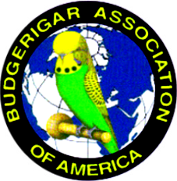
DFW Exhibition Budgie Club 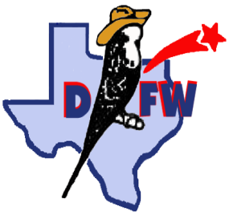

The “June Trio” show

June 24 - Judge #1: Maureen Broderick
Judge #2: Robert Marshall
June 25 - Judge: Virgil Oliphant

Ables Springs Volunteer Fire Department
30000 F.M. 429 N. Terrell, TX 75161

All Divisions – Pairs, Rare, Junior, Novice, Intermediate, Champion
**Natural Presentation entries allowed**

Entry fees - 1 show: $3/bird, $30 max 2 shows: $5/bird, $50 max 3 shows: $7/bird, $70 max

Schedule of Events

FRIDAY 3:00-6:00 PM Show hall open for Setup and Check-in
6:30 PM Dinner to be announced

SATURDAY 7:00 AM Show Hall Opens
9:00 AM Bird check in and entry complete. Staging of entries
10:00 AM First Judge Begins (Maureen Broderick)
~1:30 PM Lunch – Club will provide main meal. Please bring drinks,desserts and sides.
~2:00 PM Second Judge Begins (Robert Marshall)
~7:00 PM Dinner provided by the club at the show hall following the 2nd show.

SUNDAY 7:00 AM Show Hall Opens
9:00 AM Judging Begins (Virgil Oliphant)
Noon - 1:00 PM Lunch, Raffle – All donations are appreciated
6:00 PM Show Hall Closes – Awards, wrap up, and clean up. All help is appreciated

-Sales Division, Raffle Extraordinaire and a Budgie Auction-
*Budgie Auction may take place on Saturday or Sunday after lunch, depending on the members request*

Local hotels in Terrell, TX:
Further information contact : Joshua Anthony
- 381-9051 joshda12101984@gmail.com

Show Secretary contact: Julie Willis
(469)524-9700 juliebelle57@gmail.com
*Preregister: Email. Electronic entry form to Julie Willis*
Lowest-highest ($77 -$110 per night)

Red Roof Inn: (972) 551-1090
Baymont Inn: (972) 563-1521
Tru By Hilton: (469) 837-7200
Holiday Inn : (972) 563-7888

