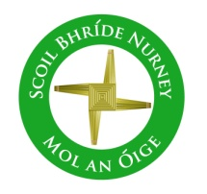
Scoil Bhríde
Nurney, Co. Kildare
Telephone: (045) 526767
www.nurneyns.com
sbnurney@gmail.com

7th December 2022
Dear Parents/Guardians

It’s a pretty full newsletter this week, so please read both sides!!!!
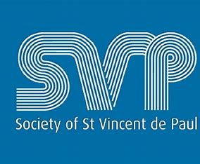

Our School’s Annual Winter Fest Hamper Raffle organized by 6th class for all pupils in memory of Catherine O’Donoghue late of Walterstown Nurney (partner of our great school caretaker Pat) begins this week. All donations go to ‘St. Vincent De Paul’

Tickets for the raffle will be sold to pupils in the school by 6th class on Tuesday the 6th and Thursday the 8th of December. Tickets are 1 Euro per line.
Winners of the raffle will be announced at our December school assembly. The winner will get a hamper. There are two hampers. One for junior infants to 2nd class and one for 3rd to 6th class. All raffle ticket purchases are welcome and greatly appreciated. Thank you for supporting St. Vincent De Paul.

Drum lessons payment due – all pupils
A 4-week course of drumming classes for all pupils with a specialist instructor started on November 7th. To cover the cost a payment of 8 Euro is now due from each pupil. This can be paid online or by cash. Thank you to all who have paid in full to date.

Sacred Space, School Christmas Tree and School Crib
Many thanks to Lily Ann, Rachel, Zuzanna, Kiera and Braden for decorating this year’s School Christmas Tree and School Crib!
Super job children!
Well done!

5th class Swimming payment due!
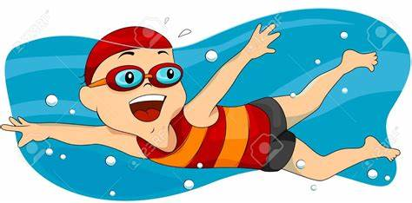
A six-week course of swimming classes in K-Leisure Athy for 5th class began on November 9th. Payment of 50 Euro from each 5th class pupil is now due. Thank you to all who have paid in full to date.

A six-week course of swimming in K-Leisure Athy for all other senior classes will start as follows:
4th class – February 22nd 2023
3rd class – April 26th 2023

School Admissions Policy
In light of the recent amendment to the Schools Admissions Act from the Department of Education, the School’s ‘Admissions’ Policy has been reviewed and updated. It can be viewed or downloaded from our school website for comment at https://www.nurneyns.com/policies

Substitution crisis in primary schools
As you may be aware from news channels, newspapers and social media, currently there is a severe shortage of primary school teachers and special needs assistants in our country and county. At times it has been a real challenge to keep our school operational. However, with the great team spirit within our school staff we have managed to plug any gaps as best as we can using whatever staff we have been able to pull from other duties (such as special needs teachers, principal and deputy principal, work placement teachers etc.), however we have also had to send pupils to other classes where no substitute cover was available or not funded by the Department of Education. Qualified primary teachers and trained SNAs are currently like gold dust. To protect the continued operation of the school and the pupils’ teaching and learning, it has been and still is vital, in as much as is possible, to protect the health and well-being of the staff that we are lucky enough to have, because there are literally no easy replacements to be found.
Thank you to all parents and pupils for your continued past, present and future support in this endeavour.
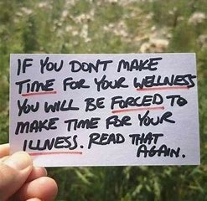

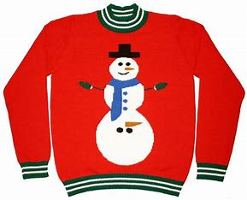
Christmas Jumper Day!
Wednesday, December 21st we invite all pupils, if they so wish, to wear a Christmas jumper in our school!

Christmas and Thematic Art Displays
Thank you to all the children and their hardworking teachers for having all their wonderful seasonal work on display in our corridors and their classrooms. Our school looks so well and full of colour for the festive season!
Well done everyone! We will post photos on our school website next week for all to see at home!

Home Learning page on our school website
If your child has to isolate and stay out of school due to COVID-19, please go to the following link on our school website to access the school work they would be doing at that time in class https://www.nurneyns.com/home-learning

In line with Public Health Advice, Schools have been asked to ensure that all classroom are well ventilated to limit the possible spread of infectious disease even during the Autumn and Winter months. Public Health Advice has asked schools to open doors and window vents to increase natural ventilation where possible. To minimize discomfort, they ask that such vents be opened above the schools heating systems (radiators etc) To view this Public Health Advice please click the following link:

https://www.gov.ie/en/publication/ad236-guidance-on-ventilation-in-schools/

For that reason, we ask all parents to ensure that their children have good thermal under garments under their school uniform as we head into the Winter months. We would also ask all parents to ensure that their child comes to school prepared for all weathers as the staggered entry and exit to school buildings takes time and your child will be standing outside waiting their turn in all types of weather.
Public Health advice also asks schools to bring the children outside more than usual. For that reason, they need to have the proper clothing for all weathers.
As Mr. Thorpe’s Mum used to say “There is no such thing as bad weather, just bad clothing”

Dates for your diary
- School closes at 12:30pm on December 16th for all pupils as staff must attend Department of Education training in the New Primary Language Curriculum. The bus has been told.
- End of Term School Mass – Tuesday December 20th. School Hall. Parents welcome. Standing only.
- School will close for Christmas on Wednesday December 21st for all pupils at 12.30pm. Buses have been told. The school will re-open on Thursday January 5th 2023 for all pupils at 9.20am
- School Book Fair – Spring 2023; risk assessment pending
- The Parish office wishes to inform you that Communion for families with children in 2nd class will be May 13th 2023 @ 11:30am in Nurney Church
- The Parish office wishes to inform you that Confirmation for families with children in 6th class will be March 25th @ 12 midday in Nurney Church

Wednesday Note and school information also available
on www.nurneyns.com
Thank you for your co-operation with the above.

__________________________
Dr. Vinny Thorpe – Principal
Ed.D (SL) M.Ed (SL), MA.Comp.Mus, H.Dip.Prim.Ed, H.Dip.Mus.Tech, P.Grad.Dip.Ed.St(SEN), B.Mus.Ed(H.Dip.Ed), Dip.Mus.Ed, T.Dip.ICT

