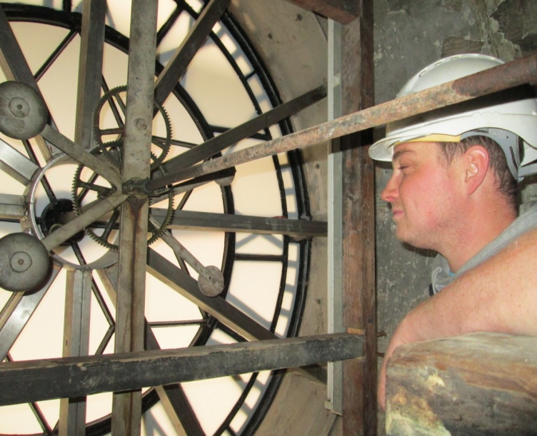
Phases 1-3 have seen the restoration of the clock faces (north, south, west). The east face clock is at present away for restoration. Paul the site foreman look on at the impressive steel wheel, which has been specially made to keep the clock face the correct shape.
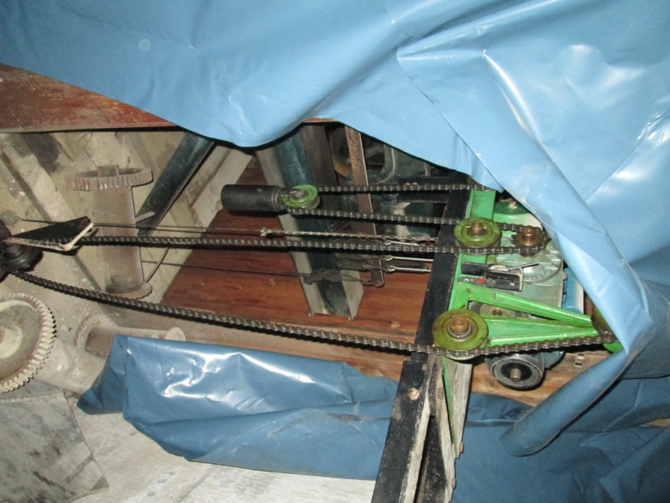
During Phase 5 of work on the Tower the clock is being kept going, but care has been taken to cover over the mechanism to reduce dust contamination. In Phase 3 a small piece of tape caught in the mechanism – and the clock stopped!
The hour chimes of the clock – such a familiar sound – have been suspended for the time being – to spare the Stonemason’s ears!
St Mary’s in the Marketplace.

Issue No 12 (7th October 2012)

“Securing the future for the next 100 years”
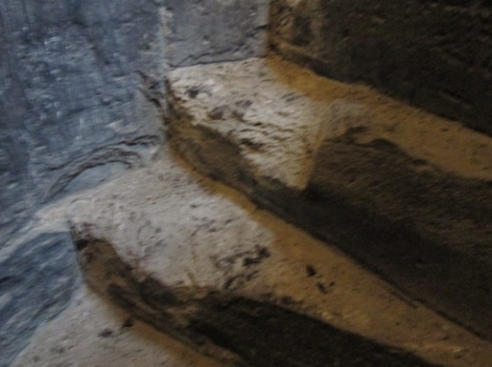
One step at a time, and 142 steps
to the top of St Mary’s Tower
where things are beginning to
happen, out of sight from the
ground, but very dramatic close
at hand.
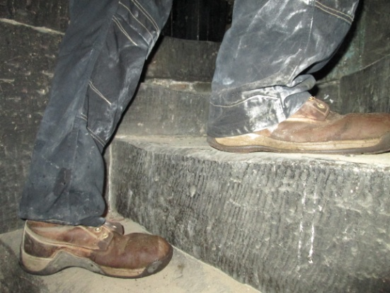
The steps at the very top of the
spiral staircase to the roof have
weathered badly and will
eventually be repaired.
The Stonemasons have a choice –
stairs – or vertical ladders to the
platform, then more to the very
top.
Either way – its one step at a time.
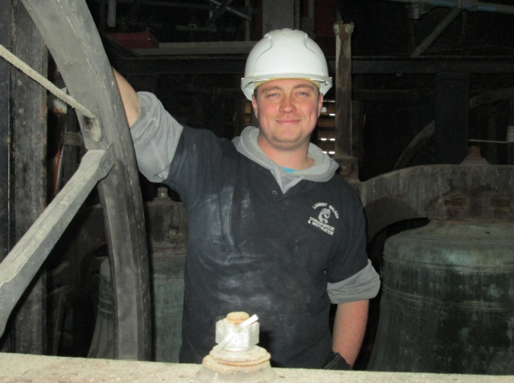
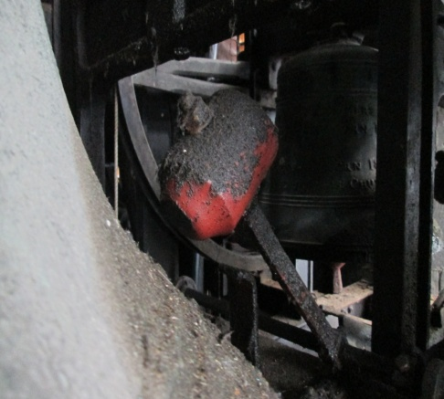
Paul is very interested to see this aspect of St Mary’s – and for a moments rest as long as the bell isn’t rung while he’s there. It can be quite a shock!

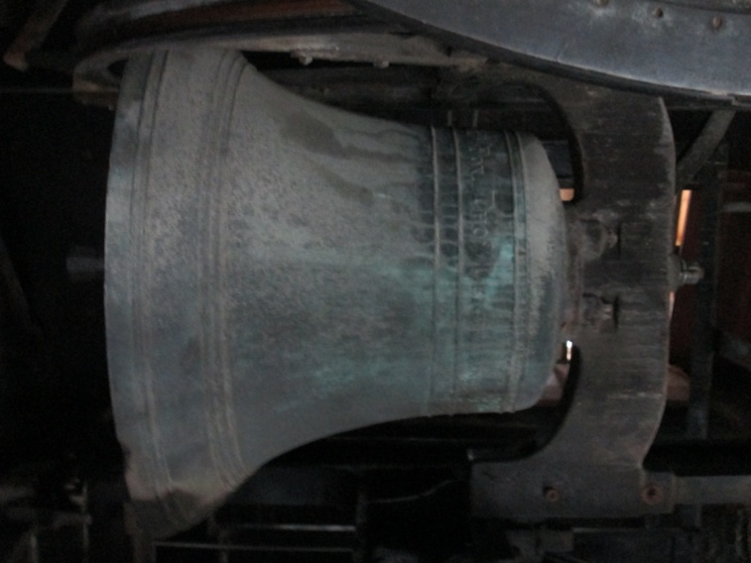

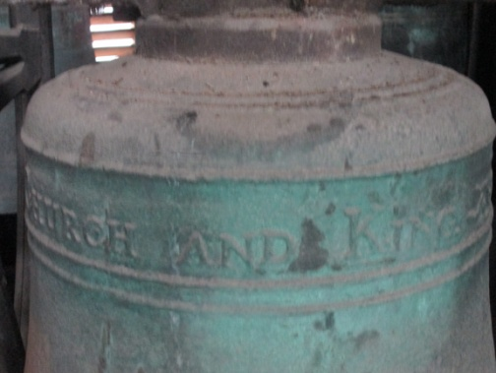
Eight of St Mary’s bells were re-cast in 1817, which is clearly obvious from the inscription on some of the bells. The largest bell seen here was made in 1897 to mark the 60th Anniversary of Queen Victoria’s reign. The hammers are wired to the clock mechanism on the floor below, ready for the automatic progress of each hour and quarter hours. They are having a few months off!
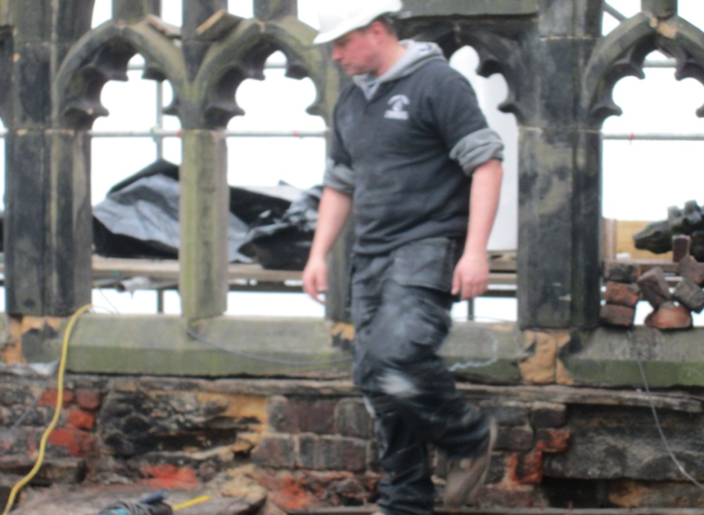

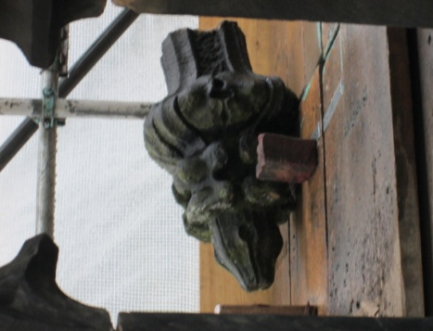
Now that the roof has been stripped
of its lead and the timber covering
removed the contractors can begin
to assess how much work needs to
‘ be done, before a fine new lead roof
is put on, in a substantially different
and more effective design to the
previous one.
Before work can get fully underway on the East wall the finials, such as seen here, must be removed and taken to ground level allowing space for the Stonemasons to work on the walls. In some cases they are needed to create templates (pattern sheets) for replacement finials in the Lambert Walker workshops.
One step at a time!

