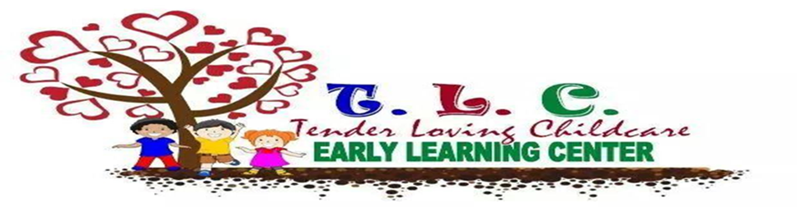
Pre-k program
TLELCC’s Pre-k Program is for our 2 to 4 year olds. TLELCC offers age-appropriate opportunities to discover, explore and learn. Our pre-k teacher’s use teaching techniques that enhances and develops brain based learning. Our program provide a combination of independent and organized activities, education and recreation opportunities, our program offers an involving experience for all students while giving order and routine to their day.
Our students work with activities that promote the main areas of development:
• Cognitive Development
• Social and Emotional Development
• Language Development
• Physical Development
• Music and Movement
• Creative Art
• Healthy and Safety
TLELCC follow the STEM Curriculum our program. The STEM curriculum refers to the areas of Science, Technology, Engineering and Mathematics. However, STEM initiatives are not science, technology, engineering and mathematics in isolation.
Elaine Hom states “STEM is a curriculum based on the idea of educating students in four specific disciplines — science, technology, engineering and mathematics — in an interdisciplinary and applied approach. Rather than teach the four disciplines as separate and discrete subjects, STEM integrates them into a cohesive learning paradigm based on real-world applications”.
STEM Curriculum is different than traditional science and math education. Elaine Hom states “What separates STEM from the traditional science and math education is the blended learning environment and showing students how the scientific method can be applied to everyday life. It teaches students computational thinking and focuses on the real world applications of problem solving”.
Our staff is first aid and cpr trained, and we do have staff that is MAT trained. All staff has been backgrounds and Cps processed and cleared. All staff have training in the following topics: Daily Health Observation, Child Abuse Prevention and Playground Safety. All staff must continue required training hours yearly.

Citation:
http://www.livescience.com/43296-what-is-stem-education.html
What is STEM Education? By Elaine J. Hom, LiveScience Contributor

