1. Explanation of the test
Helicobacter pylori (H. pylori) was initially isolated by Warren and Marshall from biopsy samples taken from patients suffering from active chronic gastritis. In fact, it is now clear that H. pylori is the principle etiologic agent in type B gastritis (chronic active antral gastritis) pathology for which it appears to be the triggering and perhaps aggravating factor. Increasing data are being accumulated regarding the fundamental role of H. pylori in active chronic gastritis, in gastric ulcer and in duodenal ulcer and its close correlation with gastric lesions. H. pylori is isolated in culture medium and examined by microscopy after staining or is detected by urease test. Both these techniques are lengthy to implement and their sensitivity and specificity have yet to be demonstrated. The immunochromatographic techniques (rapid) for the detection of antibodies specific to H. pylori has substantially resolved these problems, ensuring a serological monitoring in a very short space of time using simple, highly specific technology without recourse to invasive techniques. The serum test for H. pylori can be utilized as a rapid screening process for large populations of patients and highly indicated in the early diagnosis of H. pylori infection as the immune response can often precede clinical manifestations of disease. From a diagnostic point of view, a high serum level specific antibodies against H. pylori must be interpreted as an indication of type B asymptomatic gastritis.
The H. pylori test is a rapid test for the qualitative detection of antibodies of all isotypes (IgG, IgM, IgA, etc) specific to Helicobacter pylori in human serum, plasma or whole blood. This test kit is intended as an aid in the diagnosis of H. pylori infection in patients with gastrointestinal symptoms.
The H. pylori test contains a membrane strip, which is pre-coated with H.pylori capture antigen on test band region. The H. pylori antigen– colloid gold conjugate and serum sample moves along the membrane chromatographically to the test region (T) and forms a visible line as the antigen-antibody-antigen gold particle complex forms with high degree of sensitivity and specificity. This test device has a letter of T and C as “Test Line” and “Control Line” on the surface of the case. Both the Test Line and Control Line in result window are not visible before applying any samples. The Control Line is used for procedural control. Control line should always appear if the test procedure is performed properly and the test reagents of control line are working.

2. Materials provided
H. pylori test kit contains following items to perform the assay;
- H. pylori test device.
- Assay diluent : 4 ml/vial
- Instructions for use
3. Precautions
H. pylori test devices should be stored at room temperature. The test device is sensitive to humidity and as well as to heat. Perform the test immediately after removing the test device from the foil pouch. Do not use it beyond the expiration.

4. Specimen collection and storage
- [whole blood ] Collect the whole blood using the suitable anti-coagulant.
- [serum or plasma] Centrifuge whole blood to get plasma or serum specimen.
- If specimens are not immediately tested they should be refrigerated at 2 ~ 8ºC. For storage periods greater than three days, freezing is recommended. They should be brought to room temperature prior to use.
- Specimens containing precipitate may yield inconsistent test results. Such specimens must be clarified prior to assaying.
- The whole blood may be used for testing immediately or may be stored at 2 ~ 8ºC up to three days.

5. Warnings
  - For in vitro diagnostic use only.
  - Do not eat or smoke while handling specimens.
  - Wear protective gloves while handling specimens. Wash hands thoroughly afterwards.
  - Avoid splashing or aerosol formation.
  - Clean up spills thoroughly using an appropriate disinfectant.
  - Decontaminate and dispose of all specimens, reaction kits and potentially contaminated materials, as if they were infectious waste, in a biohazard container.
  - Do not use the test kit if the pouch is damaged or the seal is broken.

6. Procedure of the test
- Remove the test device from the foil pouch, and place it on a flat, dry surface.
- Add 10 μL of serum, plasma or 20 μL whole blood to the sample well (S), and then add 3 drops of assay diluent
- As the test begins to work, you will see purple color move across the Result Window in the center of the test device.
- Interpret test results within 10 minutes. Do not interpret after 20 minutes.
Caution: The above interpreting time is based on reading the test results at room temperature of 15 to 30 degrees C. If your room temperature is significantly lower than 15 degrees C, then the interpreting time should be properly increased.

7. Interpretation of the test
- As the test kit begins to work, a color band will appear at the left section of the Result Window to show that the test is working properly. This band is the “Control Line.”
- The right section of the Result Window indicates the test results. If another color band appears at the right section of the result window, this band is the “Test Line.”
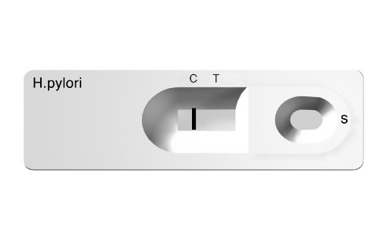
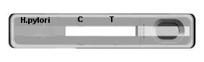
Negative Result : The presence of only one purple color band within the result window indicates a negative result.

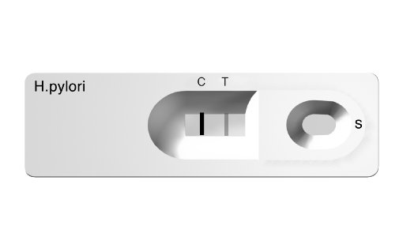
Positive Result : The presence of two color bands (“T” band and “C” band) within the result window, no matter which band appears first, indicates a positive result.

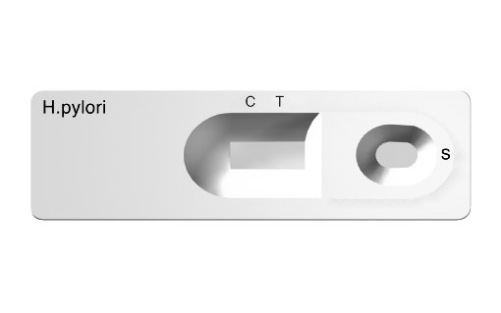
Invalid Result : If the purple color band is not visible within the result window after performing the test, the result is considered invalid. The directions may not have been followed correctly or the test may have deteriorated. It is recommended that the specimen be re-tested.

Note: A positive result will not change once it has been established at 10 minutes. However, in order to prevent any incorrect results, the test should not be interpreted after 20 minutes.

8. Performance Characteristics

- Expected Values
The majority of individuals exposed to H. pylori developed IgG antibodies against the organism. It is reported that H. pylori is universally distributed and an estimated 50% of the world’s population is colonized by H. pylori. A relatively large proportion of patients who have positive levels of IgG antibodies are asymptomatic even though they are colonized with the H. pylori. Therefore, IgG antibodies levels do not necessarily correlate with the severity of clinical symptoms.
- Sensitivity and Specificity
The clinical trial studies were carried out to evaluate the BIOLINE H. pylori.

Reference |  | BIOLINE H. pylori |  | Total Results
Method | Result | Positive | Negative | Total Results
a commercial  H. pylori ELISA | Positive | 71 | 3 | 74
a commercial  H. pylori ELISA | Negative | 5 | 43 | 48
Total Results |  | 76 | 46 | 122
In a comparison of the BIOLINE H. pylori versus a commercial H. pylori IgG ELISA kit, results gave sensitivity of 95.9% (71/74), a specificity of 89.6% (43/48), and a total agreement of 93.4% (114/122).
- Precision
  - Within run precision was determined by using 10 replicates of four different specimens containing different concentrations of antibody. The negative and positive values were correctly identified 100% of the time.
  - Between run precision was determined by using the four different specimens containing different concentrations of antibody in 3 different replicates with 3 different lots of test devices. Again negative and positive results were observed 100% of the time.
Latest revision 09.05.201

ATLAS LINK, INC
No. 811 Zeyang Plaza, No.166 Fushi Road
Shijingshan Dist., Beijing 100043, China
Tel: 86-10-88909112 Fax: 86-10-88909115
USA Headquarters:
10758-A Ambassador Drive
MANASSAS, VA 20109 USA
Tel: 703-3663851

CIRIANO GLOBAL S.L. (UNILATEX GROUP)
CIF: B50927532 C/Blancas 4-6, 1 B Oficina 1
50001 Zaragoza Spain
Tel: 34-976910399

