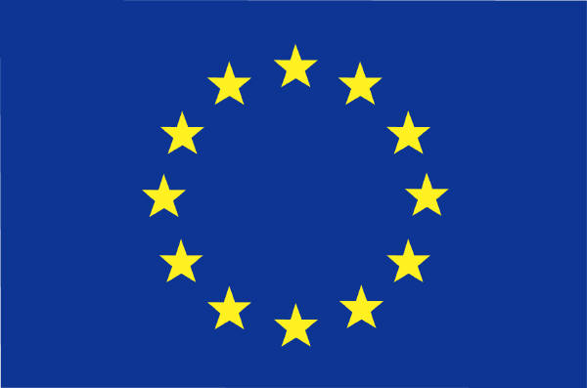

REQUIREMENTS SCHENGEN VISA

Minimum requirements for a Schengen Visa for a stay not longer than 90 days
Additional documents may be requested by the Embassy.
Applications are treated within 05 days but might take 15 days in special cases and for certain nationalities.
Applicants should apply in person at the Embassy of their main destination.
Visa fee is due upon introduction of the application and is currently € 60 (to be paid in Uganda Shillings)
Children between 6-12 pay € 35 (fees are non-refundable)

ALL APPLICANTS MUST SUBMIT THE FOLLOWING:
(Original plus one photocopy)
- One application form duly completed and signed by the applicant
- Two identical recent color passport size photographs
- A passport valid for at least three months after the expiration of the visa and with a maximum validity of 10 years, containing at least 2 empty pages
- Travel Health Insurance covering possible medical expenses (The insurance, with a minimum cover of €30,000, must be valid for all Schengen countries) throughout the whole stay in the Schengen area
- Airline reservation
- Proof of regular income (personal bank statement and pay slip)
- Copy of passport bio-data page, including page with passport file number (stamp passport office)
- Birth certificate and parental authorization for minors under 18 years

SUPPLEMENTARY DOCUMENTS TO SUBMIT FOR:
Conference/Business trip
- Letter of invitation/sponsorship or a notification or proof of enrolment for attendance of workshop, seminar, conference or business partner
- Letter of introduction from employer, organisation explaining purpose of trip, business relation and covering of costs
- Proof of hotel booking
- Official documents of the business in Uganda (“Certificate of Incorporation” and “Trading Licence”)
- Proof of financial status (e.g. salary slips and bank statements of the last 3 months)

‘Self funded’ Tourist visa without invitation
- Letter of introduction from employer, organisation, school or institution certifying granted holidays.
- Proof of regular income (Bank statements of current account (of last three months), salary slips of the last 3 months, valid credit cards…)
- Proof of hotel booking and a detailed travel plan explaining your trip to the country of destination
Visa with invitation (private / family visits)
- Proof of accommodation issued by the local council of the host. (permanent residents only)
- Identity card of host + proof of regular income of host (e.g. salary slips of at least the last 3 months of host).
- In case of family visit: relevant documents to prove the family relationship
- Invitation letter from the host stating at which address the applicant is going to stay + the nature of the relationship + purpose of the visit.
- Letter of introduction from employer, organization, school or institution certifying granted holidays.
- Proof of personal regular income or means of subsistence : Bank statements (of last 3 months), Salary Slips of the last 3 months), etc

Please be advised that submitting all required documents is not a guarantee that a visa is granted and that a visa is no guarantee of access to the Schengen territory. The final decision remains with the Immigration Office at the border. The permission to enter the Schengen territory may depend on the presentation of the original invitation letter, proof of accommodation issued by the local council, your financial means and the travel health insurance.

