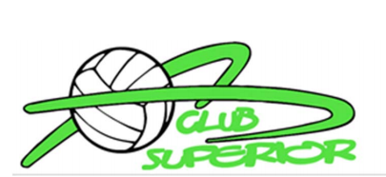

Donations Needed
Please consider Donating items for the No Shoes No Shorts No Problem Program!
• Court shoes
• Spandex shorts
• Knee pads
• Other volleyball related items to be passed to future volleyball players in need!
If you have gently used items you would like to donate, we will collect items for players in need of the above items. Please contact Club Superior csuperiorvb@gmail.com for arrangements.
*If your Daughter is in need of Court shoes, spandex or knee pads, please contact Club Superior csuperiorvb@gmail.com . We have a good supply of gently used items.

