Occipital Neuralgia
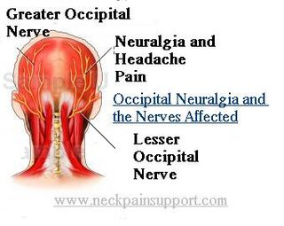

Occipital neuralgia is a medical condition characterized by chronic pain in the upper neck, back of the head and behind the eyes. These areas correspond to the locations of the lesser and greater occipital nerves.
SYMPTOMS: The symptom of this condition is chronic headache. The pain is commonly localized in the back of head and around or over the top of the head, sometimes up to the eyebrow or behind the eye. Because chronic headaches are a common symptom for numerous conditions, occipital neuralgia is often misdiagnosed at first, most commonly as tension headache or a migraine leading to treatment failure or addiction. Another symptom is the eyes being sensitive to light, especially when headaches occur.
CAUSE: Occipital neuralgia is caused by damage or irritation to these nerves. Ways in which they can be damaged include:
- Inflammation
- Infection
- Systemic disease
- Tooth decay
- Poor diet
- Eating cold foods
- Chewing, yawning, swallowing or talking
- Eye strain
- Shingles
- Arthritis
- Chronic stress
- trauma (usually concussive)
- physical stress on the nerve
- repetitious neck contraction
- medical complications (such as a benign tumour of the bone)
- vascular compression
SUGGESTED NATURAL SUPPORT:
- Lifestyle:
  - Drink ½ ounce of water per pound of body weight DAILY
  - Work hard at stress management ... supplement with Stress Relief Complex as needed
  - Exercise
  - Optimal rest
- Diet:
  - Alkaline diet
  - avoid inflammatory foods (coffee, sugar, reduce red meat, avoid white flour products),
  - avoid foods you are allergic to
  - Soy protein smoothie daily
- Supplements:
  - Reduce Inflammation & Initiate Repair: Vivix, lots of Alfalfa, OmegaGuard
  - Nutrient smorgasbord: Vitalizer, Lecithin, and additional B Complex
- Detoxification:
  - Rejuvenating Body Cleanse is recommended to jumpstart the inflammation reduction
  - Support optimal bowel elimination with Shaklee Herb-Lax
THERAPEUTIC OPTIONS:
- Shaklee Pain Relief Complex
- Infrared Saunas
- Massage Treatments and/or chiropractic support

